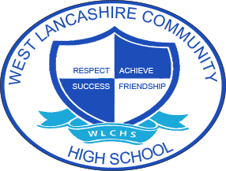
3 Year Long Term Overview
Subject:  Music | Autumn Term  Theme | Spring Term  Theme | Summer Term  Theme
Year 1 | Fair Trade  Steel bands  Bob Marley and Reggae  Music for games, religion and work | My Environment  The Beatles  Folk songs | Space  The Planets by Gustav Holst  A Journey into Space
Year 2 | Around the World  African Drumming  Indian Ragas  Samba from Brazil | Lights Camera Action  Film Music  Musicals | Farm to Fork  Musical Journeys  Ma Vlast  The Seasons
Year 3 | Best of British  Young Persons Guide to the Orchestra  British Folk and Pop Music | Looking After Me  Music to inform, educate and entertain | Animal Kingdom  The Carnival of the Animals

