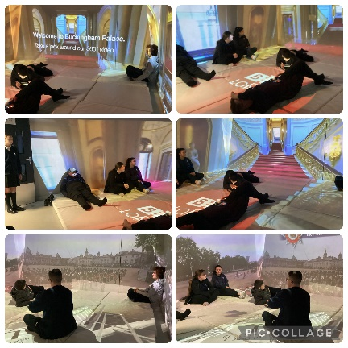
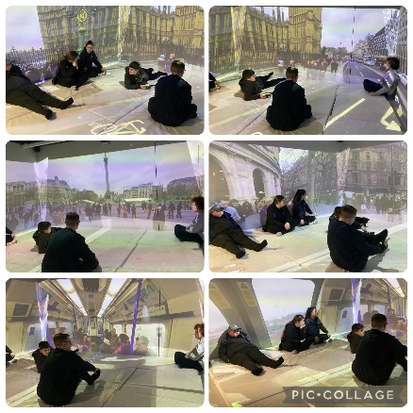
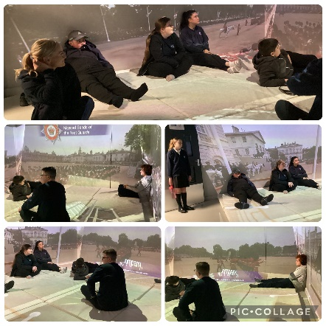
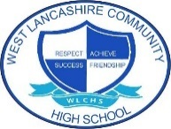
Immersive Reality – Journey to London
Students in Key Stages 3, 4 & 5 took part in a ‘Journey to London’ and what a wonderful time they had! Students boarded the virtual train taking part in many job roles which included ticket operator, train driver and ticket officer to name a few. Once boarded on the train, students used their listening skills to listen to carefully to the instructions before arriving in London for a bit of sight-seeing! Student enjoyed seeing the sights of London as took a ride in a virtual black cab.
Students demonstrated their skills in speaking and listening, adapting and planning.

Last week saw all our students immersed in the world of careers, and what an amazing week we all had!
This newsletter has been put together to help share some of the wonderful learning opportunities and experiences students took part in throughout the week.
From taking the train to London and travelling around in a taxi to see the capital as part of an immersive experience, to having the opportunity to ask questions with employers from a range of businesses, as well as dancing with the wonderful One Vision, it was certainly a busy week and I would like to extend my thanks to all who supported our events.
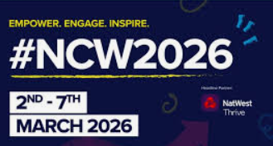
Claire Buckle
Paralympian Guest Speaker
Students in Key Stages 3, 4 & 5 enjoyed a question and answer session with Claire. Claire spoke about her journey into sport, her successes and what she does today as her job. Students asked many questions and enjoyed finding out about Claire.
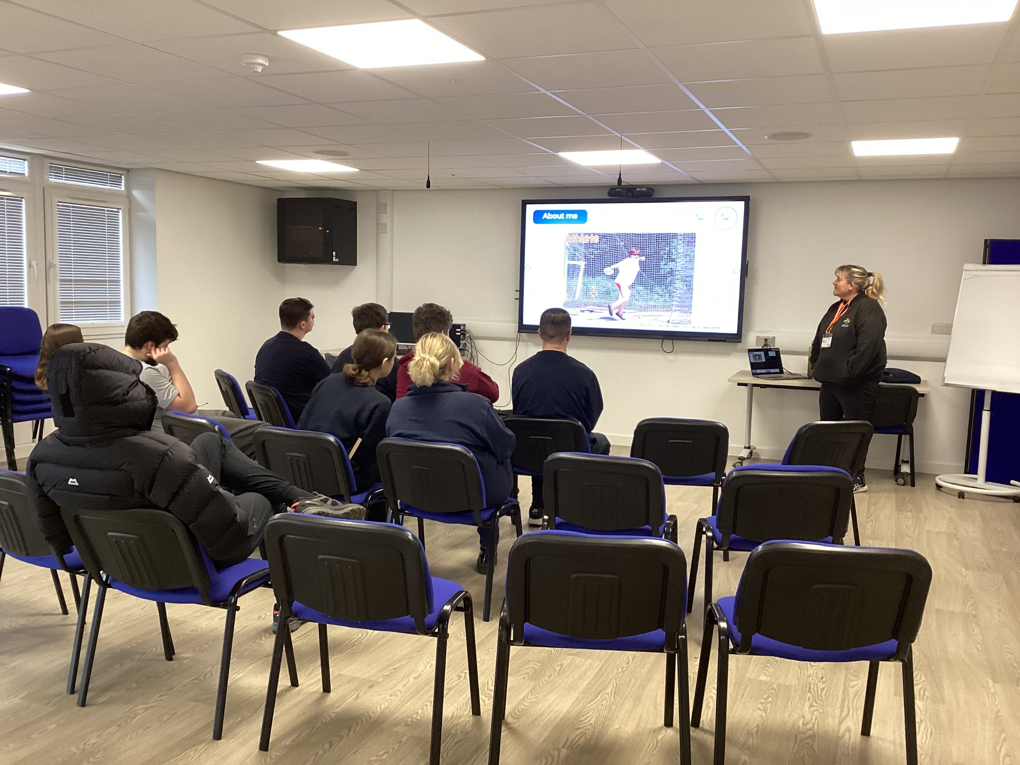
The Secret Garden Glamping
Thank you to Derry Green who supported a Q&A session about The Secret Garden Glamping.
Lots of information was shared and it was lovely to see so many students from across the Key Stages taking part in the session.

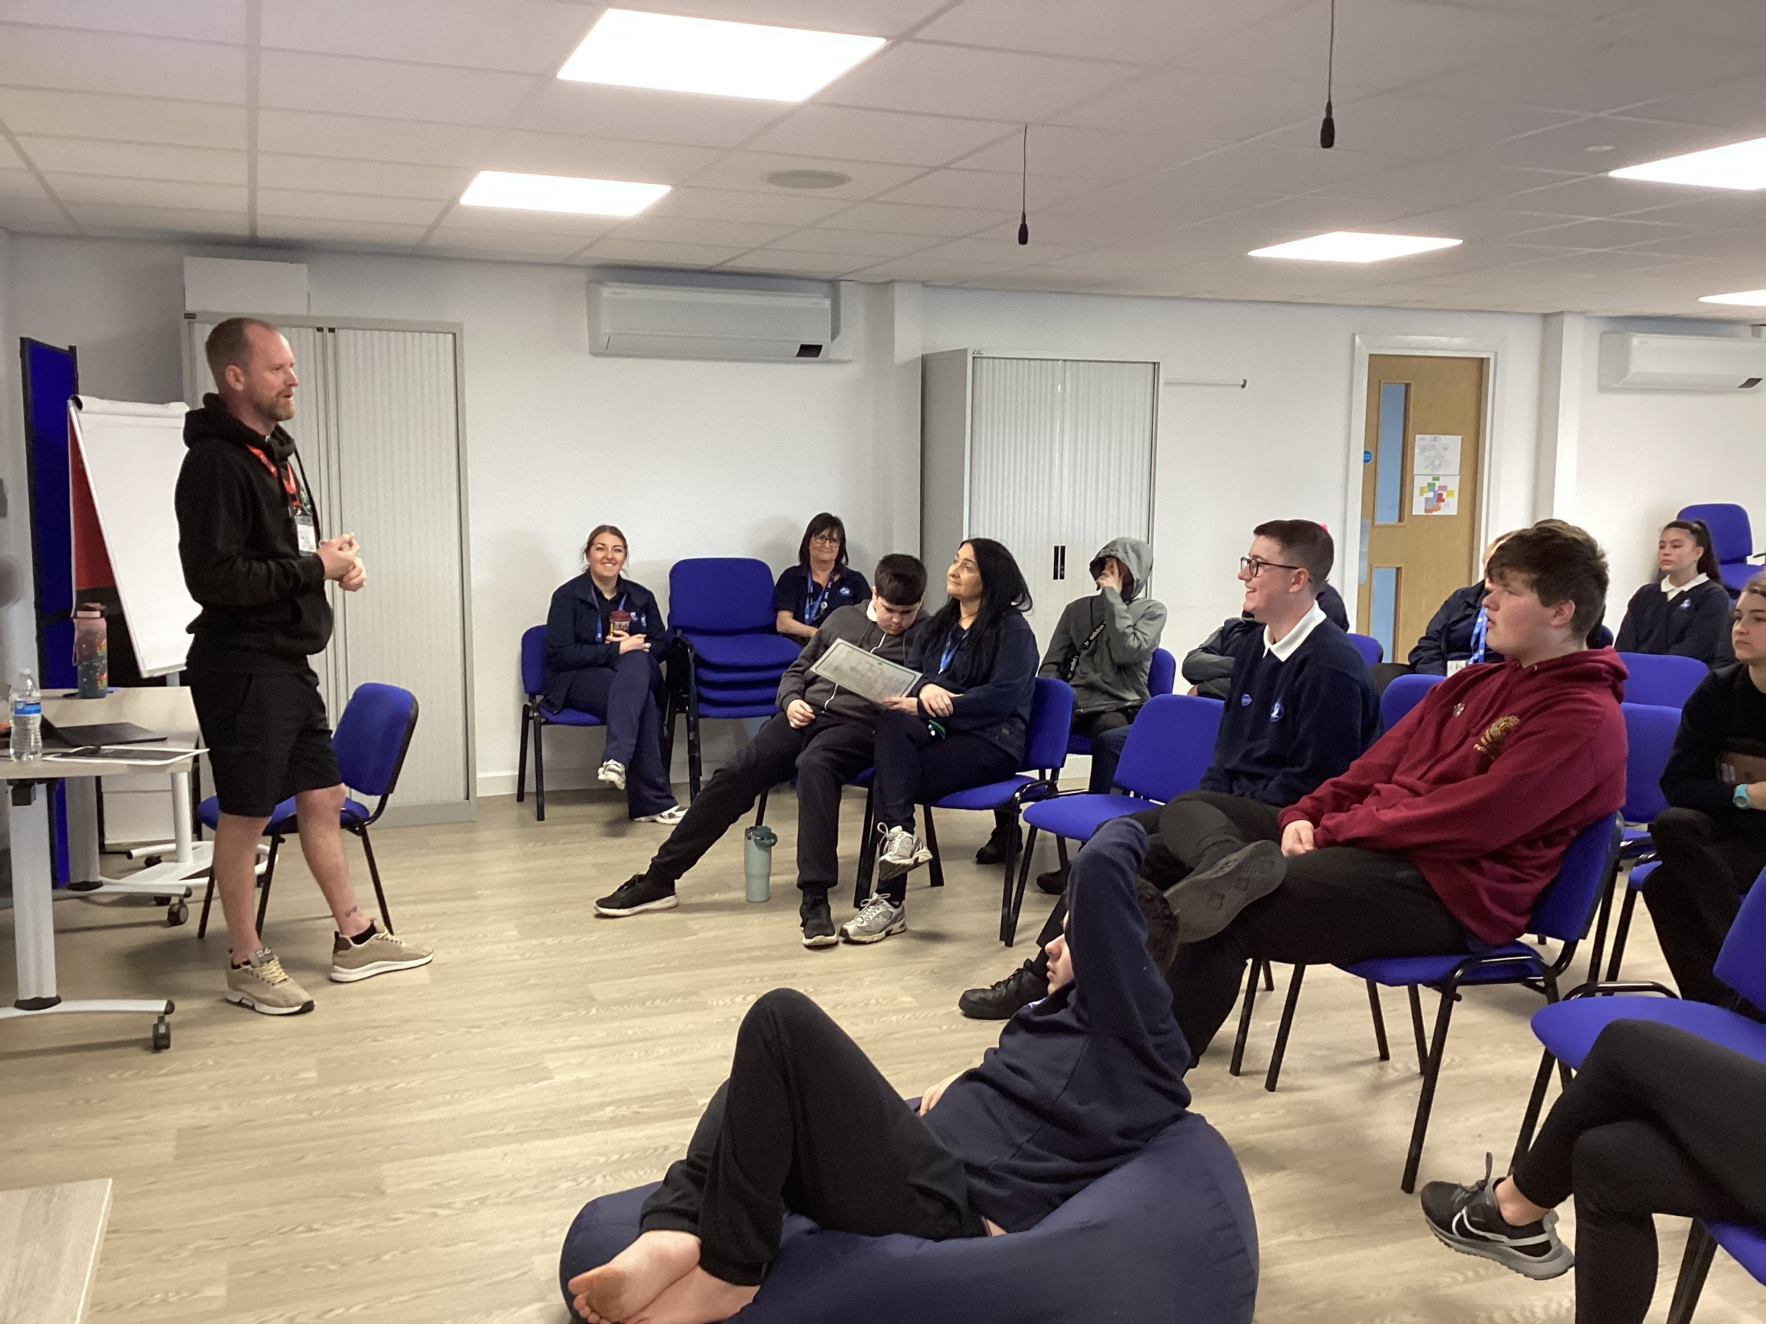

Transition and Careers Fair
Wednesday saw us hold our very first transition and careers fair. We welcomed over 15 exhibitors from education and social care for parents, students and families to come and have a look round and talk to.
It was lovely to see so many parents and students taking the time to have a look, talk to our exhibitors and find out about what is available locally when gathering information to support their future transitions.
Thank you to everyone who came

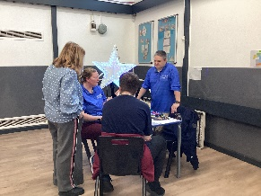
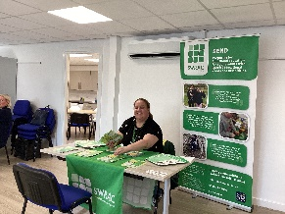

Community Visits
Throughout the week, students were given the opportunity to visit the businesses local to school. This was a great opportunity for students to ask questions to employees about their job roles and the skills they use, as well as practice using their own skills when travelling by public bus and shopping for items.

Y11 Reverse Careers Fair
Students in Y11 spent the morning showcasing their skills by taking part in a range of workshops which including construction, production, hospitality, horticulture and design. Students worked with a range of guests from different business sectors. Students had a great time showcasing many different skills.
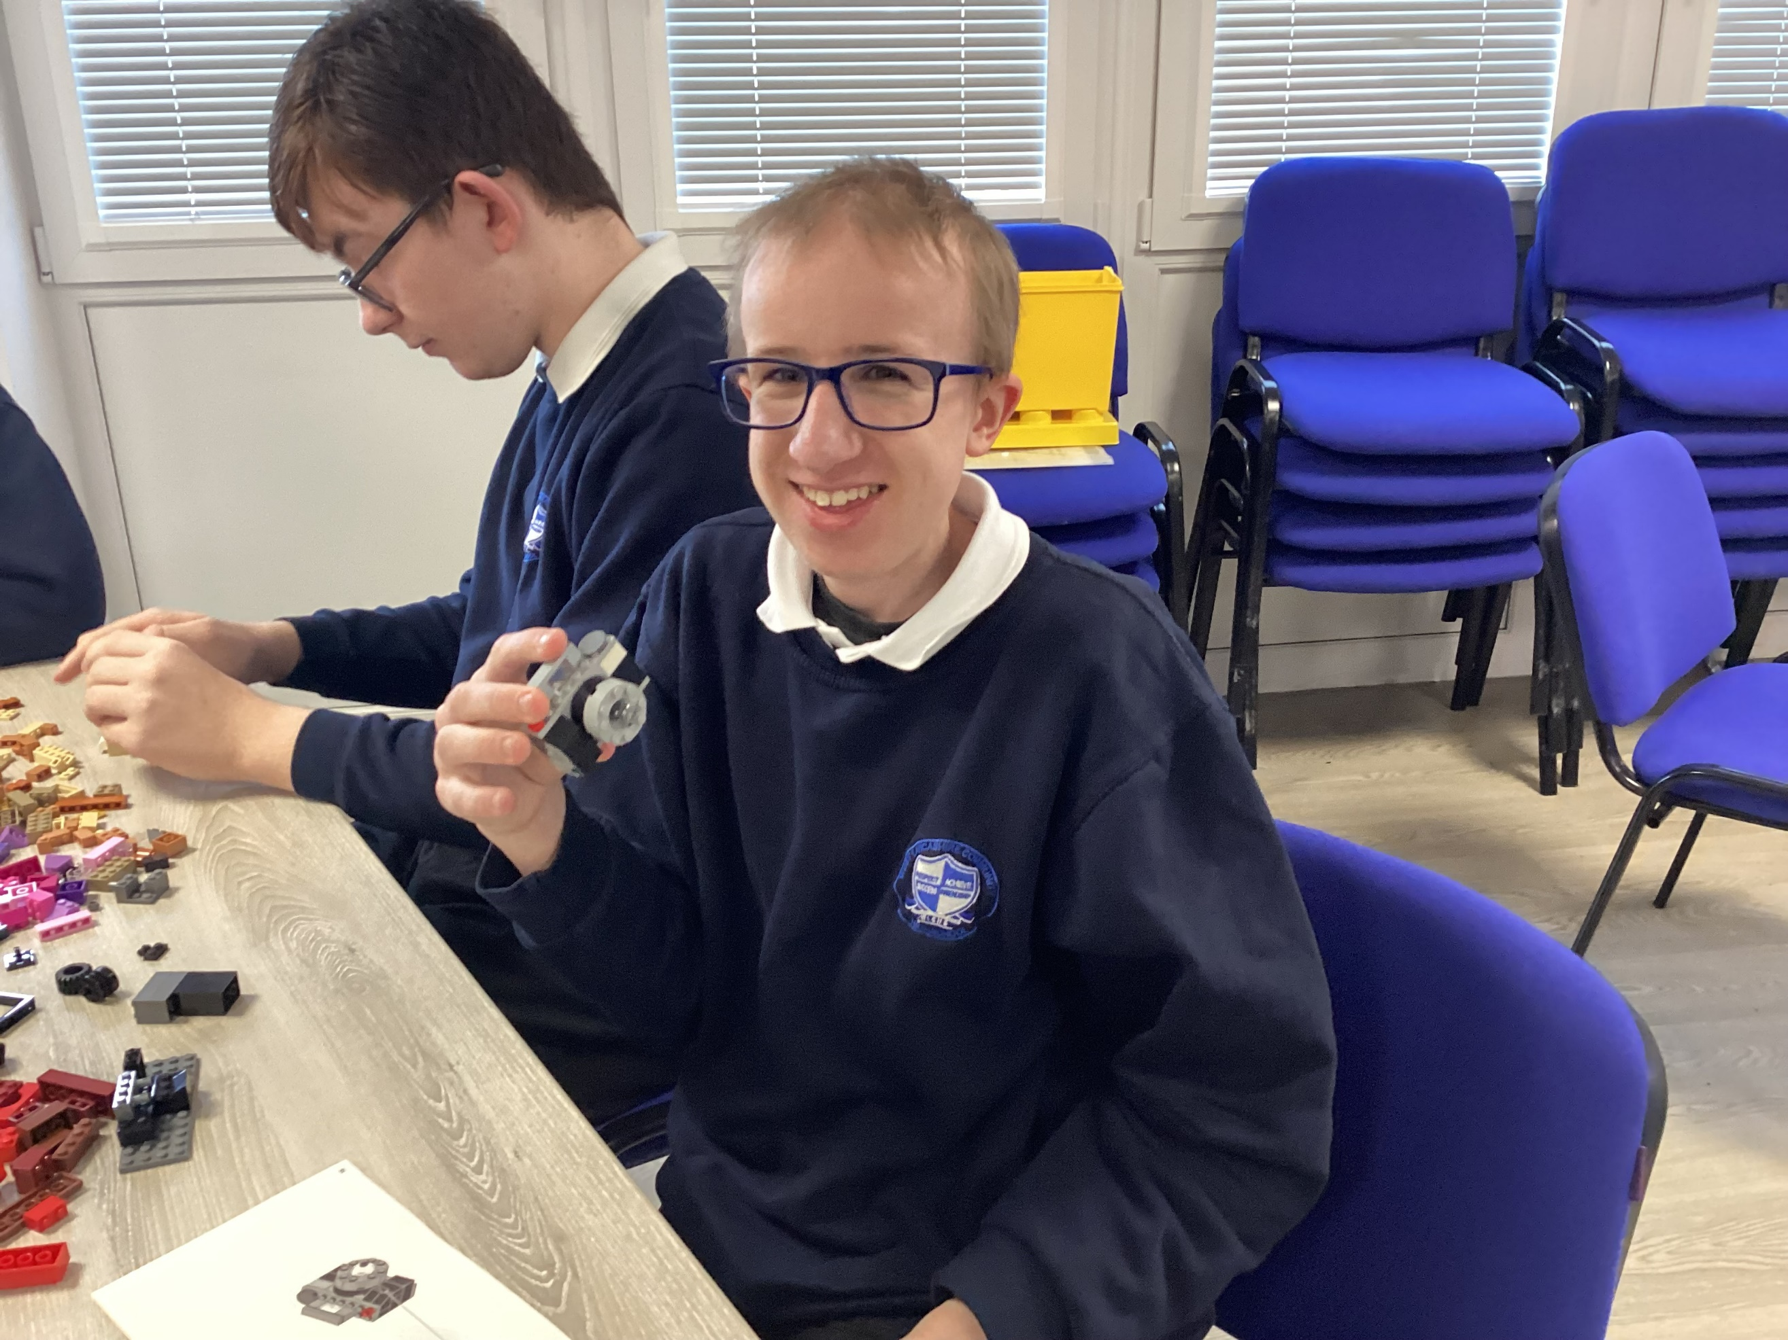

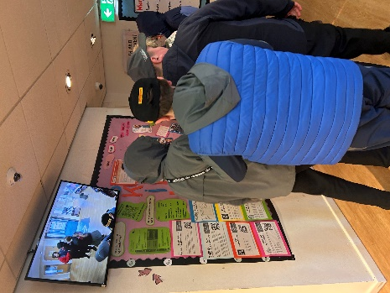

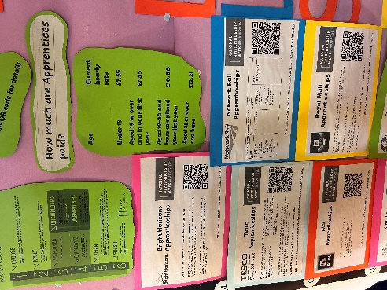
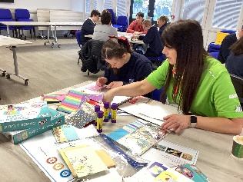



One Vision Dance
Students thoroughly enjoyed the Dance Workshop hosted by the fabulous One Vision! Students showed their amazing creative and teamwork skills.
Student practiced their routine and then came together to share their final dance with the school! Lots of smiles all round.

