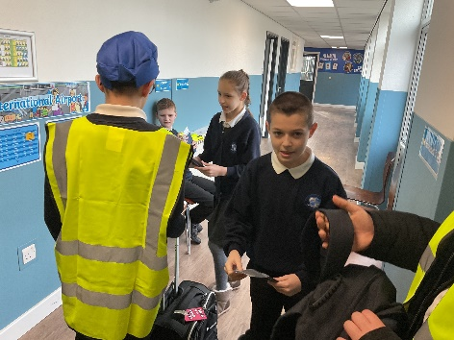
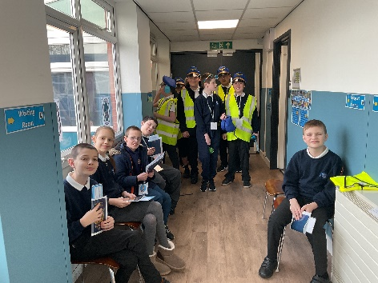
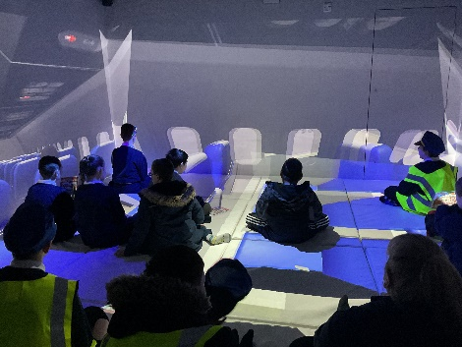
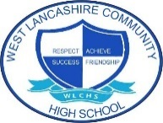
Immersive Reality – Flight to Paris
Students in Key Stages 3 & 4 took part a ‘flight to Paris’ and what a wonderful time they had! Students chose whether they wanted to be jetting off on their holidays, or if they’d like to have a ‘job’ in the airport. Students took part in many job roles which included flight attendant, luggage attendant, passport officer and ticket officer to name a few. Once boarded on the plane, students used their listening skills to listen to carefully to the instructions before landing in Paris for a bit of sight-seeing!
Students demonstrated their skills in speaking and listening.

Last week saw all our students immersed in the world of careers, and what an amazing week we all had!
This newsletter has been put together to help share some of the wonderful learning opportunities and experiences students took part in throughout the week.
From ‘flying to Paris’ to having virtual questions & answer sessions with employees from a range of businesses, as well as dancing with the wonderful One Vision, it was certainly a busy week and I would like to extend my thanks to all who supported our events.
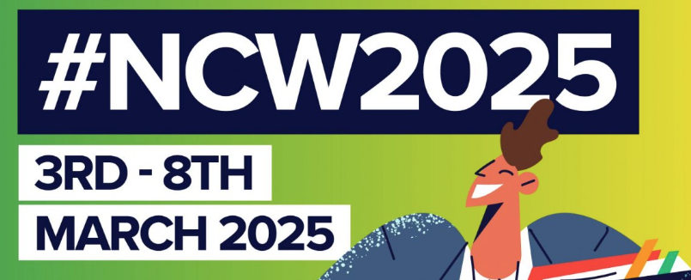
Claire Buckle
Paralympian Guest Speaker
Students in Key Stages 3 & 4 enjoyed a question and answer session with Claire. Claire spoke about her journey into sport, her successes and what she does today as her job. Students asked many questions and enjoyed finding out about Claire.
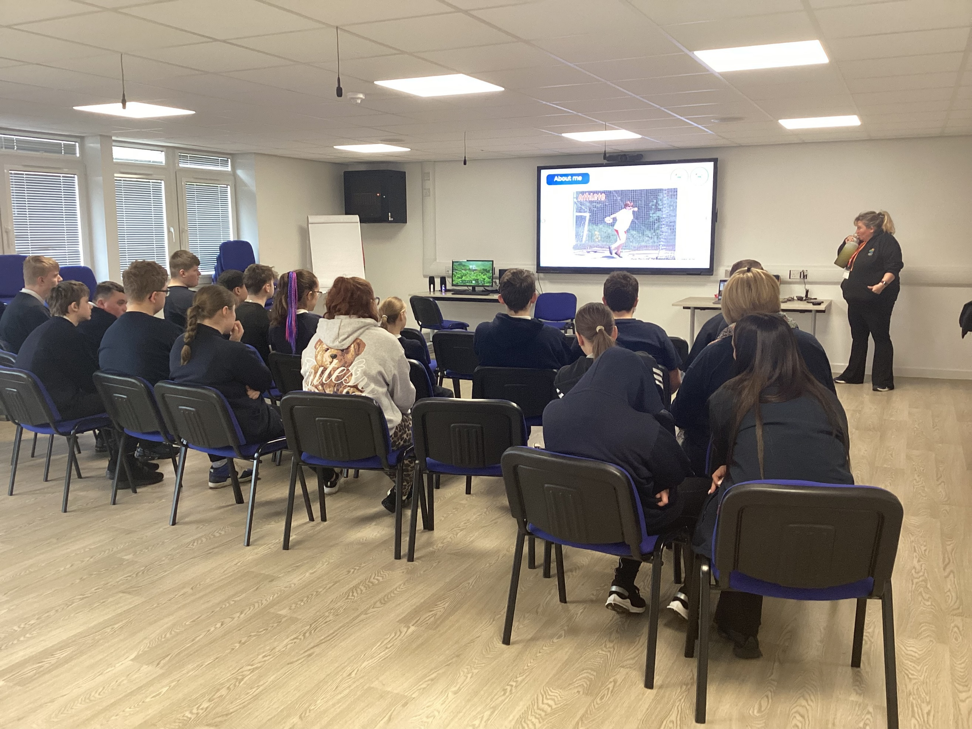
Parent Event – Careers at WLCHS
Thank you to all the parents who attended our parent event about all things careers at West Lancs. Lots of information was shared and it was lovely to see so many parents of students from across the Key Stages. As a school we are committed in providing events and opportunities for parents and carers to gain as much information as possible.
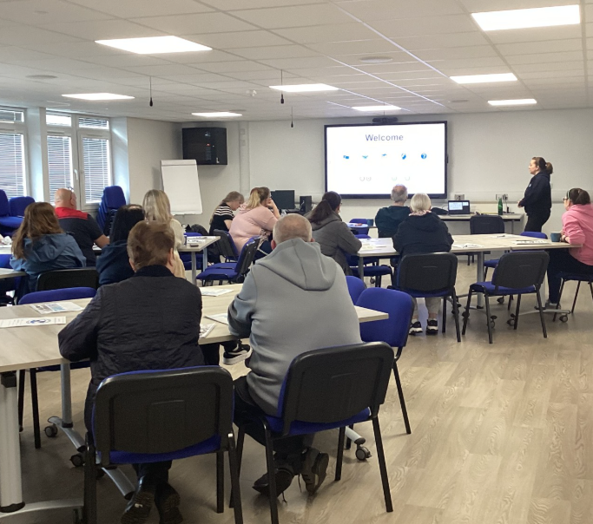

Community Visits
Throughout the week, students were given the opportunity to visit the businesses local to school. This was a great opportunity for students to ask questions to employees about their job roles and the skills they use, as well as practice using their own skills when travelling by public bus and shopping for items.
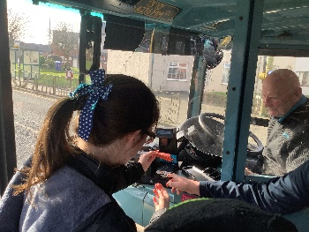
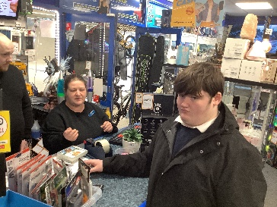
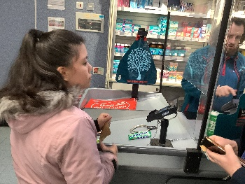
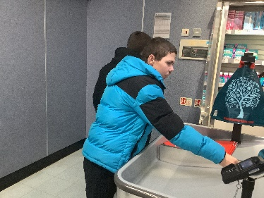

Health Workshop
Students enjoyed listening to Joeann from Lancashire Health Team. Joeann spoke about the work she does in ensuring that people get the information they need to stay healthy, as well as sharing the different job opportunities that can be found in health care.
Students again showed amazing speaking and listening skills.


Skills Builder – Employee Encounter Sessions
Students in Key Stage 4 and 5 took part in a live, virtual employee encounter session. With the support of Skills Builder, students had the opportunity to ask questions to a range of employees from businesses which included Lloyd Bank and Toyota.
Students showed amazing speaking and listening skills and really enjoyed finding out about the different jobs they did, the skills they used, as a well as how many holiday days they got!!

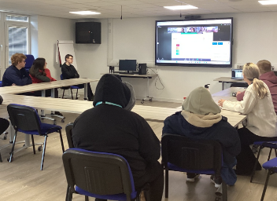



Immersive Room – My Body
Students across school enjoyed sessions in the immersive room learning about the topic ‘My Body’ . Students immersed themselves into the world of the body and all the amazing things our bodies do.

Transition and Careers Fair
Wednesday saw us hold our very first transition and careers fair. We welcomed over 20 exhibitors from education and social care for parents, students and families to come and have a look round and talk to.
It was lovely to see so many parents and students taking the time to have a look, talk to our exhibitors and find out about what is available locally when gathering information to support their future transitions.
Thank you to everyone who came

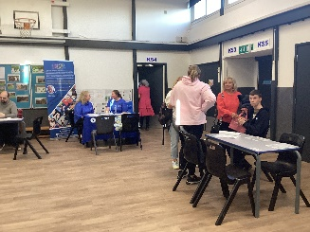
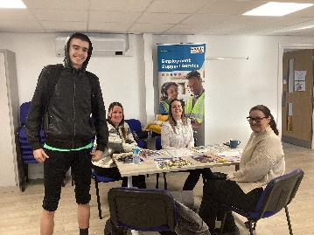
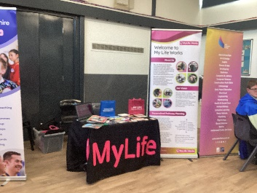

One Vision Dance
Students thoroughly enjoyed the Dance Workshop hosted by the fabulous One Vision! Students showed their amazing creative and teamwork skills.
Student practiced their routine and then came together to share their final dance with the school! Lots of smiles all round.
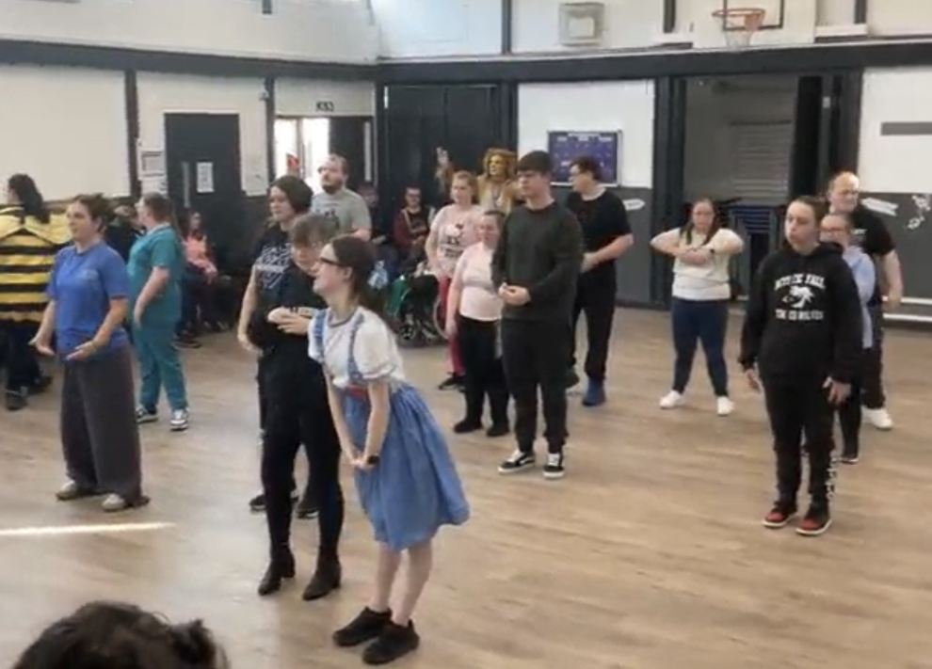
West Lancs College & Alumni
On Thursday we welcomed West Lancs College to school, including some of our alumni students who talked about their journey to college, what they are doing now, and what college has to offer. Students enjoyed listening and asking questions about college.
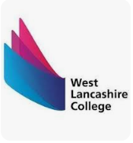

Y11 Reverse Careers Fair
Students in Y11 spent the morning showcasing their skills by taking part in a range of workshops which including construction, production, hospitality, horticulture and design. Students worked with a range of guests from different business sectors. Students had a great time showcasing many different skills.

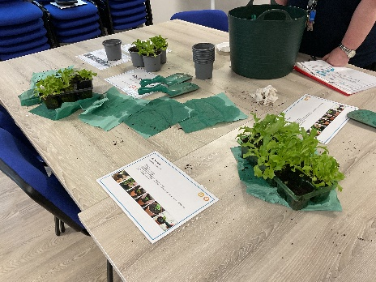
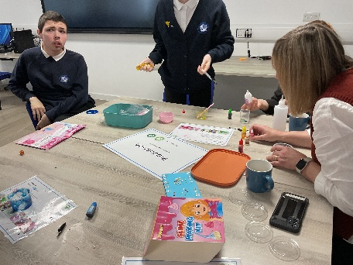
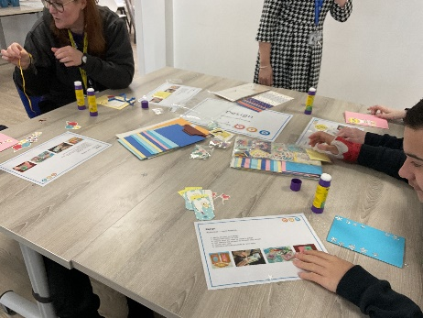

Walkers Crisp Factory
Students in Key Stage 4 immersed themselves into factory life with the support of employees from Walkers Crisp Factory! Students learned the different stages it takes to make their favourite crisps, from ensuring that they are the correct size, and most importantly, making sure that they taste right too!

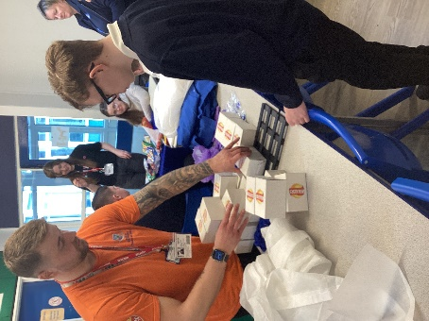
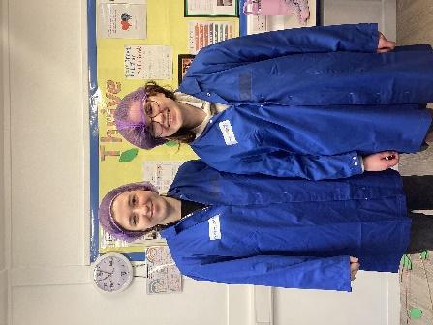
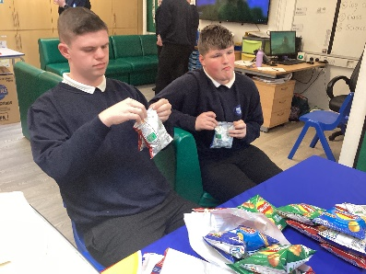
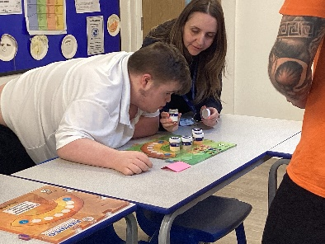


Skills Builder in the Classroom
Students in KS3C researched jobs and careers and identified the skills they would need to be able them to do their job.
Students used their speaking and listening skills to talk about and listen to others about different jobs and the tasks that you would need to complete.





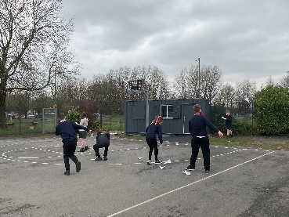
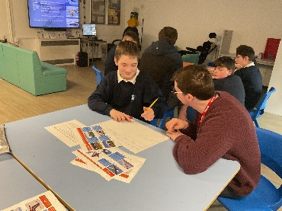
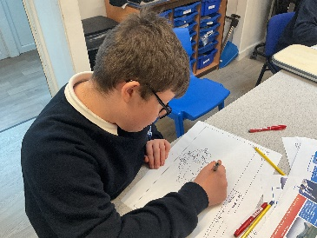
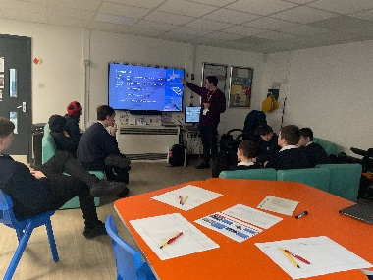
BAE Systems
Students in Key Stages 3 & 4 took part in a workshop delivered by Mr White who works for BAE Systems. Mr White spoke about his job and the skills he uses each day. Students showed a wide range of skills throughout the workshop session, with the most important ones being creative and staying positive when getting the opportunity to make and fly their own paper aeroplanes.

