**Matrix Occupational Therapy Service**

**&**

**West Lancashire Community High School**

**Occupational Therapy**

**What is Occupational Therapy?**

The role of the children's occupational therapist (OT) is to work with children and young people who have difficulties with the practical skills they need to succeed in everyday life.

Occupational therapy intervention aims to enable children to participate in their daily activities (occupations) to help improve their health, independence, and wellbeing.

Occupational therapists help children and young people to be as independent as possible and consider their physical / sensory needs, the environment, and their occupations and how the interconnection of these impacts on the child’s occupational performance and participation in their daily activities.

The model below highlights how occupational performance (the ability to perform the required activities, tasks, and roles of living) and participation (engaging in tasks and activities) is shaped by the interaction between the person, their environment, and their specific occupations.

**OCCUPATIONAL PERFORMANCE**

**& PARTICIPATION**

**OP**

**& P**

Optimum function or occupational performance and participation results from a good fit between these three components (P-E-O). These elements are dynamic, and they continue and change throughout a young person’s life.

**Areas of Occupation for Children and Young People**

**Self-care** – personal hygiene i.e. washing / bathing, dressing, eating meals, toileting, and personal grooming e.g. hair and nail care, tooth brushing and shaving.

 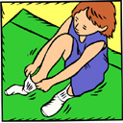 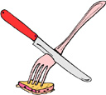 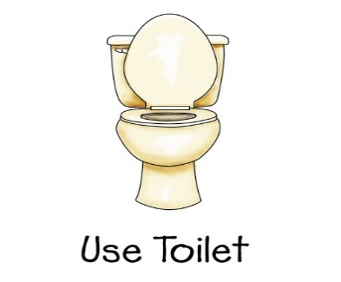 

**Washing/Bathing Dressing Eating Toileting Personal Grooming**

**Productivity / Education** – Participation in education is a key occupation for children and young people e.g. drawing, handwriting, fine motor skills, using scissors, gross motor skills, attention / concentration, planning and organisation.

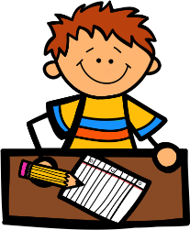 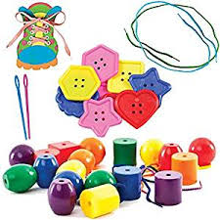  

**Drawing/Writing Fine Motor Skills Scissor Skills Gross Motor Skills**

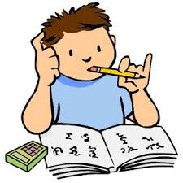 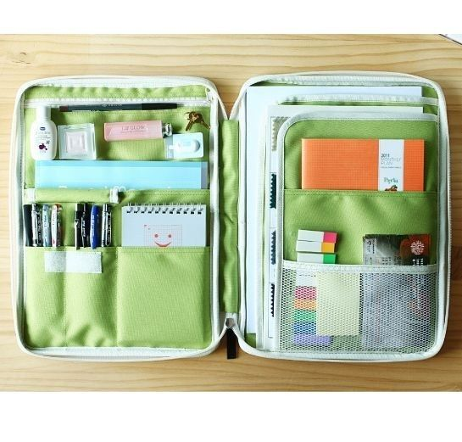

**Attention/ Concentration Planning & Organisation**

**Leisure / Play** - A child's main occupation is play and it is through play that they learn and practice new skills, make friends and find a sense of self.

**Rest / Sleep** – An important part of a child’s development is getting enough rest and sleep to ensure that they are healthy, happy, and doing their best.

Useful Link: <https://www.thechildrenssleepcharity.org.uk/>

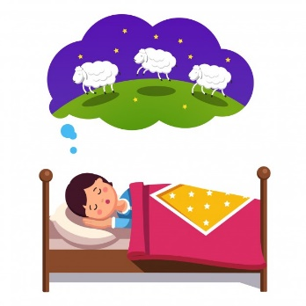

**What to do if you have concerns about your child’s functional skills:**

* Discuss your concerns with your child’s class teacher in the first instance.
* Write down your concerns and send them into school with your child; ask for the information to be passed to the OT, giving your written consent for any OT intervention(s) (OT Consent Form Link)
* Or contact school and ask to arrange a session with the occupational therapist,

**Occupational Therapy intervention within the school setting:**

* Occupational therapy intervention aims to enable a child / young person to be as independent as possible in self-care, schoolwork / productivity, leisure play and rest / sleep.
* Occupational therapy can provide specialist assessments to identify the underlying difficulties impacting on your child's function (for example motor, sensory or perceptual skills)

**How does the Occupational Therapist work?**

The occupational therapist will work with children, young people and school staff by providing:

* Training to enable staff to work with children & young people to help them to maintain independence in self-care, productivity, and mobility to enhance their daily routine and enjoy an active life.
* Advice on the use of space and equipment such as seating, angled desktops, posture packs etc.
* Strategies to support children & young people with sensory processing difficulties that impact on their daily life skills and school participation / engagement.
* Activity / task adaptations and techniques to enable participation in day to day school activities.
* Advice on equipment to enable them to access an activity or their environment more effectively.
* Advice on physical adaptations / additions to the school environment.
* Systems to ensure a person-centred approach to care is achieved.
* Outcomes that result in the improved function, health and wellbeing of children & young people.

**How will I know what the OT is working on with my child?**

The occupational therapist will endeavour to work closely with parents / carers, educational staff and other professionals involved in your child’s care in assessing, planning and carrying out interventions to maximise the effectiveness of any interventions.

The occupational therapist will produce assessment and intervention reports for any work with your child.

Copies of occupational therapy reports will be kept as part of the child school record and a copy will also be sent home. Additional copies can be supplied on request.



**Independent Occupational Therapist**

**Matrix Occupational Therapy Service**