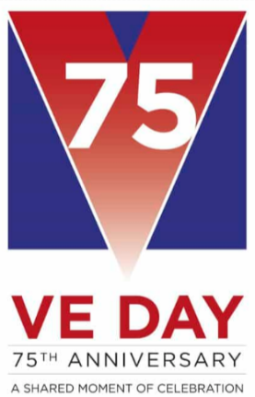
Monday- What is VE day?
All groups;
Look at the PowerPoint for Monday (there are 2)
Make some decorations, flags, hats, bunting.
Complete the thoughts worksheet.

Tuesday- Evacuees PowerPoint- dress up, make labels.
F discuss ‘the suitcase’, Make a list of what your essential items would be you can use the empty suitcase template.
P imagine you are an evacuee and have just arrived at your destination. use the writing frame to write a letter home.
T Write a postcard home as an evacuee, Use progress template if required.

Wednesday- Morse code was used to communicate during the war. Watch https://www.bbc.co.uk/bitesize/clips/zq4dq6f or https://youtu.be/iy8BaMs_JuI
F make your name in Morse code using a light/torch or long and short sounds.
P Morse code worksheets.
T Morse code worksheets.

Thursday-Designs and recipes
All groups;
Design a VE day celebratory medal, teacup or poster.
Have a look at wartime recipes, if you have the ingredients have a go at making one.

Friday- VE day
All groups;
Celebrate and remember with your family
Join the national 2 minute silence at 11am
Listen to Churchills speech https://winstonchurchill.org/resources/speeches/1941-1945-war-leader/to-v-e-crowds/

