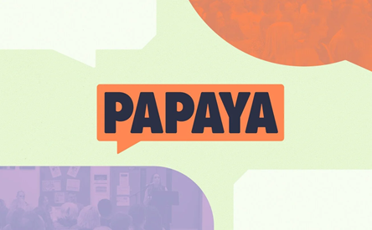

Papaya talks and workshops empower parents and young people to make informed choices about smartphones, social media and screens.

PAPAYA offer insights and practical advice about the benefits of delaying smartphone and social media use and the importance of establishing healthy tech boundaries in families.

Click on the link below to find support materials such as:
- The Power of Play
- The ‘Tech Talk’
- The Healthy Selfie
- AI attention and Algorithms
- And much more.

https://www.papayatalks.com/products

Any questions please contact the school on 01695-721487 and ask for Mr .Grant

