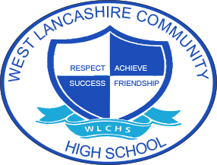

3 Year Long Term Overview
Subject  Physical Education | Autumn Term Theme | Spring Term Theme | Summer Term Theme
Year 1 | Fair Trade  Tennis skills  Using a range of tactics and strategies to overcome opponents in direct competition through team and individual games. | My Environment  Orienteering  Develop an understanding of the local environment, working in teams and developing skills to solve problems. | Space  NASA Training Programme  Practice a range of physical activities to train like an astronaut.
Year 2 | Around the World  Football skills  Using a range of tactics and strategies to overcome opponents in direct competition through team and individual games. | Farm to Fork  Gymnastics  Develop an understanding of keeping our bodies healthy and active. | Lights Camera Action  Rounders
Year 3 | Best of British  Basketball skills  Using a range of tactics and strategies to overcome opponents in direct competition through team and individual games. | Looking After Me  Dance  Develop an understanding of how we look after our bodies. | Animal Kingdom  Athletics

