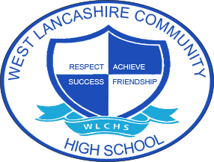

Overview of Curricular Themes for Key Stage 3 Curriculum

 | Autumn Term Theme | Spring Term  Theme | Summer Term Theme
Year 1 | Fair Trade  The World I live in:  Economic Wellbeing  Money  Managing Finances | My Environment  The World I live in:  Belonging to a community  Rules and laws  Rights and responsibilities | Space  RSE Unit: Changing and growing:  Baby to adult  Changes at puberty  Dealing with touch  Types of relationships  Healthy lifestyles:  Healthy eating  Healthy lifestyles  Physical health  Keeping well

Year 2 | Around the World  The world I live in:  Respecting differences between people  Human diversity | Farm to Fork  Healthy lifestyles:  Healthy eating  Healthy lifestyles  Physical health  Keeping well  RSE Unit – Changing and growing  Baby to adult  Changes at puberty  Dealing with touch  Different types of relationships  Friendships | Lights Camera Action  Managing feelings:  Identifying and expressing feelings  Managing strong feelings  Self-esteem and unkind comments  Mental health and wellbeing
Year 3 | Best of British  Self-awareness:  Personal strengths  Prejudice and discrimination  Getting on with others  British Values  Mutual respect  Rule of law  Democracy  Individual liberty | Looking After Me  Self-care, safety and support:  Taking care of ourselves  Keeping safe  Trust  Accidents and risk  Emergency situations  Public and Private  RSE Unit: Changing and growing:  Baby to adult  Puberty  Dealing with touch  Relationships | Animal Kingdom  The world we live in:  Taking care of the environment

