A Perfect Planet – Comprehension
https://www.youtube.com/watch?v=xxibm1ODEpI
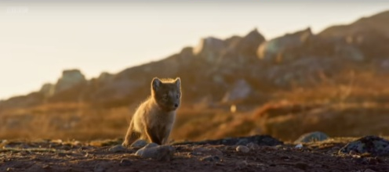
- Choose one word to describe this animal.
My word: _________________________________________________
I chose this word because ____________________________________
_________________________________________________________.
- Sir David Attenborough says, “They say perfection doesn’t exist.” Which of these words means something similar to the word perfection?
- Horrible
- Excellence
- Animals
- Hunger
- Which planet does Sir David Attenborough believe to be perfect?
________________________________________________________________________________________.
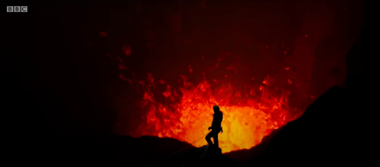
- Would you describe this person as ‘brave’ or ‘bonkers’?
I think this person is ______________ because __________________
_________________________________________________________
_________________________________________________________
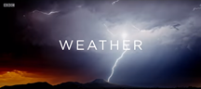
- Think about the worst weather you have ever experienced. How did you feel.
I felt ____________________ because _________________________
_________________________________________________________.
- Think about the best weather you have ever experienced. How did you feel?
I felt ____________________ because ________________________________________________________
________________________________________________________________________________________.
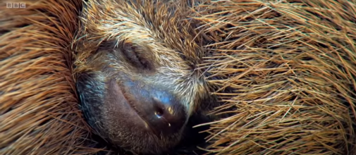
- How do you think this animal is feeling?
I think this animal feels _____________________ because it _______
_________________________________________________________
________________________________________________________.
- What four forces have allowed life on Earth to flourish?
The four forces that have allowed life on Earth to flourish are ______________________________________
________________________________________________________________________________________.
- Which animal from all those featured in the trailer do you like the most?
The animal I like most is the _____________________ because _____________________________________
________________________________________________________________________________________.
- Has this trailer made you want to watch the TV show A Perfect Planet? Why?
This trailer has/has not made me want to watch A Perfect Planet because ____________________________
________________________________________________________________________________________
________________________________________________________________________________________.

EXT: CREATE A PIECE OF ART BASED ON THIS TRAILER!
Answers
- Various answers with explanation – possible link to cute/small/alone.
- Excellence.
- Planet Earth.
- Brave – close to danger/exploration/etc.
Bonkers – putting life at risk near volcano.
- Various possible answers – linked to own experiences.
- Various possible answers – linked to own experiences.
- Various possible answers with explanation – safe/warm/happy/comfortable/etc…
- The Sun, Volcanoes, Weather, the Oceans.
- Various possible answers to discuss.
- Yes – looks exciting/love animals and nature/etc…
No – boring/didn’t like it/etc…

