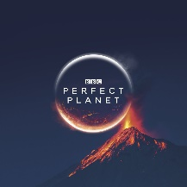
The Perfect Planet Trailer Comprehension
https://www.youtube.com/watch?v=635uup08DLU

- “Life flourishes here thanks to powerful natural forces.” Which definition most closely fits the word ‘flourishes’?
- Exists only in this place.
- Grows and develops in a healthy, vigorous way.
- Is being destroyed rapidly.
- Will never be very successful.
- How long does it take for light from the Sun to reach Earth?
- What does Sir David Attenborough is the effect of the daily and yearly rhythms of the Sun?
- Find and copy two adjectives the Sir David Attenborough uses to describe volcanoes.
- Sir David Attenborough describes volcanoes as, “the architects of the planet.” Can you think of a synonym for the word ‘architect’?
- What percentage of the Earth’s surface has been created by volcanoes?
- Why is it surprising to hear that life could not exist on Earth without volcanoes?
- Find and copy a phrase which tells you that the world’s oceans are continuously moving.
- What do the powerful currents which link the world’s oceans do?
- How long does a drop of seawater take to complete a circuit of Earth?
- What else is found where there are currents?
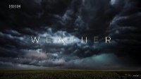
- Pause at 2.21 – What impression is created by this image?
- Find and copy a word which tells you that even mighty storms and freezing winds are very important.
- What weather carries freshwater around the globe?
- Sir David Attenborough says freshwater rain is useful for, “revitalising the land.” Can you think of an antonym for the word ‘revitalising’?
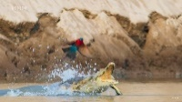
- Pause at 2.58 – Explain how you think the bird and the crocodile feel in this moment.
- List the four different forces featured in this trailer.
- Sir David Attenborough says, “it is a fragile system.” Explain what you understand the word ‘fragile’ to mean.
- What is the new force which threatens all life on Earth?
- List the two things that Sir David Attenborough says dominant human activity is disrupting.
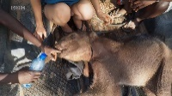
- Pause at 3.54 – How does this image make you feel? Explain your answer.
- When must we act if we are going to save the planet?
- Sir David Attenborough describes the Earth as, “our perfect planet.” Why do you think he chose to use the word ‘our’ here?
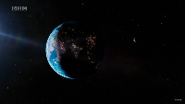
- Pause at 4.14 – Why do you think the decision was made to end the trailer with this image?
- Summarise the trailer in a paragraph, then a sentence and then a single word.
- Has this trailer successfully made you want to watch the TV show? Why?
- Order the following from 1 – 5. One has been done for you.
- Humans are revealed as a new force. _
- A volcano is shown erupting. _
- A crocodile lunges at some birds. _
- We are shown a close-up image of the Sun. 1
- A baby elephant is loaded onto a trailer. _

Answers
- B.
- 8 minutes.
- They shape the lives of every creature on Earth.
- Powerful and uncontrollable.
- Designer/Builder/Planner.
- Over 80%.
- Various answers – link to fact that volcanoes are usually considered destructive, etc…
- “… are in constant motion.”
- Carry nutrients around the globe.
- 1000 years.
- Life.
- Various answers – links to dark clouds/violence/mood/etc…
- Vital.
- Powerful winds.
- Destroy/depress/ruin/etc…
- Various answers – Crocodile = annoyed/angry/hungry with explanation. Bird = afraid/relieved with explanation.
- The Sun, volcanoes, oceans and weather.
- Easily broken or damaged/destroyed.
- Humans.
- Disrupting the forces of nature and the vital habitats life needs.
- Various answers – will mostly link to feeling sad/sorry/unhappy with explanation.
- Now.
- Various answers – should link to a sense of possession and Earth belonging to everyone/everything.
- Various answers – could discuss the size of the planet in relation to space/ how Earth is precious and should be looked after/ to impress the viewer/ etc…
- Various answers to discuss as a class.
- Various answers to discuss as a class.
- 4, 2, 3, 1, 5.

