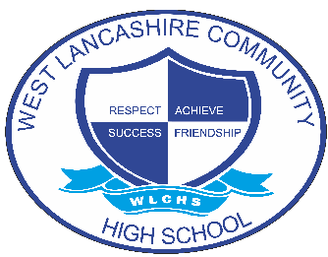
INTERVENTION OVERVIEW

NAME OF INTERVENTION
Photography
AREA OF FOCUS (PLEASE HIGHLIGHT)
COGNITION AND LEARNING | COMMUNICATION AND INTERACTION | SOCIAL, EMOTIONAL AND MENTAL HEALTH | PHYSICAL AND SENSORY | SELF-HELP AND INDEPENDENCE
INTENT
To expressively communicate emotions and feelings through imagery.
To use photography to support communication of feelings and be able to express non-verbally through imagery captured through the lens.
IMPLEMENTATION
Students engage in weekly sessions and complete a programme of study that explores;
Seeing the world through a lens
Creating imagery that reflects their feelings
Develop self-esteem through feedback and peer assessment.
The weekly intervention is not formally planned but provides an opportunity for a creative outlet for students to recognise and express feelings about themselves or the world around them.
Students guide the sessions and follow their creative instincts that leads to wider conversations.
IMPACT
Students develop a sense of wellbeing through using a preferred and motivating activity.
Students respond positively to praise and recognition.
Students see activities and hobbies as a strategy to support their social and emotional wellbeing.
Students create an event to display and communicate their achievements through a gallery exhibition.

