

Premises Management Policy

Document Control
Document name (inc version number, if applicable) | Premises Management policy
Date adopted by governing body | 27/1/2026
Next review | 27/1/2027
Owner | Darby Harrison
Approved on behalf of the governing body | Jeff Seddon (Chair of Governors)
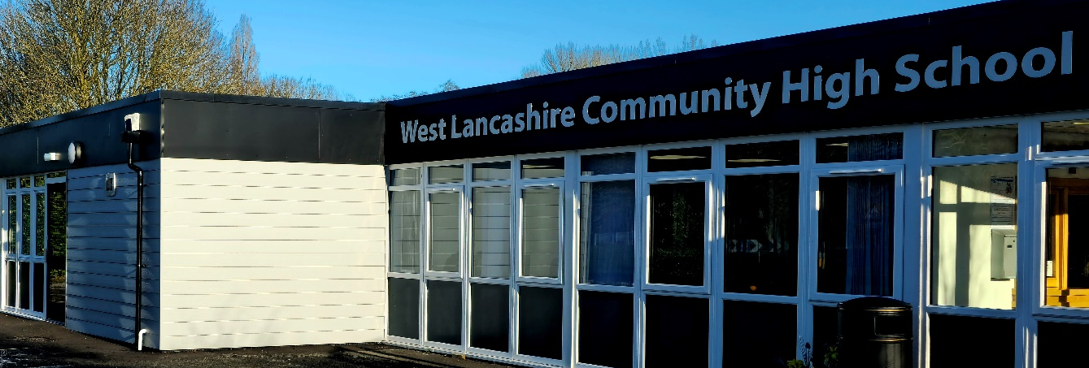

Aims
Our school aims to ensure that it:
- Manages its buildings and equipment in an efficient, legally compliant way
- Inspects and tests buildings and equipment regularly, taking into account statutory requirements and best practice recommendations
- Promotes the safety and wellbeing of our staff, pupils, parents and visitors through effective maintenance of buildings and equipment in accordance with the Health and Safety at Work etc. Act 1974
- Complies with the requirements of The School Premises (England) Regulations 2012

This document is based on the Department for Education’s guidance on good estate management for schools. As we are a Lancashire school we also follow Lancashire County Councils procedures for premises management and health and safety.

Roles and responsibilities
The governing board, headteacher and site manager will ensure this premises management policy is properly implemented, and that tests and inspections are carried out in accordance with this policy.
The headteacher and site manager are responsible for ensuring relevant risk assessments are conducted and for reporting to the governing board, as required.
The site manager is responsible for:
- Inspecting and maintaining the school premises
- Conducting minor repairs and maintenance
- Being the first point of contact for any issues with the premises
- Conducting and keeping a record of risk assessments and incident logs related to the school premises
- Liaising with the headteacher & business manager about what actions need to be taken to keep the school premises safe
This list is not intended to be exhaustive, the majority of our school repairs, maintenance and inspections are conducted by framework contractors verified by Lancashire County Council.

Inspection and testing
We maintain accurate records and details of all statutory tests which are undertaken at our premises. This includes relevant paperwork and certificates.
All requirements and recommendations highlighted in inspection reports and certificates are reviewed and acted on as necessary.
As part of the records of completed works, we include the dates when the works were undertaken and the details of the individual or company who completed them, along with their qualifications/certifications and/or experience.
The table below sets out the issues we inspect, the inspection frequency, and the person responsible for checking each issue and, where appropriate, engaging a suitably qualified person to carry out inspection, testing or maintenance. It covers statutory checks as well as recommended good practice checks from relevant guidance. It is based on the Department for Education’s guidance on good estate management for schools.

issue to inspect | frequency | person responsible
Portable appliance testing (PAT) | Variable, according to risk and how the equipment is constructed.  Regular visual inspections where PAT is not required.  We will refer to HSE guidance on maintaining portable electric equipment for suggested intervals and types of testing/inspection. | Lancashire framework contractor
Fixed electrical installation tests (including lightning conductors) | Variable, according to the number and severity of faults found at last inspection.  Inspection and testing always carried out by a competent person. | Lancashire framework contractor
Emergency lighting | Monthly flash test.  6-monthly condition test (including 3-hour battery test) by a competent person. | Lancashire framework contractor
Lifts | At least every 6 months for passenger lifts and lift accessories, every 12 months for other lifts (e.g. goods lifts) – always by a competent person. | We don’t have any lifts on site apart from vehicle lifts on to our wheelchair accessible minibuses which are checked by the Lancashire framework contractor
Gas appliances and fittings | Routinely, in accordance with manufacturer recommendations (or other professional advice if unavailable).  Annual safety checks (in line with good practice / required if the premises are used for residential accommodation).  All work carried out by a Gas Safe Registered engineer. | Lancashire framework contractor
Air conditioning systems | Inspections by an energy assessor at regular intervals (not exceeding 5 years).  Annual certificated inspection to ensure no refrigerant leakage.  Bi-annual checks and an annual maintenance schedule (in line with good practice). | Lancashire framework contractor
Pressure systems | No fixed maintenance requirement (our programme takes account of the list on page 44 of the HSE’s Safety of Pressure Systems guidance, and an examination of the system is carried out by a competent person by the date set at the previous examination – see pages 35 to 37 of the HSE guidance). | Lancashire framework contractor
Legionella checks on all water systems | Risk assessment of each site carried out and reviewed regularly by a competent person. The frequency of monitoring checks varies for evaporative cooling systems, hot and cold water systems and other risk systems – specific details can be found in guidance for each type from the HSE. | Lancashire framework contractor
Asbestos | Regular inspections as part of the asbestos register and management plan.  Reviews of the asbestos register annually.  Refurbishment and demolition surveys before any refurbishment or demolition work. | Lancashire framework contractor  We only have very low risk asbestos within school
Equipment used for working at height | Inspected before use, and at suitable intervals appropriate to the environment it’s used in and how it’s used.  In addition, inspections after anything that may affect the safety or stability of equipment, e.g. adverse weather or accidental damage. | Site manager
Fire detection and alarm systems | Weekly alarm tests, with a different call point tested each week where applicable.  Quarterly and annual inspections and tests by a competent person.  Annual fire risk assessment by a competent person also includes the maintenance of fire detection and alarm systems. | Lancashire framework contractor – annual and full checks  Weekly checks carried out by site manager
Fire doors | Regular checks by a competent person. | Site manager
Firefighting equipment | Most equipment – extinguishers, fire blankets, hose reels, fixed systems (such as sprinkler systems) and fire service facilities (such as dry risers and access for emergency vehicles) – inspected annually (by a competent person where required) unless manufacturers’ guidelines suggest differently. | Site manager – weekly  Lancashire framework contractor – annual full check
Extraction systems | Regular removal and cleaning of grease filters and cleaning of ductwork for kitchen extraction systems.  Local exhaust ventilation systems (such as those for working with hazardous substances) examined and tested at least every 14 months by a competent person.  More routine checks also set out in system logbooks. | Lancashire framework contractor
Chemical storage | Inventories are kept up-to-date.  Risk assessments for the Control of Substances Hazardous to Health (COSHH) are reviewed on a regular basis, plus whenever it’s considered that the original assessment may no longer be valid, or where the circumstances of the work change significantly and may affect employees’ exposure to a hazardous substance (in line with HSE guidance on COSHH assessment). | Site manager
Playground and gymnasium equipment | Regular inspections – at least annually, and more regularly where any equipment is used more frequently than normal (e.g. where community use increases how often equipment is used).  Outdoor fixed play equipment – periodic and annual inspections by a competent person. | Weekly checks – site manager  6 month checks - Lancashire framework contractor
Tree safety | As part of risk assessment responsibilities, periodic visual checks for stability are carried out, with more detailed assessments if suspected structural faults or other risks are found. | Site manager – daily  Lancashire framework contractor – annually
Radon | Risk assessments including radon measurements will be carried out in all of our above-ground workplaces in radon-affected areas, and all of our below-ground workplaces.  Radon measurements will last for 3 months, using radon monitors, in line with Public Health England (now the UK Health Security Agency) radon guidance for schools.  Where measurements show radon levels below 300Bq/m3, radon levels will be remeasured at least every 10 years. If significant changes are made to the buildings or work processes, remeasurement will also be considered.  For any sites with radon levels above 300Bq/m3 we will work with a radiation protection adviser to manage reduction and decide on risk assessment and remeasurement frequency. | Department for Education – every 10 years - we don’t have high radon levels detected on our premises.

Risk assessments and other checks
Please refer to our risk assessment policy for information about the school’s approach to risk assessment.
In addition to the risk assessments we are required to have in place (please refer to our risk assessment policy and health and safety policy for more information), we make sure we have risk assessments in place, regularly updated, to cover:
- Car parking and vehicle/pedestrian segregation
- Traffic management
- Lettings
- Waste disposal/ recycling
- Cleaning/ COSHH
We also make sure further checks are made to confirm the following:
- Correct and up-to-date information is displayed in all notices
- Compliance with the Construction (Design and Management) Regulations 2015 during construction projects
- Contractors have the necessary qualifications to carry out the specified work
- Compliance with the Equality Act 2010 when making changes or alterations to a building or the external environment

Monitoring arrangements
The application of this policy is monitored by the site manager and headteacher through, among other things, visual checks of the school site and equipment, and checks of risk assessments.
Copies of risk assessments and paperwork relating to any checks are kept in the school office.
This policy will be reviewed by the school business manager every 12 months. At every review, the policy will be shared with and approved by the governing body and headteacher.

Links with other policies
This premises management policy is linked to our:
- Health and safety policy
- Risk assessment policy

