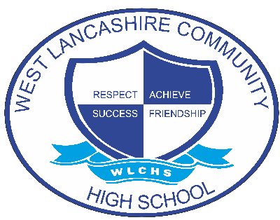

Privacy Notice (how we use student information)

Document Control
Document name (inc version number, if applicable) | Privacy Notice (how we use student information) (v1)
Date adopted by governing body | 27/1/2027
Next review | 27/1/2030
Owner | Andrew Grant
Approved on behalf of the governing body | Jeff Seddon (Chair of Governors)
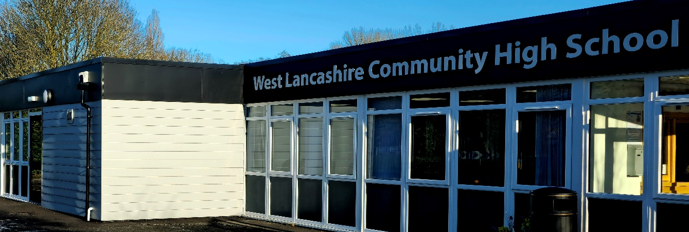

Privacy Notice

(How we use student information)

The categories of student information that we collect, hold and share include (but not exclusive to):
- Personal information (such as name, unique pupil number and address)
- Characteristics (such as ethnicity, language, nationality, country of birth and free school meal eligibility)
- Attendance information (such as sessions attended, number of absences and absence reasons)
- Assessment information
- Medical conditions and medicines
- Special Educational Needs and Disability (EHCP and Statements)
- Behaviour and exclusions
- Transitions information (New starters and leavers)
- Communication with parents/carers/students
- Communication with external agencies
- Photographs/Video evidence
- Parental consent forms for off/on site activities
- CCTV

Why we collect and use this information
We use the student data:

- to support student learning
- to monitor and report on student progress
- to provide appropriate pastoral care
- to assess the quality of our services
- to comply with the law regarding data sharing
- to meet the statutory duties placed upon us for DfE data collections
- to safeguard and protect students
- to keep children safe (food allergies, or emergency contact details)
- to support transitions
- to support outreach provision
- to improve health and well-being outcomes

The lawful basis on which we use this information
Under the UK General Data Protection Regulation (UK GDPR), the lawful bases we rely on for processing student information are:
Article 6
- Processing shall be lawful only if and to the extent that at least one of the following applies:
(c) Processing is necessary for compliance with a legal obligation to which the controller is subject;
Article 9
- Processing of personal data revealing racial or ethnic origin, political opinions, religious or philosophical beliefs, or trade union membership, and the processing of genetic data, biometric data for the purpose of uniquely identifying a natural person, data concerning health or data concerning a natural person’s sex life or sexual orientation shall be prohibited.
- Paragraph 1 shall not apply if one of the following applies:
(j) Processing is necessary for archiving purposes in the public interest, scientific or historical research purposes or statistical purposes in accordance with Article 89(1) based on Union or Member State law which shall be proportionate to the aim pursued, respect the essence of the right to data protection and provide for suitable and specific measures to safeguard the fundamental rights and the interests of the data subject.
The Education (Information about Individual Students) (England) Regulations 2013 - Regulation 5 'Provision of information by non-maintained special schools and Academies to the Secretary of State' states 'Within fourteen days of receiving a request from the Secretary of State, the proprietor of a non-maintained special school or an Academy (shall provide to the Secretary of State such of the information referred to in Schedule 1 and (where the request stipulates) in respect of such categories of students, or former students, as is so requested.'
The Education Act 1996 - Section 537A – states that we provide individual student information as the relevant body such as the Department for Education.
Children's Act 1989 – Section 83 – places a duty on the Secretary of State or others to conduct research.

Collecting student information
We collect pupil information via the Schools COLLECT Portal (DFE) and also directly from stdents previous schools if in paper format.

Student data is essential for the schools’ operational use. Whilst the majority of student information you provide to us is mandatory, some of it requested on a voluntary basis. In order to comply with the data protection legislation, we will inform you at the point of collection, whether you are required to provide certain student information to us or if you have a choice in this.

Storing student data
We hold student data for 25 years from their date of birth.
There are some exceptions to this are:
- Safeguarding information
- Physical Interventions
- Legal hold that has been put in place prior to disposal
These files will be held indefinitely.

- Photographs/Video evidence
These will be deleted at the end of the academic year of the student’s departure. An exception may be in relation to work that is subject to external accreditation/moderation where evidence is required.

Who we share student information with
We routinely share student information with:

- Schools/colleges that the student’s attend after leaving us- Public Interest
- Local authority (LCC- includes Adult and Children’s Social care) )- Public interest
- Other Local authorities-( If deemed as the home authority for the student)- Public interest
- the Department for Education (DfE) – Public Interest
- School Nurses (Virgin Care) Public interest/ Legitimate interest- See https://www.lancashire.gov.uk/council/transparency/access-to-information/service-and-project-specific-privacy-notices/public-health-schools
- SALT/CAMHS- Consent required
- Occupational Therapist (Matrix)- Consent required
- Educational Psychologist (LCC)- Consent required
- SEND Team/Transitions Team (LCC/ Other authorities- deemed as the home authority for the student)- Public Interest
- School Transport (LCC)- Public Interest
- EVOLVE (LCC)- Public Interest
- Education Business Partnership North West (Work placements)- Public Interest
- Work Experience Placements - Public Interest
- College /External provision links- - Public Interest
- Police (Legal duty requires disclosure)- Legal Obligation
- Assessment and Examination Boards (AQA, OCR, WJEC, BTEC, City and Guilds, Pearson, ASDAN)- Public Interest
- Emergency Services-(Ambulance, Fire, Police, Mountain Rescue) Vital Interest
- Catering Services (LCC)- Legal Obligation

Why we share student information
We do not share information about our students with anyone without consent unless the law and our policies allow us to do so.
We collect data from parents/carers for the safeguarding of students in our care and to meet their needs. This includes medical and health information- medical/health conditions and medication. This information may be shared, if there is a legitimate reason to do so and there is Legal basis for sharing this information.

Youth support services

Students aged 13
Once our students reach the age of 13, we also pass student information to our local authority and / or provider of youth support services as they have responsibilities in relation to the education or training of 13-19 year olds under section 507B of the Education Act 1996.
This enables them to provide services as follows:

- youth support services (SEND Transitions)
- careers advisers
The information shared is limited to the child’s name, address and date of birth. However where a parent or guardian provides their consent, other information relevant to the provision of youth support services will be shared. This right is transferred to the child / student once they reach the age 16.
Data is securely transferred to the youth support service (SEND Transitions) via Schools Portal and is stored in SIMS and held ntil the end of their EHCP (up to age of 25)

Students aged 16+
We will also share certain information about students aged 16+ with our local authority and / or provider of youth support services as they have responsibilities in relation to the education or training of 13-19 year olds under section 507B of the Education Act 1996.
This enables them to provide services as follows:
- post-16 education and training providers
- youth support services
- careers advisers

Data is securely transferred to the youth support service (SEND Transitions) via Schools Portal and is stored in SIMS and held ntil the end of their EHCP (up to age of 25)
For more information about services for young people (SEND), please visit our local authority website.
https://www.lancashire.gov.uk/children-education-families/special-educational-needs-and-disabilities/young-people-and-adulthood/

Department for Education
The Department for Education (DfE) collects personal data from educational settings and local authorities via various statutory data collections. We are required to share information about our students with the Department for Education (DfE) either directly or via our local authority for the purpose of those data collections, under section 3 of The Education (Information About Individual Students) (England) Regulations 2013.
All data is transferred securely and held by DfE under a combination of software and hardware controls, which meet the current government security policy framework.
To find out more about the data collection requirements placed on us by the Department for Education (for example; via the school census) go to https://www.gov.uk/education/data-collection-and-censuses-for-schools.
Also please see ‘How Government uses your data’ section.

Requesting access to your personal data
Under data protection legislation, parents and students have the right to request access to information about them that we hold. To make a request for your personal information, or be given access to your child’s educational record, contact
Data Protection Officer( Students) Mr Andrew Grant
West Lancashire Community High School, School Lane, Skelmersdale, WN8 8EH
Deputy@westlancs.lancs.sch.uk
You also have the right to:
- to ask us for access to information about you that we hold
- to have your personal data rectified, if it is inaccurate or incomplete
- to request the deletion or removal of personal data where there is no compelling reason for its continued processing
- to restrict our processing of your personal data (i.e. permitting its storage but no further processing)
- to object to direct marketing (including profiling) and processing for the purposes of scientific/historical research and statistics
- not to be subject to decisions based purely on automated processing where it produces a legal or similarly significant effect on you
If you have a concern or complaint about the way we are collecting or using your personal data, you should raise your concern with us in the first instance or directly to the Information Commissioner’s Office at https://ico.org.uk/concerns/.

For further information on how to request access to personal information held centrally by DfE, please see the ‘How Government uses your data’ section of this notice.

As a Lancashire County Council school, it may be of use for you to also be aware of the Lancashire Privacy Notice:
http://www.lancashire.gov.uk/council/transparency/access-to-information/privacy-notice?page=1

Withdrawal of consent and the right to lodge a complaint
Where we are processing your personal data with your consent, you have the right to withdraw that consent. If you change your mind, or you are unhappy with our use of your personal data, please let us know by contacting:

Data Protection Officer( Students) Mr Andrew Grant
West Lancashire Community High School, School Lane, Skelmersdale, WN8 8EH
Deputy@westlancs.lancs.sch.uk

Last updated
We may need to update this privacy notice periodically so we recommend that you revisit this information from time to time. This version was last updated on24th June 2022

Contact
If you would like to discuss anything in this privacy notice, please contact:

Data Protection Officer (Students) Mr Andrew Grant
West Lancashire Community High School, School Lane, Skelmersdale, WN8 8EH
Deputy@westlancs.lancs.sch.uk

