

Privacy Notice (School Workforce)

Document Control
Document name (inc version number, if applicable) | Privacy Notice (School Workforce) (v1)
Date adopted by governing body | 27/1/2026
Next review | 27/1/2030
Owner | Andrew Grant
Approved on behalf of the governing body | Jeff Seddon (Chair of Governors)
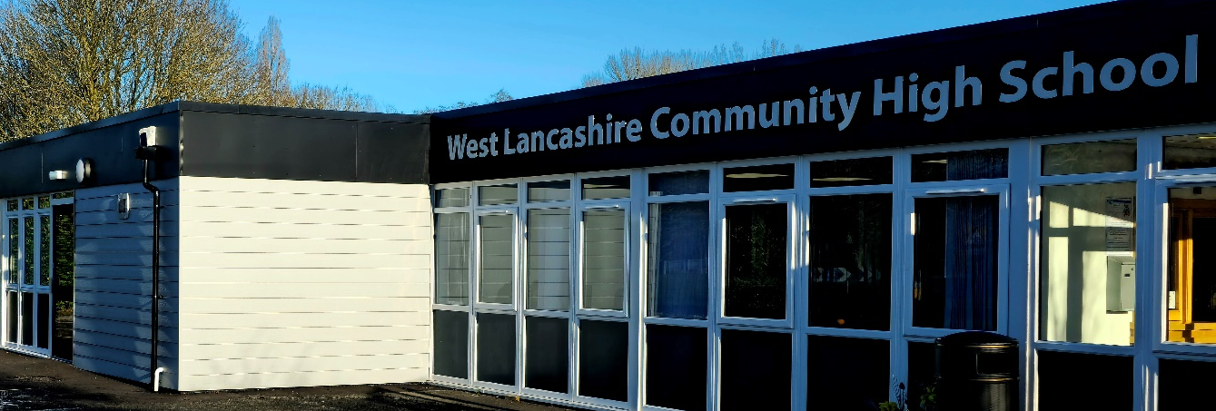

Privacy Notice

(How we use School Workforce information)

The categories of school workforce information that we collect, process, hold and share include but not exclusive to:
- personal information (such as name, employee or teacher number, national insurance number)
- special categories of data including characteristics information such as gender, age, ethnic group
- contract information (such as start dates, hours worked, post, roles and salary information, bank details)
- work absence/attendance information (such as number of absences and reasons)
- qualifications (and, where relevant, subjects taught)
- training and CPD attended/accessed
- risk assessments for medical/health related conditions
- incidents/near misses
- references as part of the recruitment and selection process
- occupational health referral outcomes
- driving licence, car and insurance details
- DBS checks
- Right to Work In the UK validation documents
- CCTV

Why we collect and use this information
We use school workforce data to:

- enable the development of a comprehensive picture of the workforce and how it is deployed
- inform the development of recruitment and retention policies
- enable individuals to be paid
- ensure the safeguarding of pupils
- support the workforce to carry out their duties
- improve our practice to avoid future accidents and incidents
- ensure compliance with the law and insurance for driving whilst at work
- ensure compliance for core training- such as Team Teach, Health and Safety, First Aid (see CPD Matrix)
- develop the skills and knowledge of the workforce to:
  - meet the needs of pupils
  - ensure compliance and best practice to meet the needs of regulators/partners
- Inform attendance, absence and performance information
- Ensure compliance to employment contract
- Enable taking of photographs for display, marketing and promotion
- Record CCTV footage
- Record use of the school’s information and communications system

The lawful basis on which we process this information
Under the UK General Data Protection Regulation (UK GDPR), the legal basis / bases we rely on for processing personal information for general purposes are:

Article 6
- Processing shall be lawful only if and to the extent that at least one of the following applies:
(c) Processing is necessary for compliance with a legal obligation to which the controller is subject;
Article 9
- Processing of personal data revealing racial or ethnic origin, political opinions, religious or philosophical beliefs, or trade union membership, and the processing of genetic data, biometric data for the purpose of uniquely identifying a natural person, data concerning health or data concerning a natural person’s sex life or sexual orientation shall be prohibited.
- Paragraph 1 shall not apply if one of the following applies:
(j) Processing is necessary for archiving purposes in the public interest, scientific or historical research purposes or statistical purposes in accordance with Article 89(1) based on Union or Member State law which shall be proportionate to the aim pursued, respect the essence of the right to data protection and provide for suitable and specific measures to safeguard the fundamental rights and the interests of the data subject.

Education Act 2005 sections 113 and 114 - is a statutory requirement on schools and local authorities for the submission of the school workforce census return, including a set of individual staff records,

Collecting this information
We collect personal information via the recruitment process (Application form, OHU screening, DBS application, Training and qualifications) and subsequently information is collected when attending site.

Workforce data is essential for the school’s / local authority’s operational use. Whilst the majority of personal information you provide to us is mandatory, some of it is requested on a voluntary basis. In order to comply with UK GDPR, we will inform you at the point of collection, whether you are required to provide certain information to us or if you have a choice in this.

Storing this information
We hold school workforce data for six years.
Recruitment information is kept for a maximum of 6 months.
(For further details refer to the Retention Schedule)

Who we share this information with
We routinely share this information with:

- our local authority(LCC)- Contract
- the Department for Education (DfE) – School Work Force Census- Public Interest
- Prospective employers (upon employees request)- Consent
- CPD providers (name and previous certificate dates)- Contract
- OH Assist/Southport and Ormskirk Hospitals- OHU (Occupational Health Referrals) - Consent
- Minibus Insurance ( Claim related) - Legal Obligation
- Health and Safety Executive (RIDDOR)- Legal Obligation
- Police (Legal duty to disclose)- Legal Obligation
- Emergency Services-(Ambulance, Fire, Police, Mountain Rescue) Vital Interest
- Catering Services (LCC)- Consent

Why we share school workforce information
We do not share information about workforce members with anyone without consent unless the law and our policies allow us to do so.

Local authority
We are required to share information about our workforce members with our local authority (LA) under section 5 of the Education (Supply of Information about the School Workforce) (England) Regulations 2007 and amendments.

Department for Education (DfE)

The Department for Education (DfE) collects personal data from educational settings and local authorities via various statutory data collections. We are required to share information about our children and young people with the Department for Education (DfE) for the purpose of those data collections, under:

https://www.lancashire.gov.uk/council/transparency/access-to-information/service-and-project-specific-privacy-notices/

We are required to pass information about our school employees to the Department for Education (DfE) under section 5 of the Education (Supply of Information about the School Workforce) (England) Regulations 2007 and amendments.
All data is transferred securely and held by DfE under a combination of software and hardware controls which meet the current government security policy framework.
For more information, please see ‘How Government uses your data’ section.

Requesting access to your personal data
Under data protection legislation, you have the right to request access to information about you that we hold. To make a request for your personal information, contact:

Data Protection Officer (School Workforce) Darby Harrison, Business Manager

West Lancashire Community High School, School Lane, Skelmersdale, WN8 8EH

business.manager@westlancs.lancs.sch.uk

You also have the right to:
- to ask us for access to information about you that we hold
- to have your personal data rectified, if it is inaccurate or incomplete
- to request the deletion or removal of personal data where there is no compelling reason for its continued processing
- to restrict our processing of your personal data (i.e. permitting its storage but no further processing)
- to object to direct marketing (including profiling) and processing for the purposes of scientific/historical research and statistics
- not to be subject to decisions based purely on automated processing where it produces a legal or similarly significant effect on you
If you have a concern about the way we are collecting or using your personal data, we ask that you raise your concern with us in the first instance. Alternatively, you can contact the Information Commissioner’s Office at https://ico.org.uk/concerns/
For further information on how to request access to personal information held centrally by DfE, please see the ‘How Government uses your data’ section of this notice.

Requesting access to your personal data

Where we are processing your personal data with your consent, you have the right to withdraw that consent. If you change your mind, or you are unhappy with our use of your personal data, please let us know by contacting:
Data Protection Officer (School Workforce) Claire Codling, Business Manager

West Lancashire Community High School, School Lane, Skelmersdale, WN8 8EH

business.manager@westlancs.lancs.sch.uk

Contact
If you would like to discuss anything in this privacy notice, please contact:

Data Protection Officer (School Workforce) Darby Harrison, Business Manager

West Lancashire Community High School, School Lane, Skelmersdale, WN8 8EH

business.manager@westlancs.lancs.sch.uk

How government uses your data
The workforce data that we lawfully share with the DfE through data collections:
- informs departmental policy on pay and the monitoring of the effectiveness and diversity of the school workforce
- links to school funding and expenditure
- supports ‘longer term’ research and monitoring of educational policy

Data collection requirements
To find out more about the data collection requirements placed on us by the Department for Education including the data that we share with them, go to https://www.gov.uk/education/data-collection-and-censuses-for-schools.

Sharing by the department
The Department may share information about school employees with third parties who promote the education or well-being of children or the effective deployment of school staff in England by:
- conducting research or analysis
- producing statistics
- providing information, advice or guidance

The Department has robust processes in place to ensure that the confidentiality of personal data is maintained and there are stringent controls in place regarding access to it and its use. Decisions on whether DfE releases personal data to third parties are subject to a strict approval process and based on a detailed assessment of:
- who is requesting the data
- the purpose for which it is required
- the level and sensitivity of data requested; and
- the arrangements in place to securely store and handle the data

To be granted access to school workforce information, organisations must comply with its strict terms and conditions covering the confidentiality and handling of the data, security arrangements and retention and use of the data.
How to find out what personal information DfE hold about you
Under the terms of the Data Protection Act 2018, you’re entitled to ask the Department:
- if they are processing your personal data
- for a description of the data they hold about you
- the reasons they’re holding it and any recipient it may be disclosed to
- for a copy of your personal data and any details of its source
If you want to see the personal data held about you by the Department, you should make a ‘subject access request’. Further information on how to do this can be found within the Department’s personal information charter that is published at the address below:
https://www.gov.uk/government/organisations/department-for-education/about/personal-information-charter
To contact the department: https://www.gov.uk/contact-dfe.

