Pupil premium strategy statement – West Lancashire Community High School

School overview
Detail | Data
Number of pupils in school | 162
Number of students in school pupil premium eligible | 37
Proportion (%) of pupil premium eligible pupils | 22.84%
Academic year/years that our current pupil premium strategy plan covers | Year 1 of 3 year plan  2024-2027
Date this statement was published | October 2024
Date on which it will be reviewed | - September 2025  - September 2026  - September 2027
Statement authorised by | Lee Fazackerley
Pupil premium lead | Andrew Grant
Governor / Trustee lead | Steve Jones

Funding overview
Detail | Amount
Pupil premium funding allocation this academic year | £65k
Recovery premium funding allocation this academic year  Recovery premium received in academic year 2023/24 cannot be carried forward beyond August 31, 2024. | £0
Pupil premium funding carried forward from previous years (enter £0 if not applicable) | £0
Total budget for this academic year | £65k

Part A: Pupil premium strategy plan

Statement of intent
We are aware that there are obstacles that may prevent our students from achieving their full individual and academic potential. Evidence, as a national picture, is clear that Covid has reversed the process of closing the academic gap for many students along with a significant increase in anxiety driven behaviours, school avoidance and families in challenging situations that services are not best placed to serve effectively. We will use evidence based research to support our specialist SEND teaching experience in order to identify and remove obstacles and ensure that our students are all able to excel, reaching their potential in all areas of school life and preparing them for further success in the next stages of their education and career and life after school.Bearing in mind that Schools do not have to spend their pupil premium solely to benefit eligible pupils, our priorities, designed to maximise the use of the Pupil Premium Grant are:
- To use evidence based research, and the EEF (Education Endowment Foundation) Guide to the Pupil Premium, (new release September 2024), DfE ‘using Pupil Premium guidance for school leaders’ the Lancashire virtual school policy for the allocation of Pupil Premium Grant & for looked after children 2024-25 and the EEF guidance on using research evidence to support spending decisions and to identify areas of need and the most effective ways in which to address them
- To ensure learners have access to Pastoral and Therapeutic interventions (within school’s ability to provide) signposting for parents and a closing of the attainment gap between particularly disadvantaged students and their peers
- To ensure all students receive quality first teaching in each lesson
- To ensure all students receive access to up to date technology to support learning including Physical Education, healthy eating and understanding how our bodies work.
- To ensure all staff are committed to raising the attainment of students through Quality First teaching, maintain standards and expectations for all and use strategies to maximise the ability of all their students to access the curriculum and extra curriculum.
- To provide targeted support for those students not making the expected progress and to act early when a need is identified
- To address the barriers to attainment, such as low attendance, behaviour, well-being, poor home study environments, mental health considerations .
- To enable engagement in all aspects of school life, both academic and the wider opportunities, to enrich the cultural capital of all students
- To ensure the impact of the grant reaches the students in a positive and pro-active manner including supporting a love of music, developing access to D.T, offsite provision and refining transitions programmes to support pupils and parents alike.
- We will:
- Diagnose pupil’s needs
- Use strong evidence to support the strategy
- Implement the strategy
- Monitor and evaluate the strategy

Challenges
This details the key challenges to achievement that we have identified among our disadvantaged pupils.
Challenge number | Detail of challenge
1 | Some students have been identified through case studies as potentially having lower attendance and may present with poor engagement in lessons and being at risk of disengaging with school thus impacting learning
2 | Previous academic years have been heavily impacted by covid-19 illness.  The education and wellbeing of disadvantaged students may have been disproportionately impacted during covid. This is backed by national studies and results in more significant knowledge gaps for some disadvantaged students resulting in lower attainment.
3 | Students may be from vulnerable families with emotional, social and wellbeing needs
4 | Some students may have poor understanding of healthy lifestyle , have access to nutritional food and suitable exercise.
5 | Students may lack access to funds for necessary equipment/uniform/resources, learning about the world beyond their own doorstep, broadening their understanding of the world. Cultural Capital
6 | Disadvantaged families may not have the same access to computing facilities including in the home ,and where present, may have to be shared with other children in the household.
7 | Research shows that less children from Disadvantaged backgrounds are accessing Design Technology which in turn is reducing numbers entering engineering career paths.
8 | Transitions between schools, year groups and key stages are a time of anxiety for many. To develop our robust transitions programme further

Intended outcomes
This explains the outcomes we are aiming for by the end of our current strategy plan, and how we will measure whether they have been achieved.
Intended outcome | Success criteria
To ensure high quality teaching and learning, driven by the curriculum rather than assessment. To close the gap academically through improved opportunities to broaden knowledge and skills away from assessment pressures and provide additional support to close the gap for those students who require targeted support.  Small group tuition | Teaching and Learning Toolkit | EEF | Department curriculum design and delivery is accessible and engaging for all students.  Long term outcomes – Progress review and end of year assessment results improved for students taking greater ownership of their success criteria and targets.
Further Development of learning outside the classroom, accessing museums, art galleries, world food exhibitions- developing cultural capital Arts participation | Teaching and Learning Toolkit | EEF | Fully or partly subsidised trips, travel, extra -curricular lessons when cost is a barrier for disadvantaged students
Further development of Technology to aid Teaching and Learning (Gigabyte Schools dependant) Using Digital Technology to Improve Learning | EEF | Lexia Reading Core5 is a computer-based integrated learning system that aims to improve reading skills.  Technology supported Physical Education.
Development of Pastoral services  Family support mechanisms  In-house wellbeing systems  Extended provision of services ( SaLT,OT,EP) What works database | Highly structured and embedded Pastoral, therapeutic provision, external educational assessment and Family-link programmes in place by year3
Healthy lifestyles, physical education, exercise environments.  https://educationendowmentfoundation.org.uk/early-years/evidence-store/physical-development | Extended opportunities for students to access healthy lifestyle choices driven by a robust PE programme, healthy eating programme and opportunities to develop core strength and fitness supported by appropriate technology.

Activity in this academic year
This details how we intend to spend our pupil premium (and recovery premium) funding this academic year to address the challenges listed above.

Teaching (for example, CPD, recruitment and retention)
Budgeted cost: £ [15k]
Activity | Evidence that supports this approach | Challenge number(s) addressed
Monitor the academic progress and attendance of students and maintain academic performance of PP students at an equivalent level to non-PP students | Departmental and pastoral Intervention after assessment data points. | 1,3
Learning support from dedicated teaching assistants and Pastoral teams. | Employing and retaining quality teaching assistants will support Individual improvement of students.  Well-being lead monitors students and ensures early intervention  Student wellbeing to be an area of focus and development in the school, bringing in parental engagement through information evenings and outreach work LPPA- Pastoral lead etc | 1,2,3,4,5
Ensure digital devices are readily available for all students and access to computer aided technologies to support teaching and learning.  ( Gigabyte school dependent)  Using Digital Technology to Improve Learning | EEF | The use of digital technology is now integral to the delivery of education at School, further development of student access to Technology to support a healthier lifestyle and Physical Education with software designed to increase engagement in learning and staying healthy/ understanding how our bodies work and keeping them fit and healthy. Increased access to technology to support development of Design Technology with a view to potential enterprise options. Potential for access to a VLE to support learning at home. | 4,6,7
CPD | Extending wellbeing training for in-house Wellbeing interventions e.g Compass Bloom, Barnardo’s counselling | 1,2,3
CPD | Increasing options for off-site learning by training an onsite MIDAS instructor for school vehicles for accessing community and supporting cultural capital opportunities. | 5

Targeted academic support (for example, tutoring, one-to-one support, structured interventions)
Budgeted cost: £ [25k]
Activity | Evidence that supports this approach | Challenge number(s) addressed
Development of Family support processes including, Pastoral lead role, LPPA developments, | WLCHS buy in additional Occupational Therapy time.  Emotional and mental health, attendance, potential interpretation services and support materials for families of some of our students.  Additional CPD to support the development of Pastoral roles around Family Thrive . | 1,2,3
Increasing opportunities for students to develop in Functional Skills in Computing for working life  N.b Outgoing laptops and Ipads to be re-purposed and given to P.P students for home-working. | Ensuring students have access to suitable computing equipment in school.  This will consist of laptops and charging trolley to ensure access to accredited routes for learning and AAC devices ( including Braille support) and ipads to support wider learning. | 6,7
Provision of interventions to support students educated offsite via Alternative Provision. | VLE options to support home learning and alternative provision e.g Home Safari Education, Moodle. | 6
Developing greater options for offsite learning, accessing the community, and cultural development | Staff trained to ‘train the trainer’ Level to enable other staff to be trained to MIDAS level as drivers to facilitate greater transport options for pupils. | 5
Developing access to Technology to support Physical Education. | Academic support around Digital programmes and Apps to encourage, track and measure progress in Physical Education and well-being.  Staff training to utilise these programmes and use the software and hardware. | 4
Increase access to music and music Therapy. | Music and the love of music taught as part of the curriculum to be supported by access to a Music Therapist. | 3,5
Developing Access to Design Technology and the equipment required to further its use. | Making provision of Design Technology more widely accessible, making provision of equipment to support Design Technology and by extension Opportunities for pupil Enterprise. | 7
Developing Transitions Programme | To develop our already robust transitions programme we will purchase bespoke Transitions ‘comics’ to support Pupils and parents.( LPPA) | 8

Wider strategies (for example, related to attendance, behaviour, wellbeing)
Budgeted cost: £ [20k]
Activity | Evidence that supports this approach | Challenge numbers
Financial support for students by the provision of free school uniform at the start of school. | By ensuring that PP students are not disadvantaged by inability to afford the school uniform. | 5
Encourage participation of all students in the wide range of co-curricular activities that are available at the school through school funded materials and equipment. | The enrichment of sport and the curriculum with a dedicated programme of sporting activities, clubs and other opportunities for students to participate in team/group activities/ use of accessible bicycles, MUGGA, sensory garden, other external provision ( e.g Gym and swim). Use of technology to support development of P.E particularly for those who struggle to engage with ‘traditional’ P.E programmes and to further enable a richer experience of OAA, LOTC, DofE and a greater input into D.T. | 4
Appointment of Ad-Hoc Educational Psychologist support for school. | Allows timely child development, psychology of learning and teaching, emotional wellbeing and the psychological aspects of our students especially when external services waiting lists are extensive. | 3
Employment of a part-time Therapeutic Practitioner. | Vulnerable students receive timely intervention through therapeutic sessions in school.  Parental support and communication is increased, leading to greater engagement with school life and education. | 3
Creation of Assistant Head Teacher role to increase pastoral monitoring, intervention and communication with home | Assistant Head Teacher support groups of students in the school through regular monitoring, meetings and home communication, improved school engagement, attendance, behaviour and progress, effective deployment and monitoring of WPVs etc | 1,2
Creation and development of online Parent Pastoral area. | Parent site provides links to agencies and guidance on supporting their child through the school website, to include video with school offer, pre-requisites for placement at school. | 2
Increased hours for Occupational Therapist | Increased student numbers dictates increased time for O.T interventions | 3
Financial support for curricular trips and activities at the School | students are able to attend all curricular trips and have the opportunity to undertake wider curriculum-based activities where any charge is levied, thus increasing participation.  One partially funded residential trip per year for disadvantaged students  Day trips funded fully by the school. | 5

Total budgeted cost: £ [65k]

Part B: Review of the previous academic years
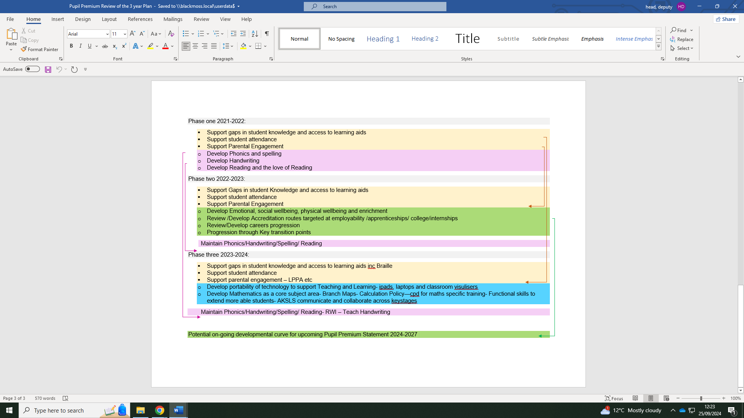
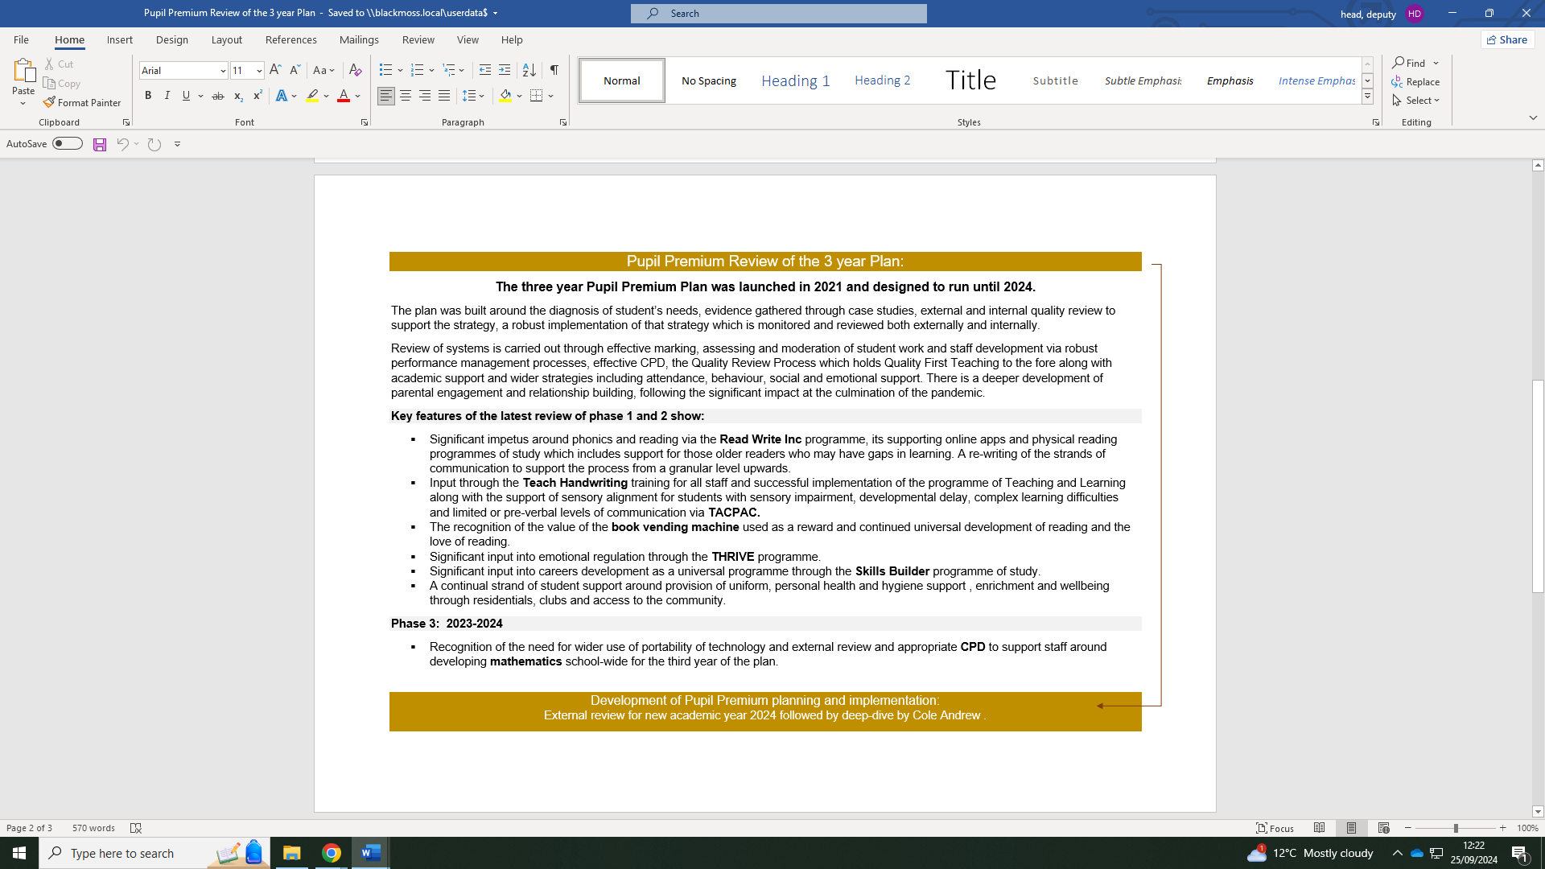

Externally provided programmes
Please include the names of any non-DfE programmes that you used your pupil premium (or recovery premium) to fund in the previous academic year.
Programme | Provider

Further information (optional)
Additional activity
Our pupil premium strategy will be supplemented by additional activities that we are not funding using pupil premium. That will include:
- Working in partnership with local colleges to provide opportunities such as taster courses, link programmes and mentoring to enable young people with SEND to familiarise themselves with the college environment and gain some experience of college life and study.
- Arranging work-based learning that enables pupils to have first-hand experience of work, such as apprenticeships, traineeships, and supported internships.
Planning, implementation, and evaluation
In planning our new pupil premium strategy, we evaluated activities undertaken and provided feedback to senior leaders and Governors.
We looked at several reports, studies, and research papers about effective use of pupil premium and the intersection between socio-economic disadvantage and SEND including reports produced by EEF.
In addition to the pupil premium funded activity outlined above, we have put in place stronger expectations around areas of effective practice, notably feedback given the impact of this identified by the EEF Toolkit. We have also put a sharp focus on supporting teachers to develop their professional practice and train in specialist areas, allowing them to develop expertise and share them with other staff clearly showing ‘why we are specialist teachers’
We have used the EEF’s implementation guidance to set out our plans and put in place a robust evaluation framework for the duration of our three-year approach. This will help us to make adjustments and quality improvements to secure better outcomes for our students over time.

