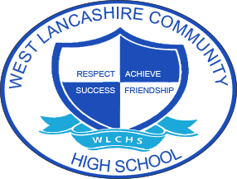

Overview of Curricular Themes for Key Stage 3 Curriculum
 | Autumn Term Theme | Spring Term  Theme | Summer Term Theme
Year 1 | Fair Trade  Islam- What is expected of a person in following a religion or belief? | My Environment  Sikh Dharam - what builds the community?  Christianity - who is my neighbour? | Space  Christianity and Humanism - created or chance?  Judaism - How do people keep faith in difficult times?
Year 2 | Around the World  World Faith- who is God? | Farm to Fork | Lights Camera Action  Buddhism - can meditation make a difference?  Celebrities who meditate
Year 3 | Best of British  Hindu Dharma - where do we see signs of belonging? | Looking After Me  Islam, Christianity and Humanism -  What happens when we die?  Hindu dharma - What is a good life? | Animal Kingdom  What is special about our world?

