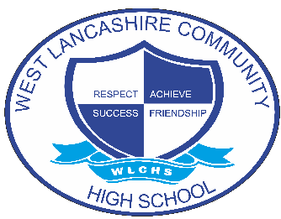
INTERVENTION OVERVIEW

NAME OF INTERVENTION
KS5 Reading – Turning Pages
AREA OF FOCUS (PLEASE HIGHLIGHT)
COGNITION AND LEARNING | COMMUNICATION AND INTERACTION | SOCIAL, EMOTIONAL AND MENTAL HEALTH | PHYSICAL AND SENSORY | SELF-HELP AND INDEPENDENCE
INTENT
Students who are identified as having development of reading as an area of need or target in their EHCP or those identified as reading being a barrier to accreditation access this intervention.

The aims of the intervention are:
- Students develop phonic knowledge to support reading and spelling
- Students develop functional reading skills
- Students become confident readers
- Reading as a barrier to the wider curriculum and accreditation is reduced, enabling students achieve to the best of their ability
- Development of reading supports students in carrying out tasks in their daily adult life, enables access to further education or employment and promotes independence.

IMPLEMENTATION
- The intervention is delivered as weekly 20 minute 1:1 sessions.
- Students are baselined using the RWI phonic assessment and the word lists for the accreditation if relevant so that any gaps in phonic knowledge can be addressed and ensuring a personalised approach.
- During the sessions, students take part in reading/spelling activities tailored to their individual needs.
- The Shannon Trust Turning Pages is used as a reading scheme. Turning Pages is a set of 5 structured manuals which use a synthetic phonics approach. Students build and practice their skills working through a range of different activities.
- There are 3 progress checks built into each manual, to ensure new skills have been embedded. As these progress checks are completed, Turning Pages reading books become available for students. These have been written to match the reading skills learners have covered in the manuals, providing the opportunity to put their new skills into action so that they can experience the joy of reading for pleasure from early on.
IMPACT
- Initial baseline assessments.
- Tracking of IEP/EHCP targets.
- Turning Pages progress checks.
- Accreditation assessments including practice English papers.
- Teachers and TA's will feedback on skills observed in wider curriculum.
- Feedback through end of year reports.

