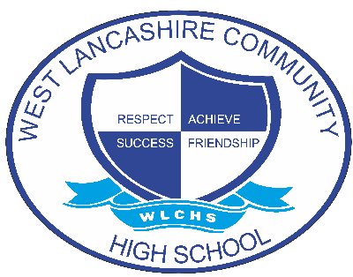

Relational Policy

Document Control
Document name (inc version number, if applicable) | Relational Policy (v1)
Date adopted by governing body | 27/1/2026
Next review | 27/1/2027
Owner | Dave Mullen
Approved on behalf of the governing body | Jeff Seddon (Chair of Governors)
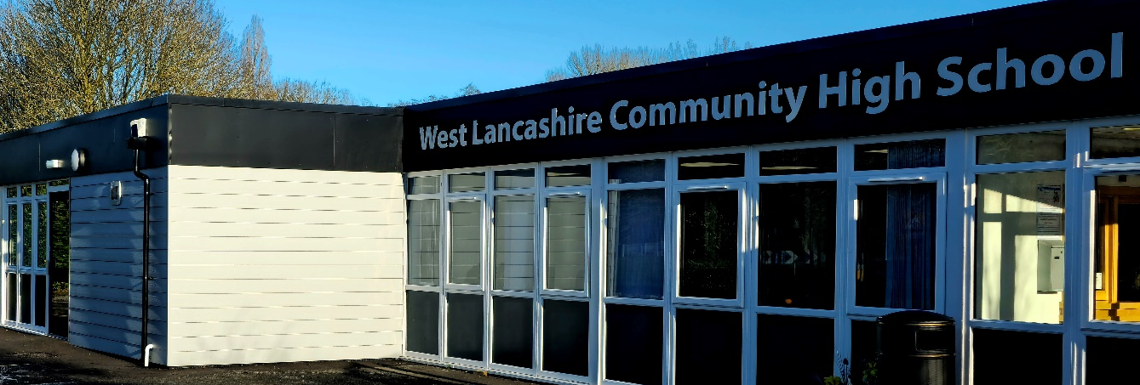

The Relational Policy

Contents
Rationale Page 3

Aims and Objectives Page 5

Managing Behaviour Relationally (The Thrive Approach) Page 6

Roles and Responsibilities Page 8

Whole School Strategies Page 10

Bullying Page 13

Physical Intervention Page 15

Exclusions Page 17

Confiscation Page 18

Uniform Page 19

Pupil Support Page 20

Written Statement of Principles Page 21

1. Rationale
At West Lancashire Community High School, we recognise that wellbeing and behaviour are inextricably linked. Research into child development, neuroscience and attachment theory all provide us with the understanding of the direct correlation between positive mental health and better educational and holistic outcomes. When children feel safe in their relationships, they are more comfortable in their ambition and are open to new learning. We know that a strong focus on a pupil wellbeing increases the likelihood of children achieving their full potential, so it is vital that wellbeing is placed at the very heart of our school offer.
We recognise that behaviour is a form of communication, we therefore take responsibility for listening to the needs a child is expressing through their behaviour, whilst setting clear boundaries and expectations. We encourage all stakeholders to recognise both their rights and responsibilities.
We recognise the link between understanding of the needs of our pupils and how this contributes to their ability to self-regulate. We use this knowledge to support our students in building their resilience by managing their reactions to situations in a positive way so they can be ready to engage with their learning. It is vital that we understand how as care givers, we can offer the students the security and positive relationships needed to meet their individual wellbeing and mental health needs, guiding them along their journey in becoming independent and resilient, life-long learners and citizens of the wider community.
As a school, we have adopted the Thrive Approach and we focus on relational connection and regulation first. We will do this by putting relationships at the heart of our approach by truly listening and responding to our children's voices, to create and foster a safe and happy environment where all feel safe, secure and respected.
This Relational Policy links to other school policies and documents including:
- Keeping Children Safe in Education
- Safeguarding and Child Protection policy
- Peer on Peer Abuse Policy
- Anti-bullying policy we have a zero tolerance to bullying (including cyberbullying, prejudice based and discriminatory bullying)

The Relational Policy refers to DfE statutory guidance and documents that should be read alongside this policy.
These include:
- Behaviour and discipline in schools
- Searching, screening and confiscation at school
- The Equality Act 2010
- Use of reasonable force in schools
- Supporting pupils with medical conditions at school

It is also based on the special educational needs and disability (SEND) code of practice.

In addition, this policy is based on:
- Section 175 of the Education Act 2002, which outlines a school’s duty to safeguard and promote the welfare of its pupils
- Sections 88-94 of the Education and Inspections Act 2006, which require schools to regulate pupils’ behaviour and publish a behaviour policy and written statement of behaviour principles, and give schools the authority to confiscate pupils’ property
- DfE guidance explaining that maintained schools should publish their behaviour policy online
- DfE Dealing with allegations of abuse against teachers and other staff.

Occasionally, there may be students who have individual plans that support their needs and any associated adverse presentations. These students very often have identified needs that are not covered by this policy. In these cases, the children's individual plans could take precedent over this Relational Policy.

2. Aims and Objectives
- To provide a framework for our understanding and insight into human behaviour and how this relates to student educational attainment.
- To build a school community which values kindness and empathy for others.
- To provide guidance to staff, parents, carers, governors and other stakeholders on how to support pupils to self-regulate, manage their emotions and feel safe so they are ready to learn.
- To provide a holistic, whole-person, inclusive model for our understanding of self-regulation and behavioural needs.
- To underpin our beliefs with evidence-based practice and current research.

To achieve these aims we will:
- Create and maintain a positive and safe school climate where positive and motivating experiences can take place and all students can grow socially, emotionally and academically, with mutual respect between all members of the school community.
- Create a culture with high expectations for positive attitudes and behaviours supporting life-long learning through a safe school ethos and environment.
- Provide a safe, nurturing environment, using responsibility, PACE (Playfulness, Acceptance, Curiosity and Empathy) and restorative approaches to foster appropriate self-regulation.
- Promote self-awareness, self-management and acceptance of responsibility for our own actions.
- Maintain a consistent, safe, caring and happy school community.

3. Managing Behaviour Relationally: The Thrive Approach

At West Lancashire Community High School, we strive to demonstrate a relational approach to supporting social and emotional development and behaviour based on the following principles.

- We understand presenting behaviours and adverse actions communicate unmet needs and can separate the student from their behaviour. We accurately assess and understand the students’ needs by referring to their Thrive action plans.
- We acknowledge the distinction between shame and guilt and recognise that shame prevents healthy emotional development. We provide empathy as an antidote to shame.
- We understand that each developmental stage has a range of typical characteristics and presentations which provide opportunities for adults to model and explicitly teach appropriate responses.
- We provide containment, predictability, and routine to build a sense of safety in the emotional and physical environment.
- We encourage the students at West Lancashire Community High School to become responsible for their actions at their level of understanding and to acknowledge the impact they may have on themselves and others, promoting a solution-focused approach to changing future behaviours.
- We keep in mind that we are the adults and that our students are still growing, learning, and developing. Mistakes are part of the life-long learning process.
- We recognise that all our pupils are at different stages of the developmental process. We don’t make a judgement about it; instead, we support and guide our pupils to make appropriate choices at their level of understanding.
- We seek to restore relationships and change behaviours rather than punish the actions a child may have taken. This does not exclude the use of sanctions as consequences, we seek the most appropriate way of supporting children to develop robust self-regulation strategies and therefore the skills of self-control, empathy, and emotional management.
- By supporting the development of student emotional development and self-regulating skills pupils can learn to improve their reactions to a range of situations.
- We recognise that learning new ways of managing their emotional regulation is a task, just like learning to read or write.
- Supporting pupils to effectively communicate in way that is right for them is a very important way to promote them to self-regulate, build resilience, and behave in a positive manner.
- All adults can learn strategies to support students to improve their responses to challenging or adverse situations. Most adults have evolved ways of responding to pupils’ presentations based on personal and professional experiences and training and experiential learning.
- All staff will be given the opportunity to learn, understand and have insight into why our pupils become dysregulated, and reflect on how and why it impacts on their presentations.
- In recognition of the rupture and repair cycle, all incidents will conclude with a restorative conversation with the member of staff with whom the rupture occurred. This is an important step, as it ensures that the relationships between staff and pupils are maintained and grow stronger.

4. Roles and Responsibilities
How all members of staff behave:
- Positively
- Calmly
- Consistently
- Our three rules: Always try to be;
  - Ready
  - Respect
  - Safe

All staff every day will:
- Promote a positive culture.
- Greet each student by name and backed with positive language.
- Provide early intervention to support children’s social and emotional needs.
- Use Vital Relational Functions VRFs. (Attune, Validate, Contain, Regulate)
- Use Three Rs. (Regulate, Relate, Reason) (Dr Bruce Perry)
- Use PACE. (Playful, Acceptance, Curiosity, Empathy) (Dr Dan Hughes)
- Listen to student voice in every situation using positive body language.

Senior Leaders will:
- Be visible and positive throughout the school day.
- Be visible at transition times.
- Engage in learning time and wellbeing walks to see positive behaviours, provide support and coach and model expectations.
- Drop into classrooms to catch children being positive.
- Ensure restorative conversations take place.

Teachers every day will:
- Greet every child with positive language and using the student’s name.
- Be responsible for the consistent awarding of rewards in their classroom.
- And over time:
- Practice VRF’s, PACE and the 3 ‘R’s.
- Take responsibility for their own learning.

All staff every day will:
- Actively promote a positive culture where students feel a sense of being and are safe.
- Greet each student with positivity and by name backed with positive and open body language.
- Build relationships by using the VRFs (Attune, Validate, Contain, Regulate), PACE (Playful, Acceptance, Curiosity, Empathy) (Dr Dan Hughes), meet and greet and check in using The Zones of Regulation™ (Leah M. Kuypers).
- Model positive behaviours and always highlight we want to see in positive terms.
- Plan lessons that engage, excite, challenge, and meet the needs of all children.
- Provide early intervention to support students that may need additional social and emotional support.
- Promote intrinsic motivation by rewarding the process of learning (behaviours for learning).
- Seek both resolution and learning when dealing with incidents. Follow up every time, retain ownership and engage in restorative dialogue with children to repair the rupture.
- Always remind students of values and expectations.
- Follow the VRF’s by using the 3 ‘Rs’ (Regulate, Relate, Reason) (Dr Bruce Perry).
- Support wellbeing through bespoke interventions or whole class/school approaches
- Use our listening skills to understand context of adverse reactions and show our students that we are listening using positive body language.

We recognise positive behaviour through:
- bespoke rewards and motivating activities.
- positive feedback across the school day.
- certificates and special awards.
- Headteacher recognition.
- Vending Book Tokens.

Support Beyond the Classroom: (To be used for change of face or to support the restorative conversation.)
- Senior Leader support
- Use of walkies for ‘Staff Assistance’ or ‘Staff Help’.
- Welfare meetings
- Student support plans
- Opportunities for students to apply self-management skills beyond the classroom.

5. Whole School Strategies



At West Lancashire Community High School, our core behaviour management training is TEAM TEACH.

The aim of Team Teach training is..

“To provide an accredited training framework designed to focus on positive behaviour support approaches, with an emphasis on de-escalation, risk and restraint reduction.”

The objectives of Team Teach training are

- To develop shared values which promote the attitude, skill and knowledge needed to implement Team Teach in the workplace.
- To develop positive handling skills in behaviour management including verbal and non-verbal communication, diversion and de-escalation and safe effective, humane physical interventions.
- To develop skills in positive listening and learning.

Our training is centred around the needs of the school and the students we are serving. Whilst physical intervention is sometimes a necessary intervention, it is only used as a last resort and the focus should be on de-escalation. This allows us to link Team Teach to several other research-based interventions to support de-escalation (Thrive Approach, The Zones of Regulation, Emotion Works etc)

At West Lancashire Community High School, we have our own Team Teach Tutors who are members of the Senior Leadership Team. They tailor the in-house training to best meet the needs of the current cohort of students. They bring day to day experiences and examples to support bringing positive behaviour management to life.

All staff working at West Lancashire Community High School will receive an initial 2-day training session followed by a 1-day refresher course every 2 years.


At West Lancashire Community High School, we have adopted a Thrive Approach as a whole school ethos towards our community’s social and emotional development. This research-based approach is founded on child development and identifies 6 stages for right-time social and emotional development.

Each stage identifies healthy developments and interruptions and through whole class. Small group and individual assessments, bespoke profiles of intervention can be developed to support student needs.

School has 4 trained Thrive Practitioners who are skilled to deliver 1:1 support for students. They will also have the responsibility for ensuring the ethos is maintained across school through high quality CPD opportunities.

Each department will run their Thrive approaches as per the need of the students within their cohort but all students access ‘Thrive Time’ as this is allocated as the first lesson on the timetable for all departments.

There are inter-connecting approached within Thrive that must be embedded;
- VRF’s (Attune – Validate – Contain - Regulate)
- 3 R’s (Regulate – Relate – Reason)
The model below shows the flow of adult intervention using these approaches.

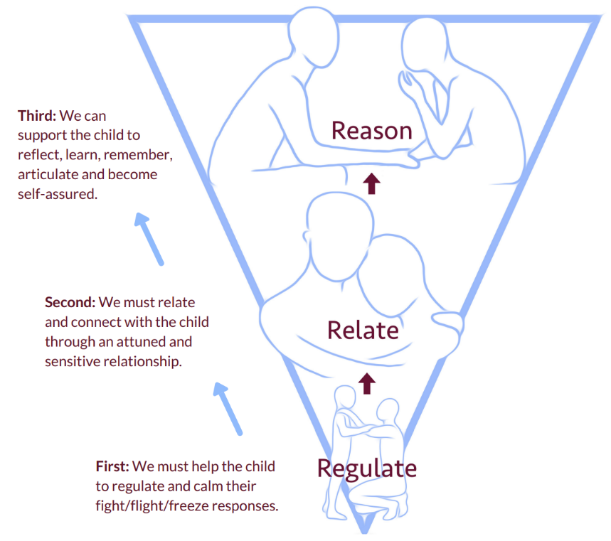
We must relate and connect with the student through an attuned and sensitive relationship
Through a range of approaches we can support the student to reflect, learn and become self-assured

Dr Bruce Perry’s ‘3 Rs’ to support emotional self-regulation.

Alongside the above model of approach, staff should also follow the principles of PACE (Dr Dan Hughes)

P | A | C | E
Playfulness  Adults should be – open, available, flexible, engaged, have a sense of fun and be imaginative and connected. | Acceptance  Adults should - acknowledge the student and their emotional state as being true and valid, and represent this back to them. | Curiosity  Adults should – show authentic interest in finding out about the child and their experiences. | Empathy  Adults should – be alongside the student without negative judgement.

All combined through bespoke and whole school interventions, these approaches drive the Thrive Approach across school.

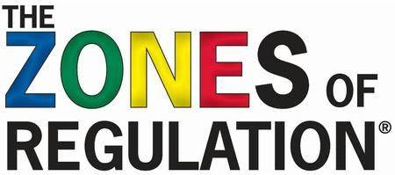

The Zones of Regulation® by Leah M. Kuyper has been adopted as a whole school approach to support students to self-manage and regulate through visual supports and continued development of emotional literacy.

The Zones represent categories of emotions and feelings that are also linked to a range of physical and sensory strategies that will enable our students to self-regulate.

The approach is supported by the school Occupational Therapist and all classrooms have a Zones of Regulation® board/display within the classroom. Using this approach all students have the opportunity to ‘check-in’ across the school day.

The four areas are;
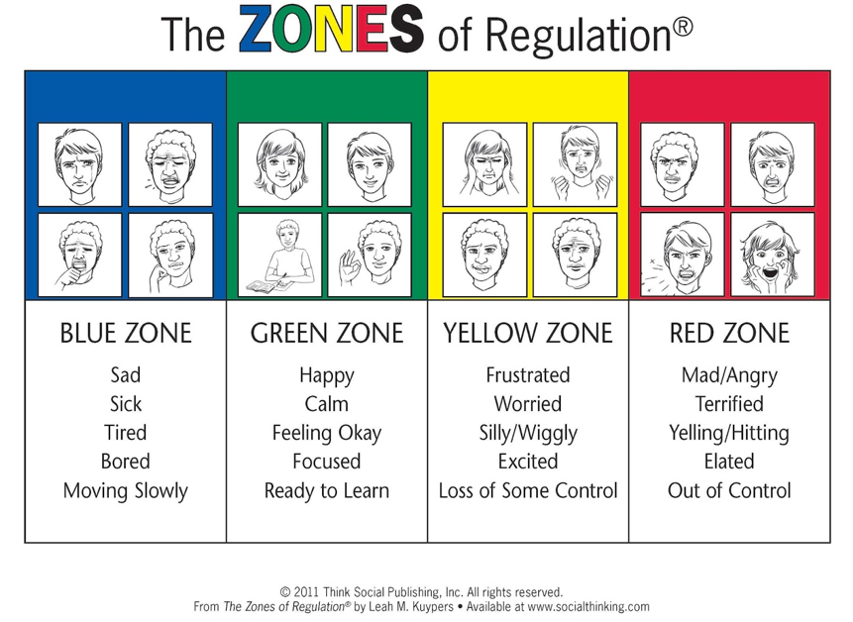

6. Bullying

Bullying is defined as the repetitive, intentional harming of one person or group by another person or group, where the relationship involves an imbalance of power.
Bullying is, therefore:
- Deliberately hurtful
- Repeated, often over a period
- Difficult to defend against

Bullying can include:

Type of Bullying | Definition
Emotional | Being unfriendly, excluding, tormenting.
Physical | Hitting, kicking, pushing, taking another’s belongings, any use of violence.
Racial | Racial taunts, graffiti, gestures.
Sexual | Explicit sexual remarks, display of sexual material, sexual gestures, unwanted physical attention, comments about sexual reputation or performance, or inappropriate touching.
Direct/Indirect Verbal | Name-calling, sarcasm, spreading rumours, teasing.
Cyber-bullying | Bullying that takes place online, such as through social networking sites, messaging apps or gaming sites.

At West Lancashire Community High School students are encouraged to develop a positive self-concept which will give them as much confidence as possible to deal with problems and events as they may occur. They should develop a capacity to have relationships with peers and adults which include empathy, cooperation, care and respect for others. Students should feel cared for and secure in an environment where they are given the opportunity to learn and to thrive.

Cyberbullying is defined as any form of bullying which takes place online or through smartphones and tablets. Social networking sites, messaging apps, gaming sites and chat rooms such as Facebook, XBox Live, Instagram, YouTube, Snapchat, House Party and other chat rooms.

Bullying may be distinguished from other incidents in that it involves the dominance of one student by another, or a group of others, it is pre-meditated and usually forms a pattern of behaviour rather than an isolated incident. Students do experience bullying at some point within their lives and the fact that incidents have not been reported to staff does not mean they are not happening.

Bullying or other forms of harassment can make student lives unhappy and can hinder their holistic progress and can sometimes push otherwise ambitious students into persistent absenteeism or deeper mental health issues.

School staff must act – and importantly be seen to act – firmly against bullying wherever and whenever it appears.

Students should actively be encouraged and constantly reminded that they should tell a member of staff whenever they feel that they are being victimised for whatever reason.

Members of staff should;
- Investigate claims thoroughly. Failure to respond to incidents may be interpreted as condoning the behaviour.
- Report incidents through the CPOMS and track events to observe patterns and intervene at the earliest opportunity.
- Discuss bullying issues within the Personal, Social and Health Education Programme.
- Interventions which were introduced in which provides the opportunity for students to share concerns and worries across a range of personal and social issues including aspects of bullying. In addition to this, students are encouraged to share interests, to interact appropriately with each other and to work together on given practical tasks.
- Students across the key stages take part in structured practical tasks and activities relating to a range of issues re. Bullying through the SEAL programme.
- The school holds weekly Welfare meetings and issues including bullying are discussed and actioned.
- During the less structured times of the school day (breaktimes, lunchtimes etc.), involve and encourage students to play and interact constructively.
- Share information with each other in order that patterns of behaviour can be identified.
- Involve parents – explain what is happening – where parents report, report back to parents as soon as possible.

Prevention of bullying including Cyber Bullying is addressed through;
- Anti-Bullying week or focussed curricular events.
- E-Safety training.
- Personal and Social Development Curriculum.
- Pastoral Time with Teachers.
- Departmental assemblies.
- Welfare Meetings.
- Meetings with parents.
- CIN and TAF meetings.

7. Physical Intervention

At West Lancashire Community High School, all staff are trained in Positive Behaviour Management Strategies including physical intervention techniques through the TEAM TEACH approach (See Section 5).

All physical interventions are logged on CPOMS and are linked and referenced to the Serious Incident Log which is signed by a member of SLT/Team Teach Tutor.

Training will be adapted to the current needs of the students including a rage of de-escalation techniques which form 95% of the Positive Behaviour Management training and physical intervention techniques relevant to out students which form 5% of the training.

The training also links all other whole school approaches including The Thrive Approach, The Zones of Regulation and elements of ACES (Adverse Childhood Experiences).

The Conflict Spiral is core to the training delivered and intrinsically links to Thrive. The focus of the Thrive Approach is to ensure that students experience safety, wellness, a sense of belonging and feeling special. The aim being that if those intervention support the development of self-belief and resilience, the spiral is broken and conflict can be averted.


Conflict
Reactions
Behaviour
Feelings
Experiences
Conflict can lead to risk, restriction & restraint.
Reactions can lead to conflict.
Behaviour can produce reactions.
Feelings can change behaviours.
Experiences can change feelings.

Physical intervention is a last resort and through dynamic risk management should only be used when;
- Staff or other students are liable to injury.
- The students is liable to injury themselves.
- The destruction of property.
- Good order and disruption to the wider school community.

Senior Leadership Responsibilities;
- Ensure all staff are trained within a reasonable period of time after starting employment at West Lancashire Community High School.
- Ensure the Team Teach Tutor training is updated yearly.
- Set out clear recording procedures through CPOMS and Serious Incident Log.
- Refresh training of staff every 2 years.

Staff Responsibilities;
- To follow policy.
- To dynamically risk assess situations before intervening.
- To ensure all de-escalation options have been used and that physical intervention is the last resort.
- Ensure family and any other stakeholders have been informed if physical intervention has been used.
- To use techniques authorised during training.

Governor Responsibilities;
- To check the Serious Incident Log/CPOMS records at regular interviews.
- To have knowledge through updates of the numbers of physical interventions.

At West Lancashire Community High School, all appointed teaching staff and specialist support assistants (TA’s) who have control or charge of students are authorised to use reasonable force for management or control.

Authorisation is not given to volunteers or parents.

The headteacher is responsible for making clear to whom such authorisation has been given, in what circumstances and settings they may use force and what duration of time this authorisation will last.

The headteacher will ensure that those authorised are aware of, and understand, what the authorisation entails. Those whom the headteacher has not authorised will be told what steps to take in case of an incident where control or restraint are needed, for example to contact an authorised member of staff.

Supply staff will not be authorised to use reasonable force unless they are familiar with the school’s policy and have undertaken training at this school.
The headteacher will maintain a list of those who have been authorised and training which has been provided. This list will be constantly reviewed.

8.Exclusions

At West Lancashire Community High School, exclusions are extremely rare. As a school we utilise the DfE guidance.

DfE Guidance for Exclusions

There are occasions where for a range of reasons, school need to implement a fixed term exclusion or permanent exclusion. These are rare and will only ever be a last resort when all other options have been exhausted.

In all cases, this decision is made by the headteacher as per the DfE and Local Authority guidance.

In all cases the school will need have;
- Put in place support plans and interventions to reduce the risk of exclusion.
- Included multi-agency working to ensure the right support is in place for the student before exclusion.
- Discussion with family to discuss alternatives to exclusion.
- Referral (with consent) to relevant Early Help services or Childrens Social Care.
- Completed Risk Assessments to ensure the safety of students and staff.
- Held emergency Annual Review meetings to discuss the appropriateness of the EHC Plan and work in collaboration with the local authority Inclusion Team.

9. Confiscation of Student Items

Any prohibited items listed below found in pupils’ possession will be confiscated. These items will not be returned to pupils.
We will also confiscate any item which is harmful or detrimental to school discipline. These items will be returned to pupils after discussion with senior leaders and parents, if appropriate.
Searching and screening pupils is conducted in line with the DfE’s latest guidance on searching, screening and confiscation.
- Knives or weapons
- Alcohol
- Illegal drugs
- Stolen items
- Tobacco and cigarette papers
- Fireworks
- Pornographic images
- Any article a staff member reasonably suspects has been, or is likely to be, used to commit an offence, or to cause personal injury to, or damage to the property of, any person (including the pupil)

10. School Uniform

At West Lancashire Community High School, we place high value on our community and its appearance. School uniform is vital in ensuring a sense of belonging and collective culture.

As a school we also recognise the challenges facing families in relation to costs and to the individual needs of the students in relation to school uniform. Whilst there is a set uniform, it has been considered in a way that families can seek elements from a range of sources.

All new students coming into school are provided with a school branded jumper, cardigan, or hoodie.

Uniform Expectations are;
- Grey or black trousers or skirts.
  - (In some cases, students for a range of needs may wish to wear non-branded black tracksuit bottoms.)
- White shirt or polo shirt.
  - (In some cases students may wear a plain non-branded white t-shirt)
- Branded School Jumper/Cardigan
  - (Some students prefer ‘hoodie’ tops. This will need to be dark blue)
- Black shoes, leisure shoes or trainers (non-branded)

Being a special needs school, we are open to discussions with families if uniform is a known issue. Many of our students have a range of needs including those physical and sensory needs that may mean adaptions to the uniform.

Piercings
Whilst school are aware that piercings are a modern trend that students may wish to engage in, we must consider wider implications. Our students engage in a range of activities in a range of environments which makes certain piercings not conducive to the health and safety of our students and may lead to unintentional injuries.

For this reason;
- Students are only permitted to have ear-piercings and should only wear stud earrings for health and safety reasons.
- Students are not permitted piercings through any other body part.

Make-Up
Make is not permitted for any student at West Lancashire Community High School.

11. Pupil support
The school recognises its legal duty under the Equality Act 2010 to prevent pupils with a protected characteristic from being at a disadvantage. Consequently, our approach to challenging behaviour may be differentiated to cater to the needs of the pupil.

The school’s annual review process will evaluate the needs of a student who exhibits challenging behaviour to determine whether they have any underlying needs that are not currently being met.
Where necessary, support and advice will also be sought from an educational psychologist, medical practitioners and/or others, to identify or support specific needs.
Many students have acute needs, and we will liaise with external agencies and plan support programmes for that student bespoke to their needs. We will work with parents to create the plan and review it on a regular basis.

Pupil Transition
To ensure a smooth transition to the next year, pupils have transition sessions with their new teacher(s). This is planned to allow the student time to acclimatise to new situations and expectations and prepare them for change. In addition, staff members hold transition meetings to ensure current and up to date information is transitioned with the student including Student Support Plans.

To ensure behaviour is continually monitored and the right support is in place, information related to pupil behaviour issues may be transferred to relevant staff at the start of the term or year through CPOMS. Information on behaviour issues may also be shared with new settings for those pupils transferring to other schools.

Appendix 1: Written Statement of Principles
- Every student will be supported to understand that they have the right to feel safe, valued and respected, and learn free from the deliberate disruption of others.
- All students, staff and visitors are free from any form of discrimination.
- Staff and volunteers always set an excellent example to students.
- Rewards, sanctions and reasonable force are used consistently by staff, in line with the Relational Policy.
- The Relational Policy is understood by students (where appropriate) and staff
- The Exclusions Policy explains that exclusions will only be used as a last resort, and outlines the processes involved in permanent and fixed-term exclusions.
- Students are supported to take some personal responsibility for their actions based on the level of their cognitive understanding.
- Families are involved in behaviour incidents to foster good relationships between the school and students’ home life.

The governing board also emphasises that violence or threatening behaviour will not be tolerated in any circumstances.
This written statement of behaviour principles is reviewed and approved by the full governing body every year.

