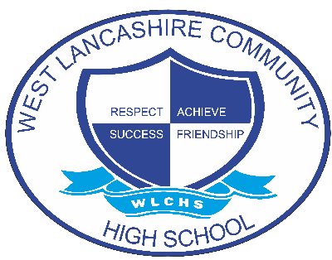

Relationships and Sex Education and Health Education Policy

Document Control
Document name (inc version number, if applicable) | Relationships and Sex Education and Health Education Policy (v1)
Date adopted by governing body | 27/1/2026
Next review | 27/1/2027
Owner | Louise Holcroft
Approved on behalf of the governing body | Jeff Seddon (Chair of Governors)
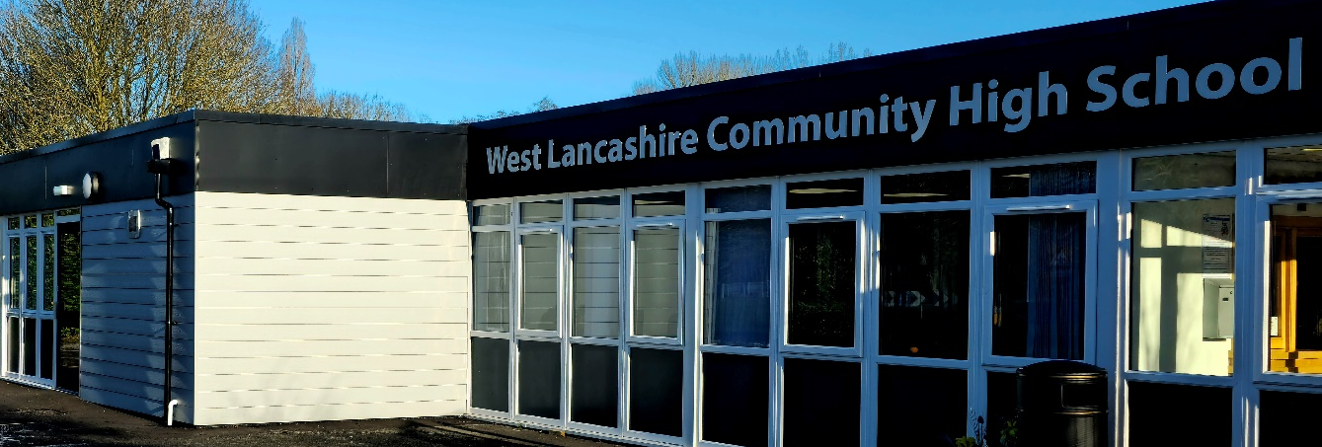

Intent

This policy covers West Lancashire Community High School’s approach to Relationships and Sex Education. We define ‘relationships and sex education’ as the emotional, social and physical aspects of growing up, having relationships, engaging in sex, and learning about human sexuality and sexual health.

The RSE Programme at WLCHS aims to:
- Develop moral understanding
- Encourage pupils to feel positive about themselves, develop confidence and self-esteem
- Develop respect for others
- Encourage pupils to make positive choices
- Help pupils to develop healthy relationships within a moral framework
- Help pupils understand how relationships are formed, maintained and sometimes ended
- Prepare pupils for change, physically and emotionally
- Teach pupils about appropriate and inappropriate behaviour
- Encourage assertiveness
- Help pupils stay safe
- Help pupils to understand emotions and feelings
- Develop an awareness of family life and the responsibilities of parenthood
- Develop an understanding and acceptance of diversity

Implementation

Delivery is organised across ability-based teaching and learning groups in each key stage. This allows work to be differentiated to meet ability ranges with access to staffing ratios that offer small group and individual 1:1 support when needed. Each subject follows a curriculum map that highlights the content and progression. Assessment is both formative and summative to inform next steps in learning and summarising attainment and progress. Some students will also access enhanced personalised timetables to meet specific additional needs if appropriate.

Where appropriate, external agencies and organisations provide input to enhance learning.

Assessment

Pupils learning is monitored and assessed against outcomes in the form of ‘I can’ statements, which are assessed by the teacher via the following criteria:
- Mastered
- Involvement
- Engaged
- Encountered

Students also complete an RSE questionnaire prior to starting their RSE Units, which is specifically designed for young people with learning disabilities. The assessment tool allows teachers to assess levels of sexual knowledge and understanding before and after completing the RSE programme.

Equal Opportunities
We strive to make the RSE curriculum relevant to all pupils regardless of age, culture, gender, sexual orientation, religion or social class. We avoid enforcing gender or racial stereotypes.

Parents and RSE

Parents are informed of their child’s participation in RSE work and are legally entitled to withdraw their son or daughter at any age. This does not apply to those aspects covered by the science curriculum.

We are aware that some parents find it difficult to cope with their child’s sexual development and are happy for school to take the initiative. Equally, we are happy to work with parents to ensure they are confident that we are meeting the needs of their child. We understand the importance of consistency of information given to the child or young adult.

Impact

Through this programme of study, pupils develop an understanding of, and ability to form positive relationships. They will have a better understanding of themselves and their place in the wider world. They will have strategies to keep them safe and healthy and where to go for help if required, including sexual health and social media. By developing awareness, confidence and self-esteem we aim to equip them with a set of skills to support them into a successful transition to adulthood.

Curriculum mapping

Key Stage 3:

Students in Key Stage 3 access a thematic curriculum and PSHE topics are weaved throughout each theme. Students also access one discreet RSE Unit per half term where they learn about:

- Developing from a baby to adulthood, including the human life cycle
- Changes at puberty
- Dealing with touch (Consent)
- Types of relationships
- Friendships

This Unit is repeated once per year on a three-year rolling programme. All students in KS3 will follow the same topic each term but schemes of work and activities are differentiated to suit each group level. This is to ensure that students are not repeating the same topics whilst in KS3. For students benefitting from a more sensory approach to learning, a personalised plan is developed by the class teacher including opportunities for overlearning.

Key Stage 4:

At Key Stage 4, students access accredited modules focused on:

- Keeping safe and healthy
- Sexual health
- Respectful relationships
- Families and parenting
- Living in modern Britain

Students also access a ‘RSE week’ where they are placed in smaller groups and

This is a two-year rolling programme. All pupils in KS4 will follow the same topic each term but schemes of work and activities are differentiated to suit each group level. This is to ensure that pupils are not repeating the same topics whilst in KS4.

Work is accredited through the PSHE ASDAN Short course.

Key Stage 5:

Learning at Key Stage 5 is highly personalised and developed by experienced class teachers delivering the subject.

Students access one half term of discreet Relationships and Sex Education content, which covers:
- How to recognise and manage emotions within a range of relationships
- How to manage risky/unhealthy relationships, including harassment and abuse
- Respecting equality
- How to identify appropriate advice and support
- Developing an understanding of parenting and responsibilities of parenthood
- Consent in a range of contexts
- Sexual health and intimate relationships

