WE ARE A SAFE SCHOOL 2023-24 IF YOU ARE WORRIED ABOUT A CHILD IN SCHOOL, YOU SHOULD PASS ON YOUR CONCERNS TO THE DESIGNATED SAFEGUARDING LEAD OR THEIR BACK-UP

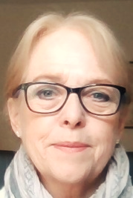
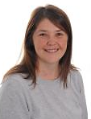
The Designated Safeguarding Leads are:

MRS.E. HARRISON SAFEGUARDING ADMIN
MRS J.BILL BACK-UP GOVERNOR LINK
MR.M.TEDFORD SCHOOL GOVERNOR
MR. GRANT DEPUTY HEAD DSL
MR. MULLEN ASSISTANT HEAD DSP
MR.FAZACKERLEY HEAD TEACHER DSP
CHILD PROTECTION REFERRALS
WHISTLEBLOWING HELPLINE
The following services can also be contacted:

- 01772-532500

