**WE ARE A SAFE SCHOOL 2025-2027**  IF YOU ARE WORRIED ABOUT A CHILD IN SCHOOL, YOU SHOULD PASS ON YOUR CONCERNS TO THE DESIGNATED SAFEGUARDING LEAD OR THEIR BACK-UP

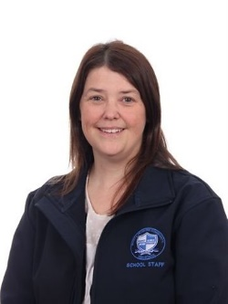 **The Designated Safeguarding Leads are:**

MRS.E. HARRISON SAFEGUARDING ADMIN

MR.J.SEDDON CHAIR OF GOVERNORS SAFEGUARDING GOVERNOR

safe

MR. GRANT DEPUTY HEAD **DSL**

MR. MULLEN ASSISTANT HEAD **DSP**

MR.FAZACKERLEY HEAD TEACHER  **DSP**

CHILD PROTECTION REFERRALS

WHISTLEBLOWING HELPLINE

The following services can also be contacted:

* **01772-532500**