Please take a minute to visit the website and increase your knowledge of Child Exploitation.

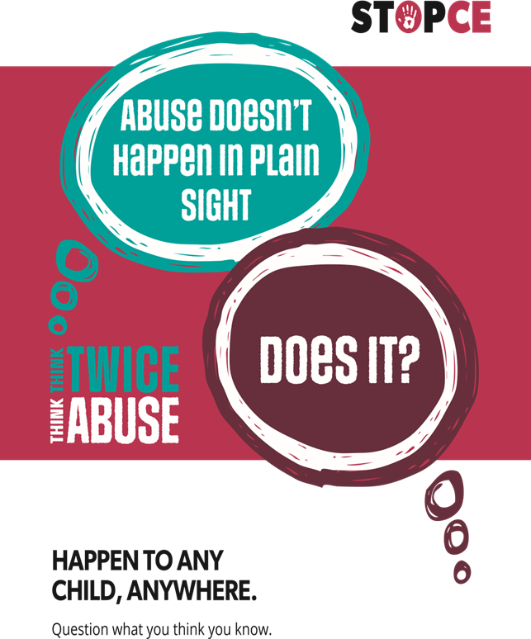
Click this link jointhefight@stop-cse.org

ABUSE CAN

