Wearing a Mask

There is a virus in our country at the moment which can make some people feel very poorly.

To help stop people getting poorly, most students will be asked to wear a mask on the bus and when we are walking around school

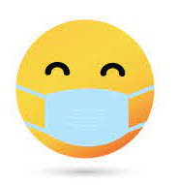

Wearing a mask might make me feel anxious. It is ok to feel anxious. Wearing a mask will help to keep you safe in school and on transport.

It is okay to feel anxious and upset when things are different to normal. To help me to feel happy I can talk to my family, my friends and my trusted adults at school.

I will try my best to wear a mask. I will wear a mask on transport and in school.
I am proud of to myself for wearing a mask. My teachers are all very proud of me.

