

Special Educational Needs and Disability Policy

Document Control
Document name (inc version number, if applicable) | Special Needs and Disability Policy (v1)
Date adopted by governing body | 27/1/2026
Next review | 27/1/2027
Owner | Dave Mullen
Approved on behalf of the governing body | Jeff Seddon (Chair of Governors)
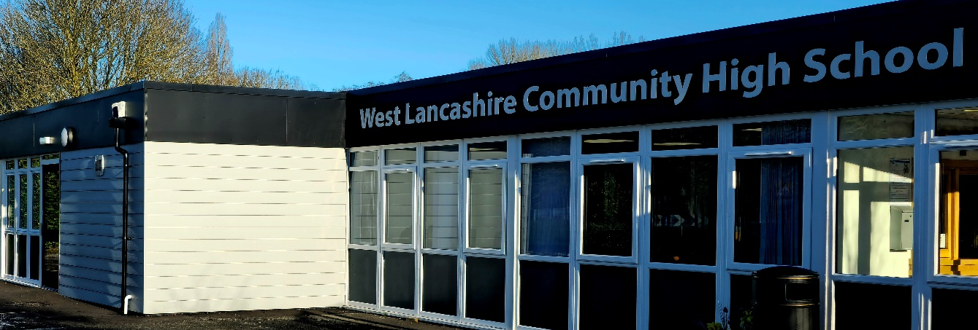

SPECIAL EDUCATIONAL NEEDS & INCLUSION POLICY

The special educational needs (SEN) code of practice gives schools, early education providers, local authorities and those who help them – including health and social services – a duty to provide reasonable adjustments for disabled students.
Since 1 September 2012, schools and local authorities also have a duty to provide auxiliary aids and services to disabled students.
The SEN Code of Practice 2014 updated statutory guidance to make provision for children/young person and young people from 0 to 25 years.
General Principles
Every student, regardless of sex, race, religion and special needs, should be valued equally and should have access to educational opportunities, which include a broad balanced curriculum, which prepares students for adult life. For all of our students, the purpose of education is the same.

To capitalise on each child/young person’s developmental capacity to learn academically, socially and emotionally with particular reference to preparing the child/young person for the adaptive responses necessary for successfully meeting the varying demands of an ever changing society.

However, the help an individual child/young person needs in making progress will be different.

Arrangements for assessment on arrival at the school, recognises the child/young person as a whole person and will, wherever necessary, be co-ordinated with other agencies. In this way the school demonstrates itself to be part of a ‘holistic’ approach, which is based on shared values and beliefs in relation to the child/young person.

Assessment
The provision made in school recognises the individual needs of the students and is reviewed regularly through liaison at key stage level to ensure that the resources of the school are offered efficiently in relation to the students.
The identification of the needs of the student involves co-operation with the parents and they are encouraged to be active partners with the school in meeting the needs of their respective child/young person.

The provision made within the school is designed to meet the needs of the students. Educational objectives are identified which are appropriate to the needs of the individual child/young person. The reviewing process assesses the achievement of objectives set out and identifies new objectives appropriate to the efficient use of resources.

The school contributes to and co-ordinates the annual reviews and 14+ Transition Plans of the students in the form of educational advices. Other agencies contribute to these reviews as appropriate at the request of the school and the parents.

Transition at Post 19 will also involve multi-agencies as a summary of the holistic work carried out since 14+ reviews.

Provision
Parents will be given the opportunity to gain a clear understanding of the provision to be made for their child/young person in the school. This process will begin at the Without Prejudice Visit (WPV).

The school has developed a whole school approach to meeting the needs of the students, which is differentiated, age-appropriate and reflects its commitment to the curriculum entitlement of all students.

Methods, materials and content of the curriculum available to students will reflect the nature of their respective individual needs. Such provision will be flexible and responsive to the individual needs of the students. The annual review is an essential feature of the monitoring process which enables a response to student need.

Where a mainstream approach is deemed appropriate, provision for some inclusion time can be negotiated and the Inclusion Leader will ensure appropriate support where necessary.

Appropriate in-service training will be provided for all staff to assist in keeping abreast of national legislative developments and teaching methods and the changed requirements of our client. This is developed in a CPD plan by the Deputy Head Teacher.

Assessment of Performance
The performance of the school will be demonstrated through the head teacher’s report presented each term at the meeting of the full governing body. The progress of individual students will be demonstrated through their Annual Reviews and by reports to governors re: accreditation.

Treatment of Complaints
Any complaints must follow the Complaints policy within school. As per policy, in the first instance, complaints should be addressed to the head teacher in order that specific issues can be addressed as early as possible. Thereafter, they should be addressed to the Governing Body in writing to the Chair of Governors.

To be read with:
- Inclusion Policy
- Admissions and Transfers Policy
- SEN report
- Local Offer
- Assessment on Entry

Inclusion

As a school we are commitment to valuing the individuality of all of our children. We give all of our children every opportunity to achieve the highest of standards. We do this by respecting and taking account of pupils’ varied life experiences and needs. We offer a broad and balanced curriculum and have high expectations for all our children. The achievements, attitudes and well-being of all our children are paramount. This policy helps to ensure that this school promotes the individuality of all our children, irrespective of ethnicity, attainment, age, disability, gender or background and that pupils have a common curriculum experience.

We actively seek to remove the barriers to learning and participation that can hinder or exclude individual students, or groups of students. This means that equality of opportunity must be a reality for our children. We make this a reality through the attention we pay to the different groups of children within our school:

Objectives
The school will:
- ensure implementation of government and LA inclusion recommendations
- ensure the school’s inclusion policy is implemented consistently by all staff
- ensure any discrimination or prejudice is eradicated
- identify barriers to learning and participation and provide appropriately to meet a diversity of needs
- ensure all pupils have access to an appropriately differentiated curriculum
- recognise, value and celebrate pupils’ achievements, however small
- work in partnership with parents / carers in supporting their child’s education
- guide and support all staff, governors and parents in inclusion issues

Defining Inclusion
Inclusion is an on-going process that celebrates diversity and involves the identification and minimising of barriers to learning and participation that may be experienced by any pupils irrespective of age, ability, gender, ethnicity, language and social background, and the maximising of resources to reduce these barriers. As a school we also recognise that inclusion is a two-way process of involving others to develop opportunities and skills both within and beyond our own setting, ensuring that all pupils experience equality and opportunity of access to learning

Co-ordinating Inclusion
The school, particularly senior staff are responsible for:
- induct new staff in the school’s commitment to inclusion;
- monitor the inclusion policy and report annually to the governing body on its effectiveness;
- Work collaboratively to monitor pupil progress
- co-ordinate external specialist provision.
- work positively with all members of the school community to promote inclusion;
- monitor and assess inclusive provision by helping the school to establish indicators to judge its effectiveness in relation to inclusion;
- report annually on the efficient and effective use of resources for pupils;
- analyse with key staff the recording of incidents which may relate to bullying or discrimination of students on the grounds of SEN;
- liaise with parents;
- co-ordinate cross-phase / key stage transition;
- share inclusive expertise with, and support the professional development of classroom teachers and teaching assistants;
- liaise with the various Educational and Health Services and contribute to students annual reviews

All staff are committed to meeting the needs of all students in their class and promoting the culture and ethos of inclusion within the school community.

Inclusive Provision
The school offers a continuum of provision to meet a diversity of students’ needs.
Class groups and departments are organised to best meet needs of students with an appropriate peer group. These groupings are revised regularly and adapted accordingly.

Class support is available in all lessons provided by teaching assistants (TAs). This additional support used and directed by the class teacher for individual students and small groups.

Access to learning is enhanced through technology and study aids, following outcomes of multi-agency collaboration and guidance obtained from medical, health and other education professionals.

A room is available for private treatment sessions (light room/sensory room) but therapy is often incorporated into classroom practice. The school has Specialist Trained staff who offer teaching and INSET support in local special and mainstream primary and high schools

Social Language Program (SLP) and SEAL groups are provided both within schools and in other local schools where pupils and staff are able to share skills and develop expertise in social language skills

Promoting an inclusive Curriculum
The National Curriculum is our starting point for planning a curriculum that meets the specific needs of individuals and groups of children. We meet these needs through:
- setting suitable learning challenges
- responding to children’s diverse learning needs
- overcoming potential barriers to learning and assessment for individuals and groups of pupils
- Providing other curricular opportunities outside the National Curriculum to meet the needs of individuals or groups of children.

When setting suitable learning challenges, we aim to give every student the opportunity to experience success in learning and to achieve as high a
standard as possible.

When planning, we set high expectations and provide opportunities for all pupils to achieve.
This is based on a system of tracking student achievement in order to ensure that student do not underachieve or fail to reach their potential. We respect and value student that bring to school different experiences, interests and strengths which will influence the way in which they learn. Our teachers plan their approaches to teaching and learning so that all pupils can take part in lessons fully and effectively.

To ensure that we meet the full range of students’ needs, our teachers are aware of the requirements of the equal opportunities legislation that cover race, gender and disability. We take specific action to respond to students’ diverse needs by:
- creating effective learning environments
- securing their motivation and concentration
- providing equality of opportunity through teaching approaches
- using appropriate assessment approaches
- Setting targets for learning.
- providing for pupils who need help with communication, language and literacy
- planning, where necessary, to develop pupils' understanding through the use of all available senses and experiences
- planning for pupils' full participation in learning and in physical and practical activities
- helping pupils to manage their behaviour, to take part in learning effectively and safely, and at key stage 4, to prepare for work
- Helping individuals to manage their emotions, particularly trauma or stress, and to take part in learning.

External Support
The school will liaise and seek additional external advice and support from Lancashire Education Inclusion Service, Lancashire Schools Effectiveness Service, Health related services and the Learning Disability Team. Specialist teachers from these services provide
Intervention in the form of assessment of students’ needs and progress.
The school also engages in collaborative partnerships with special and mainstream schools, local colleges and training providers to promote inclusive networked learning communities. The school has access to an Inclusion (SEN) adviser, educational psychologist, student access and educational welfare officer.

Resource Allocation
The school allocates some of its budget to resourcing educational curriculum/inclusion. In April the Headteacher, Deputy and SBM in conjunction with the Inclusion Leader/Support Leader will review monies allocated to each curriculum cost centre and with the governing body (based on the SIP), approve the necessary curriculum priority pending, that supports moving inclusive practice.

The Senior Management Team organise and plan the amount of additional in-class and external specialist support required for students. Students receive in-class support from teaching assistants and / or direct small group teaching.

The Inclusion Leader will report annually on the efficient and effective use of resources for students and the development of Inclusion initiatives.

Assessment Procedures
We believe that all children and young people deserve to have their achievements and progression recognised and the school’s curriculum reflects the different levels of attainment likely to be achieved.

The school uses Evidence for learning to record student progress against Personal Learning Goals linked to their EHCP. This, along with EHCPs of the individual guides us in the process of seeking and interpreting evidence for use by students.

All teachers monitor, review and analyse student progress in accordance with the school’s assessment policy. In order to ensure accurate assessments are made, teachers continually moderate and standardise samples of students work and achievements across the curriculum.

