

CANDIDATE INFORMATION – TEACHING ASSISTANT 1 VACANCY
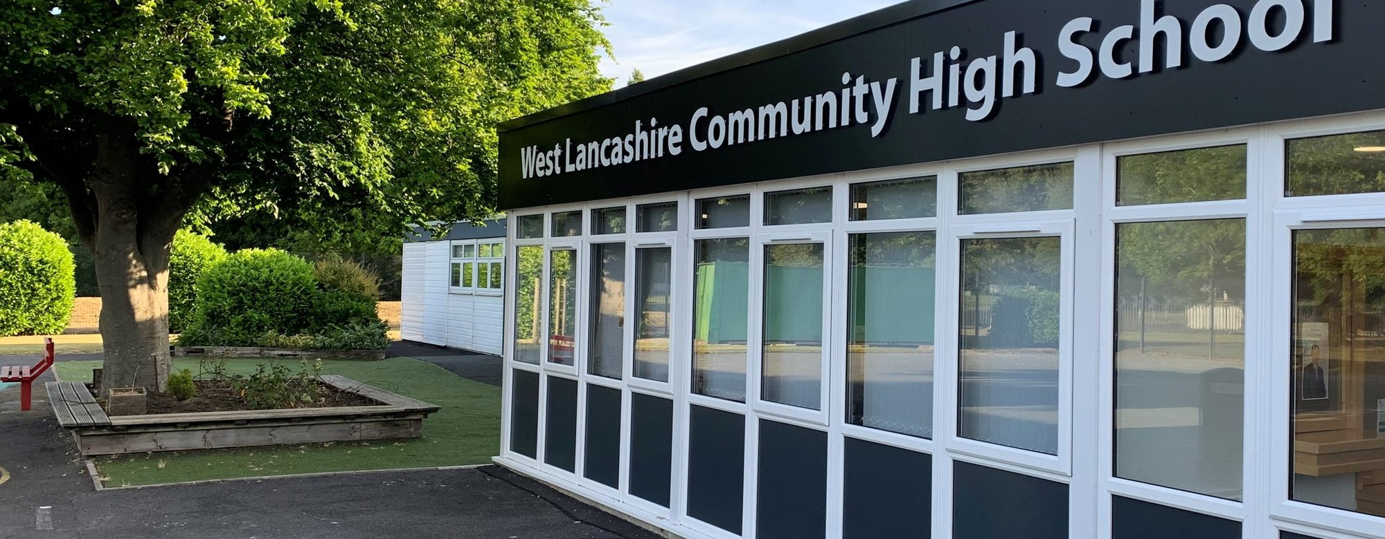
School Lane, Skelmersdale WN8 8EH
01695 721487
Welcome

Thank you for expressing an interest in the post of Teaching Assistant Level 1.
The Governing Body and Headteacher of West Lancashire Community High School are currently inviting applications to fill Teaching Assistant, Level 1 vacancies.
The hours are 25 per week, 9.30 am to 2.30 pm, term time (38 teaching weeks plus one week for INSET training). These are permanent posts.
The Teaching Assistant level 1 is a Grade 3 post, Scale points 3-4, £24,796 to £25,185 per annum (full time equivalent). If successful the salary received will be paid on a pro-rata basis which equates to a salary range of £14,579 to £14,807 per annum.
The role involves supporting students with generic learning difficulties, within a specialised environment. To support the classroom teacher, mainly concerned with the physical needs of students, will have a limited involvement in the supervision of directed set tasks, and care of students including those with special needs and in the preparation of resources and classroom organisation but will have greater involvement in the preparation of resources, basic record keeping and supporting the teacher with classroom organisation. It is envisaged that their contribution to the curriculum would be limited to ensuring the availability of resources, aids and materials. You will also assist in monitoring student progress and supporting them in their social, emotional and personal needs.
We are looking for individuals who;
• are enthusiastic and committed with a ‘can do’ attitude
• can work as part of a team
• can work effectively with students, parents and other school stakeholders.
• have the ability to motivate and inspire students to achieve
• are willing to promote our school values of respect, achieve, success and friendship.
The post is covered by the Rehabilitation of Offenders (Exceptions) Act 1975. If successful, you will be required to apply to the Disclosure and Barring Service for an Enhanced Disclosure. References will be sought for all applicants. We will always consider your references before confirming a job offer in writing.

The closing date for the post is 6th February 2026 at 9.00 am.
If you decide to apply for the post, please return the application form and letter by email to the School Business and Premises Manager: Business.manager@westlancs.lancs.sch.uk
We look forward to hearing from you in the near future.
Lee Fazackerley,
Headteacher
About us

West Lancashire Community High School is a vibrant generic learning difficulties school and has previously been inspected by Ofsted and rated good. Our students all have an Education Health Care Plan. We currently have 128 students on roll with numbers increasing, students are aged between 11 and 19 years. Our school is organised into three key stages/departments Key Stage 3, Key Stage 4, Key Stage 5.

At West Lancashire Community High School, we want our students and young adults to be the best they can be within an environment which challenges and supports. We focus upon academic, social and emotional development and progress but equally important to us is the development of independence skills to enable all to achieve, stand out as valued member of their communities and successfully meet the varying demands of an ever-changing society.

It is our dedication to achieving three core principles that allow us to develop students and young adults that are resourceful, resilient and that approach challenges with a ‘can do’, ‘nothing is impossible’ attitude. These are:

- Providing the highest quality of specialist teaching and learning experiences for all students and young adults
- Providing a curriculum that meets the needs and aspirations of all students and young adults
- Providing the highest standard of care, support and guidance to allow every student to achieve their aspirations.

We aim to provide an educational experience focused on improving education experiences and outcomes for all by:

- Developing well rounded individuals, that demonstrate greater resilience, determination and strength of character to succeed
- Equipping students and young adults with the skills to access increased opportunities and enhance their life chances
- Insisting on high expectations and challenge
- Developing an aspirational school community
- Engaging all parents and carers.

If you want to find out more about our school, please visit our website www.westlancs.lancs.sch.uk or contact the School Business and Premises Manager to arrange a visit: business.manager@westlancs.lancs.sch.uk

Job Description

JOB TITLE Teaching Assistant Level 1
GRADE Grade 3
RESPONSIBLE TO Classroom Teacher/Department Lead
STAFF RESPONSIBLE FOR N/A

PURPOSE
Under the teacher’s clear guidance to establish positive relationships with students and support the education, personal and social development of students in the class, within an establishment catering for children with special educational needs.

CORE TASKS
In addition to the following duties, the postholder may be required to undertake any of the duties normally associated with a lower graded Teaching Assistant post.

Support for Students
To meet the needs of student(s) in relation to welfare, hygiene, toileting, dressing, feeding and mobility.
To assist with movement around the school environment and during school activities.
To assist in the development of independent social skills.
To assist in the proper use of specialist aids and equipment.
To assist in the supervision of set tasks and integrated therapy for an individual/small group of students.
To accompany students on visits.
To administer basic first aid/paediatric first aid where appropriately trained.
To assist in the specific medical/care needs of students when specific training has been undertaken. In a special school, this may include complex medical needs.

Support for the Teacher
To assist in preparation of resources and tidying away.
To assist with the maintenance of classroom equipment ensuring it is kept in a clean and tidy condition and reporting damages.
To assist in monitoring, displaying and the removal of work displays.
To report students problems/achievements to the teacher as necessary.
To undertake photocopying and routine clerical duties.
To report student absence to the school's nominated person.
To report information from parents/carer as directed.

Support for the School
To assist in providing an atmosphere in which effective learning can take place.
To attend staff training/meetings where appropriate.
To work within school policies and procedures.
To take care for their own and other people's health and safety.
To be aware of the confidential nature of issues related to home/student/teacher/school work.
To assist with the supervision of student out of lesson times, including before and after school.

Support for the Curriculum
Ensure the availability of appropriate learning aids, materials and equipment.

OTHER DUTIES AND RESPONSIBILITIES
Undertake other duties in line with the role, as appropriate.

Equal Opportunities
We are committed to achieving equal opportunities in the way we deliver services to the community and in our employment arrangements. We expect all employees to understand and promote this policy in their work.

Health and Safety
All employees have a responsibility for their own health and safety and that of others when carrying out their duties and must help us to apply our general statement of health and safety policy.

Safeguarding Commitment
This school is committed to safeguarding and protecting the welfare of children and young people and expects all staff and volunteers to share this commitment.

Person Specification

Note: Candidates failing to meet any of the essential criteria will
automatically be excluded

Requirements | Essential (E) or  Desirable (D) | To be identified by:  Application form (A), interview (I), reference (R)
Qualifications  Relevant Child Care qualification (or equivalent) | D | A
Experience  Experience of working with or caring for children of relevant age | D | A, I
Knowledge/skills/abilities  Ability to relate well to children | E | A, I
Ability to work as part of a team | E | A, I
Ability to organise classroom resources | E | A, I
Good communication skills (oral and written) | E | A, I
Knowledge of classroom roles and responsibilities  Knowledge of the concept of confidentiality  Basic knowledge of First Aid/Paediatric First Aid  Ability to use relevant technology (e.g. video, photocopier)  Flexible attitude to work | D  E  D  D  E | A, I  A, I  A, I  A, I  A, I
Other  Commitment to undertake in –service development Commitment to safeguarding and protecting the welfare of children and young people  Satisfactory attendance record/commitment to regular attendance at work | E  E  E | A  A, I  R
Note: We will always consider your references before confirming a job offer in writing

APPLICATION FORM
The Application Form should be fully completed, addressing the criteria as outlined on the person specification and free from errors.

CONFIDENTIAL REFERENCES AND REPORTS
References should provide a strong level of support for relevant professional/personal knowledge, skills and abilities referred to above. | Essential
Positive recommendation from current employer | Essential

EVIDENCE CODES
Application form- A, Interview- I, Observation- O, Reference- R

