Look at the job adverts below and answer the questions evaluating each advert.

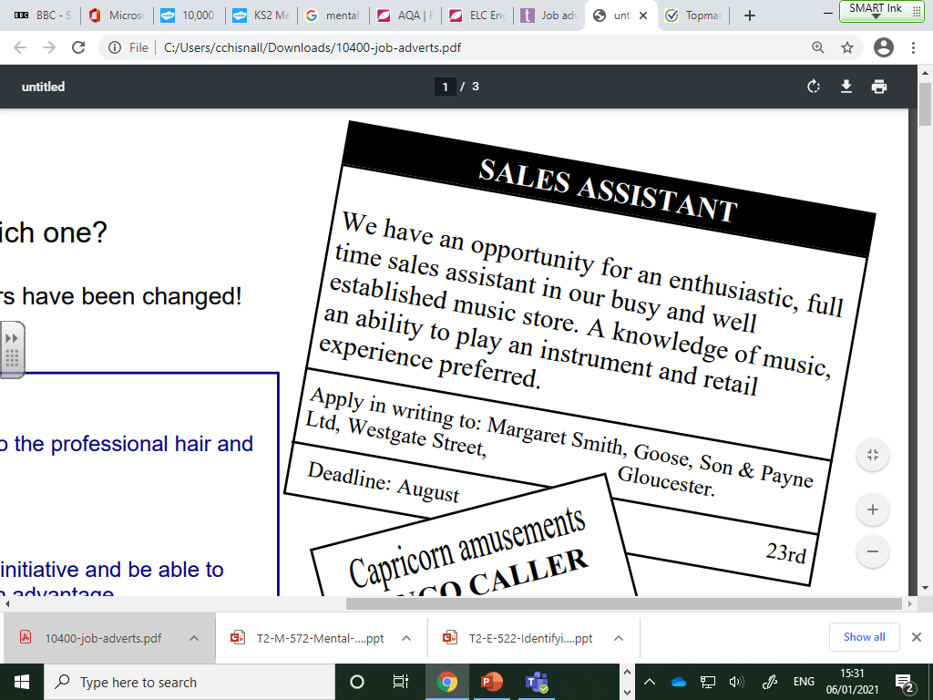

Circle or highlight the key information.

What information is missing? ______________________________

______________________________

______________________________

______________________________

How could it be improved? ______________________________

______________________________

______________________________

______________________________

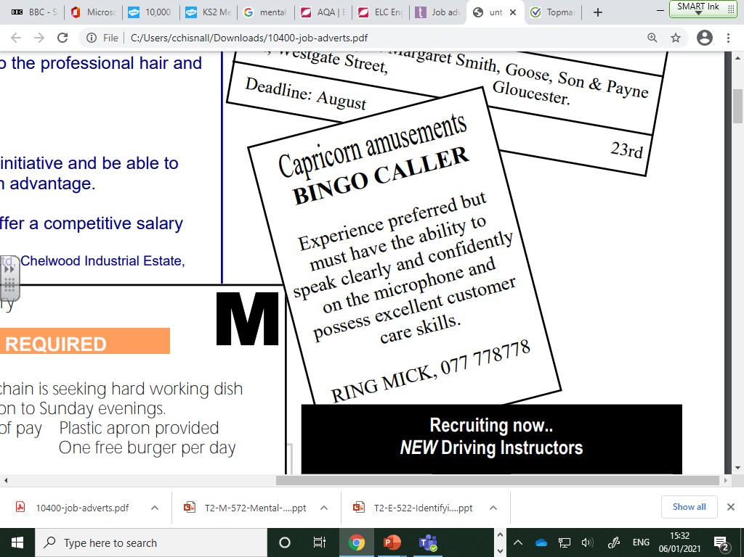

Circle or highlight the key information.

What information is missing? ______________________________

______________________________

______________________________

______________________________

How could it be improved? ______________________________

______________________________

______________________________

______________________________

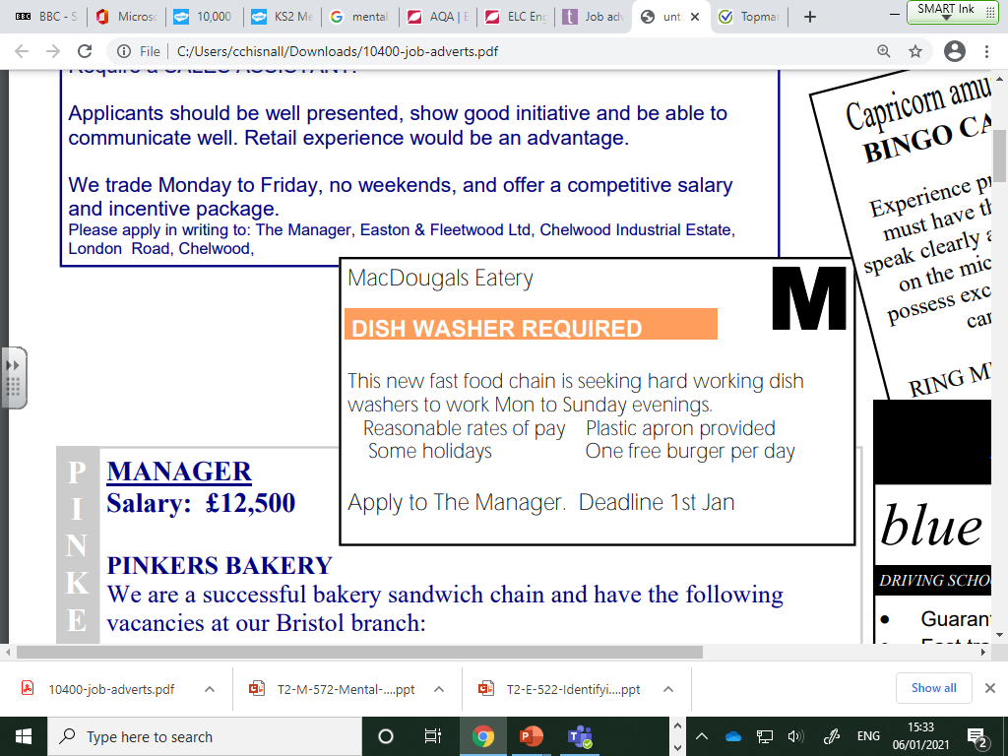

Circle or highlight the key information.

What information is missing? __________________________________________________

__________________________________________________________________________

How could it be improved? ____________________________________________________

__________________________________________________________________________

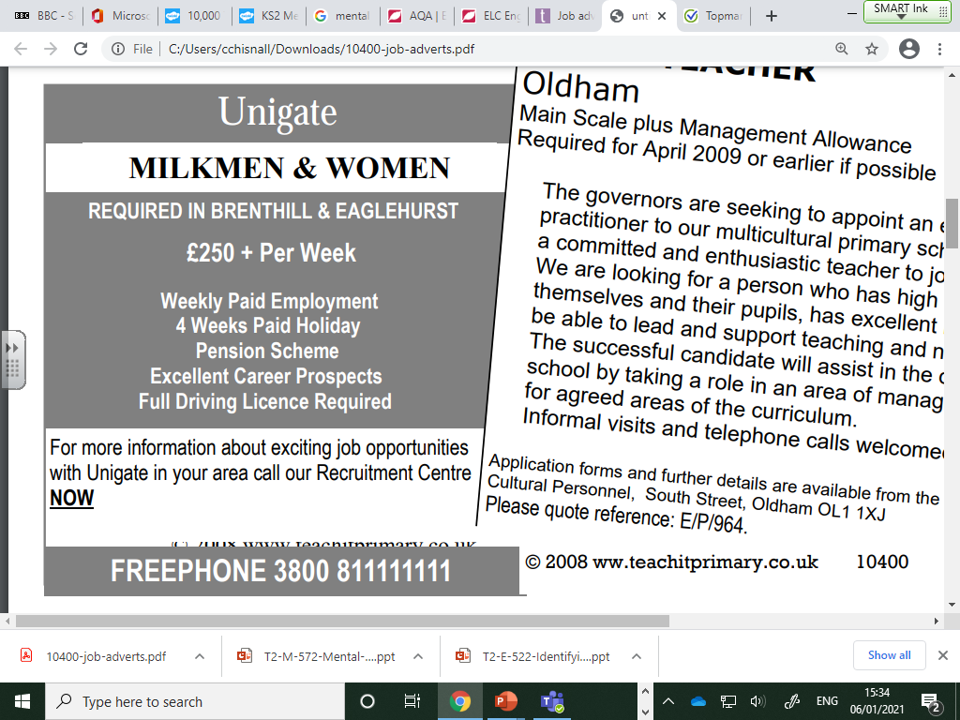

Circle or highlight the key information.

What information is missing? ______________________________

______________________________

______________________________

______________________________

How could it be improved? ______________________________

______________________________

______________________________

______________________________