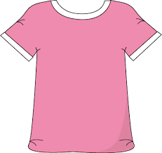
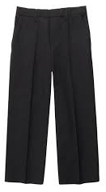
Dressing Skills Advice

General Principles:
For a child to be able to learn new skills the environment must be appropriate. It is important to think about possible distractions i.e. other people / children in the room, pictures on walls, toys on the floor or the bed, background noises and also any smells.

- Allow extra time for the child to be able to learn the new dressing technique(s). Progress at the child’s pace and give them lots of praise for practicing skills, even if they are not always successful at completing the task.
- Success for the child is important. Begin with breaking the dressing activity into small, straightforward steps. Tackle one step at a time and give help where needed e.g. help them to gather the garment to place it over their head.
- Undressing is usually easier to learn than dressing.
- Dress in front of a large mirror, as this will provide visual cues and use it to check all is correct before going out. This is often helpful for children who struggle with motor planning / body awareness.
- Follow a consistent sequence and technique when dressing:
- Clothes can be placed in a pile or laid out on the bed / floor, in the order in which they need to be put on.
- Follow the same technique for each garment, each time.
- Try not to watch the child all the time; the child may do more when left alone.

Activity Ideas:
- Play games where the child has to reach outside of their base of support without falling over. Practice in sitting or standing, depending upon the child’s skill level e.g. the child can try hitting a moving balloon in the air with their hands, without moving their feet (the child will be practicing trunk rotation, eye hand coordination skills and balance skills).
- Play body awareness games such as Simon Says; try adding in directions such as “Simon says touch both hands to your left foot” or “Simon says squat down and touch the floor”. If Simon Says is difficult for the child, play a game where they copy your actions / movement sequences. Move your body a certain way i.e reach your right arm behind your back and then the child will try to match your actions exactly.
- Try doing art and craft projects which involve ripping paper / card, which can help to increase hand strength (needed when managing fastenings or tying shoelaces).
- Paper weaving, constructional toys, lacing games are all activities to try regularly with your child as they help develop the fine motor skills needed when dressing / undressing.
- Obstacle courses – practicing concepts of under, over, around and through. Try copying these in a set sequence.
- Play catch or kick a ball with each other. Simple games of catching, throwing and kicking include many of the underlying skills necessary for learning how to get dressed. When catching a ball, a child brings his hands to midline (skill needed for unzipping, buttoning, etc.). When throwing a ball, a child rotates the trunk and brings their arms across midline during the follow through phase (skill needed to reach for socks and shoes). When kicking a ball, a child has to momentarily stand on one foot while the other side of the body is moving (skill needed for getting pants on and off in standing).
- Velcro - Pulling against heavy duty Velcro is another great hand strengthener. Try using Velcro to make file / folder games, or making other fun Velcro fine motor tasks!
- Rolling Pins - grasping, pushing, and rolling with a rolling pin are all great ways to strengthen hands and fingers. Try it on play dough, bubble wrap, or during cooking activities.
- Cooking - kneading dough, rolling it within hands, stirring the mix, scooping and cutting.
- Practice with scrunchy bobbles: picking them up and stretching them and placing them over ankles (this can help children learn the skills required for putting on socks).
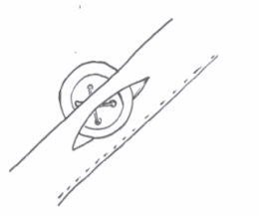

Buttons:
- Ideas to help with fastenings include button boards, play cubes, cloth button or popper books.
- Practice putting things through slots, starting with a posting box / piggy bank or other narrow slots to push pennies or buttons through.
- Push things through slots where you can see it, and handle it, as it goes in one side and comes out the other.
- Lacing cards and stringing beads build the concept of pushing through and pulling out
- To get extra fabric out of the way, create a strip of buttons and button holes, or cut off the panel of buttons, button holes and the collar off of an old shirt.
- Try ‘backwards chaining’: this is when you model the steps in the process and the child does only the last step, then the last 2 steps and so forth, until they have mastered it all!
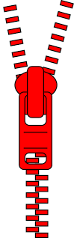
- When buttoning with the garment on the body, it is often easier to align the buttons at the bottom of the shirt and button from
bottom to top
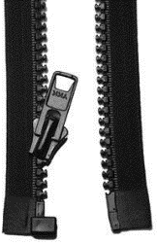
- Button in front of a mirror. This is especially helpful for managing the top shirt / blouse button.

Zips:
- Practice zipping / unzipping attached zippers first, such as those that are on backpacks, purses or pants.
- For ‘separated’ zips, such as those on jackets, show child that there is a slot under the zip by passing a pipe cleaner through it. Have the child practice pushing and pulling the pipe cleaner through that narrow slot.
- Try ‘backwards chaining’: this is when you model the steps in the process and the child does the last step, then the last 2 steps and so forth, until they have mastered it all!

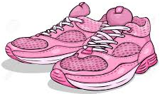
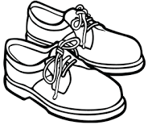
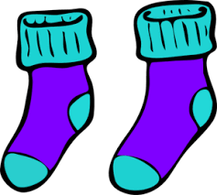

Socks / Shoes:
- Place a small toy / object of interest inside the sock or shoe and see if the child can feel it, grab it, and pull it out.
- Slippers - another great way to practice putting on and taking off shoes is to start with slippers! They are softer, less rigid, and easier to get on and off , but still require the same movements and a little bit of strength too.
- Planning how to reach the feet while maintaining a stable position is challenging for some children. To make it easier and to give them a more stable base get the child to:
  - sit on a chair or the last step on the stairs and cross one ankle over the opposite knee
  - lie on their back, bend one knee and have the foot flat on the floor and then cross the other leg over the bent knee to bring the foot closer in. These positions place the foot in a position that is closest to the child's reach and field of vision.
- "Backwards chaining" is helpful for both socks and shoes: this is when you model the steps in the process and the child just does the last step, then the last 2 steps and so forth, until they have mastered it all.
- Shoes and socks that is slightly too large for the child will be easier to begin practicing with.
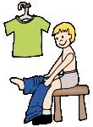
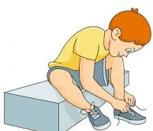
- Practice tying bows with ribbon or pipe cleaners (as this is less likely to slip) or practice tying their dressing gown cord around their waist.

Positioning:
- Ensure that the child is sitting in a stable position, e.g. on the floor, sitting on a chair or on a firm bed with their feet supported. Some children may sit better in a corner where both walls give added support. Alternatively stand against a wall.
- Sit next to, in front of, or directly behind the child during the dressing activity, in order to guide the child through the task.
- Instead of automatically correcting a mistake, get the child to look (maybe in a mirror) and feel if all is correct. Then encourage them to identify and sort out what needs to be done e.g. buttons not all completed, need to zip their trousers up.

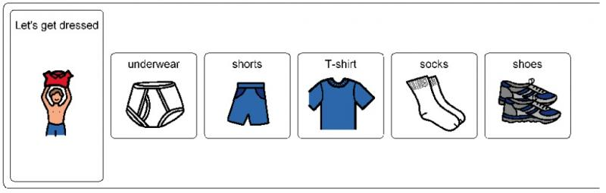
Putting clothes on in the correct order and the correct way round:
- To organise dressing and get things on in the right order, get your child to lay out their clothes in order of what comes first.
- Practice sequencing dressing by making picture cards of the process and get the child to arrange them in the right order.
- Get your child to lay their clothing out and turn it over so it is face down before putting it on. Clothing with patterns or pictures on the front is easier to practice with.
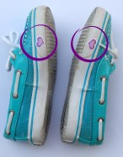
- Put a mark on the inside of the hem, or on the label to remind your child which is the back.
- To get shoes on the right feet put a coloured dot or mark inside or outside the shoe where your child can see it e.g. put a red dot inside the right shoe so your child can remember their red / right foot goes in the red right shoe or put marks on both shoes that need to be joined together to get the shoes ready for putting on

Judith Ann Cookson
Independent Specialist Occupational Therapist

Devised by: JAC (OT) June 2020. To be reviewed in May 2022.

