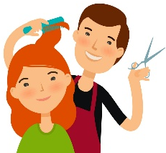

Hair Washing / Cutting - Tips for the Hypersensitive Child

Because of the high amount of unfamiliar and unpredictable sensations involved in getting a haircut/wash (in movement, touch and sound), the following strategies may help the hypersensitive/over-responsive child prepare for and therefore be more accepting of getting a haircut:

- Schedule the haircut / wash at a time of day when the child is most relaxed and calm.

- Visit or meet the barber / hairdresser before the haircut.

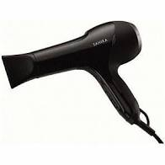
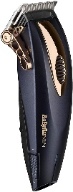
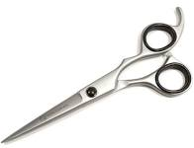
- Introduce the child gradually to the ‘tools’ used in haircutting, such as the soft ‘shaving’ brush, clippers, hairdryer, combs and the scissors, etc.
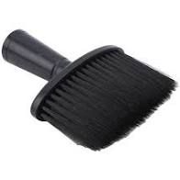

- If the child is bothered by noise, use ear buds / plugs to reduce the level of sound stimuli.

- Go with a haircut that can be done in the least amount of time possible with the fewest number of tools. It is much more important that the child has a positive experience with a “so-so” haircut rather than having a perfect trim.

- Try using proprioceptive / calming techniques prior to the hair cut / wash - massage the head and give deep pressure input to head and shoulders prior to the appointment. The increased proprioceptive input to their head and shoulders will provide a calming effect, enabling them to better tolerate the multisensory environment of the hairdressers / barbers and the touch encountered during hair cutting.

- Avoid tipping the head backwards as this can cause balance issues.

- Use an eye guard or goggles during hair washing if the child dislikes water in their eyes.
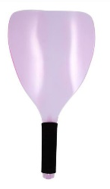
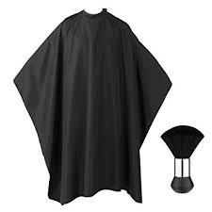

- Use a hair cape to avoid any loose hair falling onto the child and causing irritation.

- Brush off any loose hair immediately after cutting using firm pressure (or use a dryer to blow off the hairs if the child prefers).

- Take a ‘distracter’ to use during the haircut, such as a hand held electronic game, book or music player to focus the child’s attention on something of interest.

- Talk calmly to the child about topics of interest to help divert their attention.

- Make a picture card sequence of a haircut, so they know what to expect.

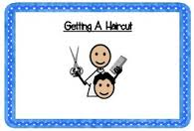

- Use a social story to help your child become more familiar with the hair cut process.

- Bring a chewy snack / chewlery for the child, to help keep them calm.

- Ask the stylist / barber to use firm brush or comb strokes and press down on top of head and shoulders while cutting hair.

- When drying the hair use a low / warm setting on the hairdryer.

- Teach the child a ‘stop’ signal to use, such as holding up a hand. If the child signals to stop, then stop immediately.

- Using a timer may help the child feel confident that the haircut will end shortly.

- At the end of the visit, use calming strategies to regulate any increase in arousal level i.e. walk home wearing weighted backpack and / or cap.

Judith Ann Cookson
Independent Specialist Occupational Therapist

