Tooth Brushing - Sensory Advice

There may be many different reasons for a child’s dislike or avoidance of tooth brushing. There may some oral defensiveness i.e. hypo-responsiveness/under-reactivity or hyper-responsiveness / over-reactivity.

Hypo-responsive children are those who cannot sense / feel what is happening inside their mouth and this sometimes results in the child over stuffing their mouth or drooling excessively. They tend to develop a lot of anxiety with anything to do with their mouth.

Hyper-responsive children are extra aware of the sensations in their mouth and this can result in them being picky with foods, having problems with food textures and refusing to brush their teeth. Oral sensations can be perceived as being painful to the child.

The child may also struggle with the additional sensory demands placed on them in the bathroom while teeth brushing i.e temperature, lighting, colour, clutter, smells, background noise of extractor fans, flooring texture on their feet etc.

Activity Advice / Strategies

Environment
- Keep the bathroom area clutter free.
- Store tooth brushing tools and materials so they are easily accessible for the child.
- Consider the level of lighting the child prefers.
- Consider the temperature of the room – do they prefer it hot/cold/warm?
- Does the child need a mat to stand on if they are sensitive to the flooring material?
- Do they need a raised platform to stand on to reach the sink more easily?
- Use a mirror - this might help the child feel more in control. Visually being able to see what they are doing can help reduce stress and anxiety.
- Try tooth brushing in a different location if they are struggling to be in the bathroom. Look for a space where they feel comfortable such as their bedroom or sitting in their favourite chair.

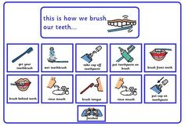
Sequence
- Establish a clear routine for when the child’s needs to brush e.g. before breakfast / bedtime.
- Ensure the child knows the tooth brushing process / sequence.
- Provide the child with a visual schedule.
- Brush your teeth alongside the child or have another sibling brush their teeth with them so they can follow what needs to be done.

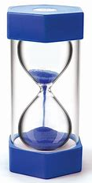
Timing
- Give a clear indication of the time to spend on teeth brushing.
- Use a timer e.g. sand timer or a mobile phone countdown.
- Play a familiar, short song throughout the process. When the song is over, the tooth brushing ends.
- Give a clear signal when to stop.

Toothpaste
- Start without toothpaste initially until they get used to the sensation of the toothbrush in their mouth and the technique of brushing.
- Introduce toothpaste to the brush in small amounts initially; building up to the full amount needed to clean teeth effectively.
- Toothpaste that foams a lot can be an issue for some children, so choose a brand carefully.
- Try changing their current brand of toothpaste to a flavour they enjoy. (Some children do not like the taste of peppermint and describe it as being ‘painful’ or ‘like a burning sensation’).
- If other flavours are not tolerated, try a flavourless/non-foaming toothpaste e.g. OraNurse.

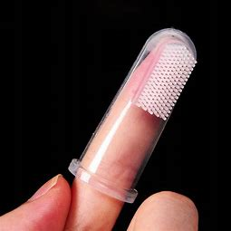
Toothbrush
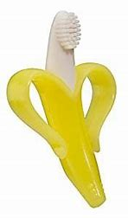
- Consider the toothbrush bristles and how these may affect the child’s responses.
- Begin with a finger toothbrush so they feel more in control.
- Try with a softer brush or silicone bristles (seek advice from your dental practitioner).
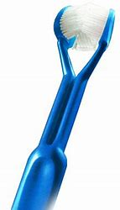
- Consider using a 3-sided toothbrush such as this cleans faster and gets all 3 sides of teeth done with just one brushing stroke.
- The child may cope better if they use an electric versus a manual toothbrush, depending on their level of sensory arousal. Feeling the vibrations may create a more tolerable and enjoyable experience (usually more effective with under-responsive or sensory seeking children).
- Alternatively trial a sonic u-shaped automatic brush.
- Also consider if the child prefers to have the toothbrush wet first or not and if so, what temperature of water do they prefer.
- Allow the child to hold the toothbrush while you gently guide his/her hand, as tolerated.

Sensory & Equipment
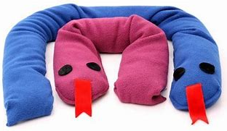
- Prepare the child before tooth brushing using deep pressure proprioceptive touch to their arms, upper body and progress towards the face.
- Desensitise the child’s mouth – following instructions from your therapist.
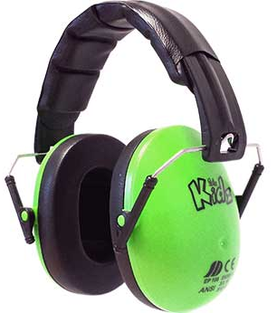
- Try using a weighted blanket / shoulder snake around the child’s shoulders to help calm their nervous system as they brush and for a short period afterwards.
- Try using ear defenders, noise cancelling headphones or ear buds if they dislike the sound of brushing or the electric toothbrush.
- Wearing compression clothing may also help calm the child during the brushing process.

When considering the best tools / materials and techniques to use with your child it is also recommended that you consultant your child’s own dentist.

The above information is a general guide to supporting your child’s oral hygiene but if your child has ongoing problems with their dental care please contact your child’s dentist for advice.

Judith Ann Cookson
Independent Specialist Occupational Therapist

