War Horse Adjectives

Write 3 adjectives next to the pictures to describe what you can see, feel, smell, hear or touch. Then come up with a sentence underneath which includes your adjective.

___________________________________________________

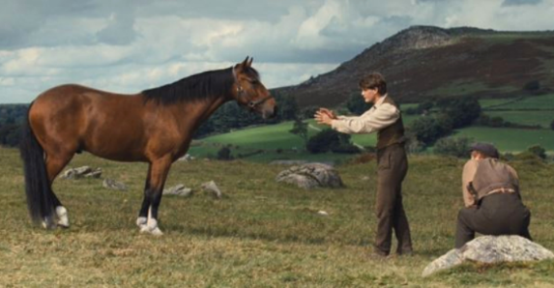
_________________________________________________________________________________________________________

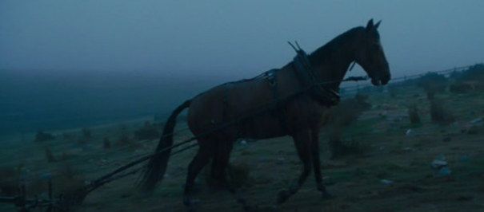
___________________________________________________

_________________________________________________________________________________________________________

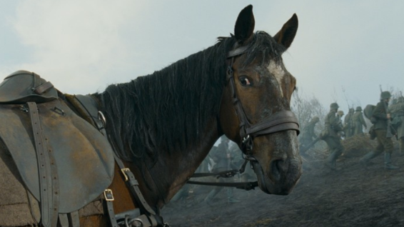
___________________________________________________

_________________________________________________________________________________________________________

Challenge

Write a sentence about a character in warhorse that includes adjectives.
_________________________________________________________________________________________________________

