Lunch Crunch – What’s My Name?
Finish the table by filling in the type of food (fruit or vegetable) and the foods name. Use the pictures and clues to help you:
Picture | Type  F/V | Description | Origin | Hint | What’s My Name?
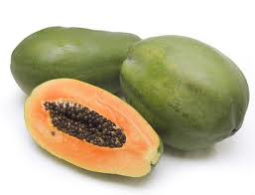 |  | Amber orange in colour, contains numerous dark seeds | South America | Used to treat cuts, rashes, stings and burns in many countries
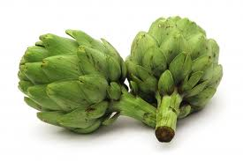 |  | Arching, deeply lobed green leaves | Egypt and North Africa | Has spiky triangular scales
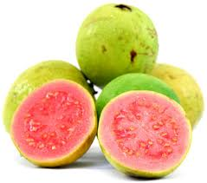 |  | Comes in a variety of colours including yellow, maroon and green | Mexico, Central America and Caribbean | Often prepared as a dessert
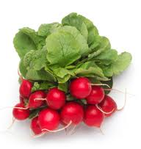 |  | Edible root, usually red | Europe | A member of the turnip family
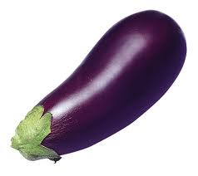 |  | Elongated with dark purple skin and a bitter taste | India | Also known as an aubergine
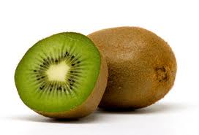 |  | Fuzzy brown skin with soft green inside | China | An edible berry also known as the Chinese Gooseberry that was renamed after the New Zealand national bird
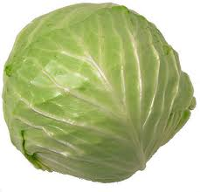 |  | Leafy green plant made of a short stem and massive leaves | Mediterranean | Also known as bowkail
 |  | Long stout with stems and feathery foliage | Europe | Catharine de Medici made this a fashionable snack in France
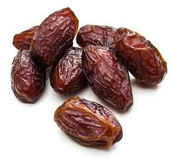 |  | Oval shaped, colour ranges from bright red to yellow | Iraq, Arabia and Morocco | Can take four to five years to grow
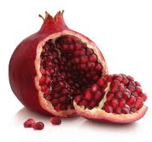 |  | Round and pretty bright red | Iran and Himalayas | A berry with over 600 seeds and grows well in droughts

