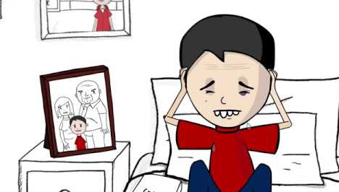
Adverse Childhood Experiences (ACEs)

What are ACEs?
Childhood experiences have a massive impact on lifelong health and opportunity.

Adverse childhood experiences (ACEs) refer to stressful or traumatic events that children and young people can be exposed to as they are growing up. ACEs range from experiences that directly harm a child, such as physical, verbal or sexual abuse, and physical or emotional neglect, to those that affect the environments in which children grow up, such as parental separation, domestic violence, mental illness, alcohol abuse, drug use or imprisonment. There is however a distinction between ‘normal’ stressful life events, such as parental divorce or illness of a loved one, and adverse childhood experiences, very traumatic life events, such as being or seeing someone else physically or sexually abused. These are experiences that will often be associated with post-traumatic stress disorder.

West Lancashire Community High School trains our staff via our Continued Professional Development programme to recognise and understand the impact of ACEs, effectively respond to students, mitigate and reduce trauma supported by the implementation of trauma-informed policies and procedures

Please click on the link below to watch the ACES video.

https://youtu.be/XHgLYI9KZ-A

Please click on the link below for Free ACEs training course for Parents and Carers.
https://www.acesonlinelearning.com/
We are ALL responsible for keeping our children safe, healthy and happy.

