We have been working on circuits this half term. I would like you all to complete a circuit at home and keep record of your achievements. Complete each exercise for 1 minute and ask an adult or count aloud how many you do. Can you improve your score each time?
Click on this link to follow a warm up https://www.youtube.com/watch?v=aW_JqSK-CgY
Exercsise | Set 1 (1 minute) | Set 2 (1minute) | Set 3(1 minute)
Sit ups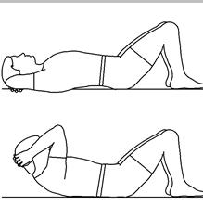
Star jumps
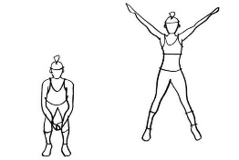
Squats
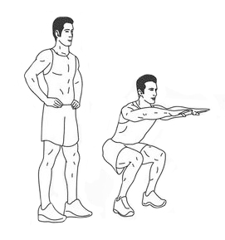
Plank
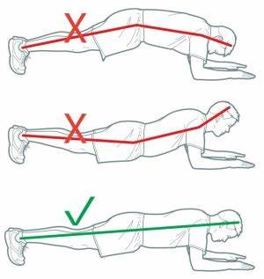
High knees
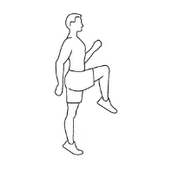
Push ups
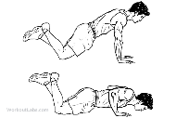
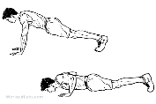
level 1 level 2

What did you do well today?

What could you improve?

