Name ___________________________________

Date ___________________________________

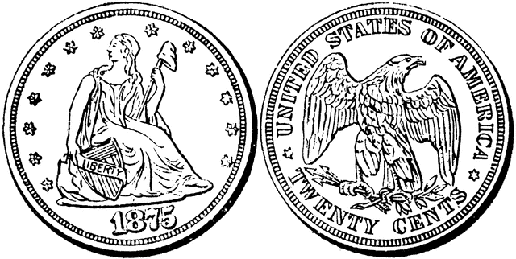
Two Sides of the Same Coin!
Division is the inverse of multiplication

LO:
I can use inverses to multiply and divide.
I can work out divisions by using my knowledge of multiplication number facts.

If you know that 6 x 3 = 18 then, you know that 18 ÷ 6 = 3

and that 18 ÷ 3 = 6

- Make 2 division sentences from these multiplications. Look at the example
9 x 5 = 45 45 ÷ 9 = 5  45 ÷ 5 = 9 | 9 x 7 = 63 ÷ =  ÷ =
8 x 6 = 48 ÷ =  ÷ = | 8 x 7 = 56 ÷ =  ÷ =
5 x 7 = 35 ÷ =  ÷ = | 6 x 7 = 42 ÷ =  ÷ =
9 x 6 = 54 ÷ =  ÷ = | 6 x 5 = 30 ÷ =  ÷ =
- Multiply the following numbers and then make 2 division sentences.

3 x 2 = 6 6 ÷ 2 = 3  6 ÷ 3 = 2 | 3 x 4 = ÷ =  ÷ =
5 x 6 = ÷ =  ÷ = | 3 x 7 = ÷ =  ÷ =
5 x 3 = ÷ =  ÷ = | 2 x 7 = ÷ =  ÷ =
9 x 3 = ÷ =  ÷ = | 5 x 6 = ÷ =  ÷ =

Successful criteria:

I could make division sentences from multiplications at least 10 times.

