


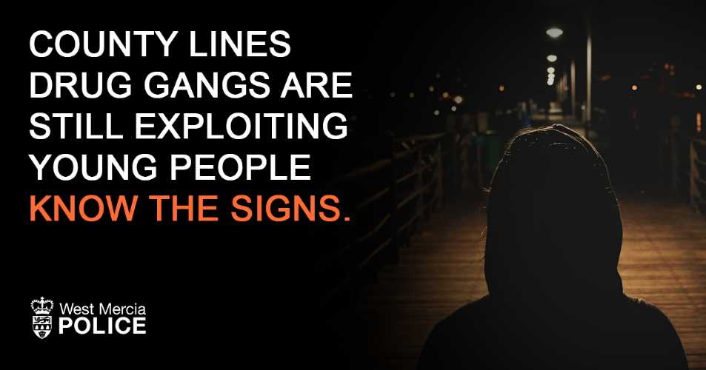

Parents Against Child Exploitation (Pace) UK are running free webinars to support parents affected by county lines and child criminal exploitation.
Parents and Carers can learn from the panel of experts what criminal exploitation is, how to spot signs it may be happening their child and how to seek help.
The interactive webinar will also give the audience the opportunity to ask questions, share concerns and connect with others.

• Learn what county lines is
• Understand what is happening in your local area
• Understand the signs that your child might be at risk
• Learn how offenders groom and exploit children
There are several dates throughout 2026 into 2027

Please click on the link below :
https://paceuk.info/for-parents/parentwebinars/

