Dear Parents and Carers, welcome to February’s Safeguarding letter

**Snapchat –‘MY AI’**

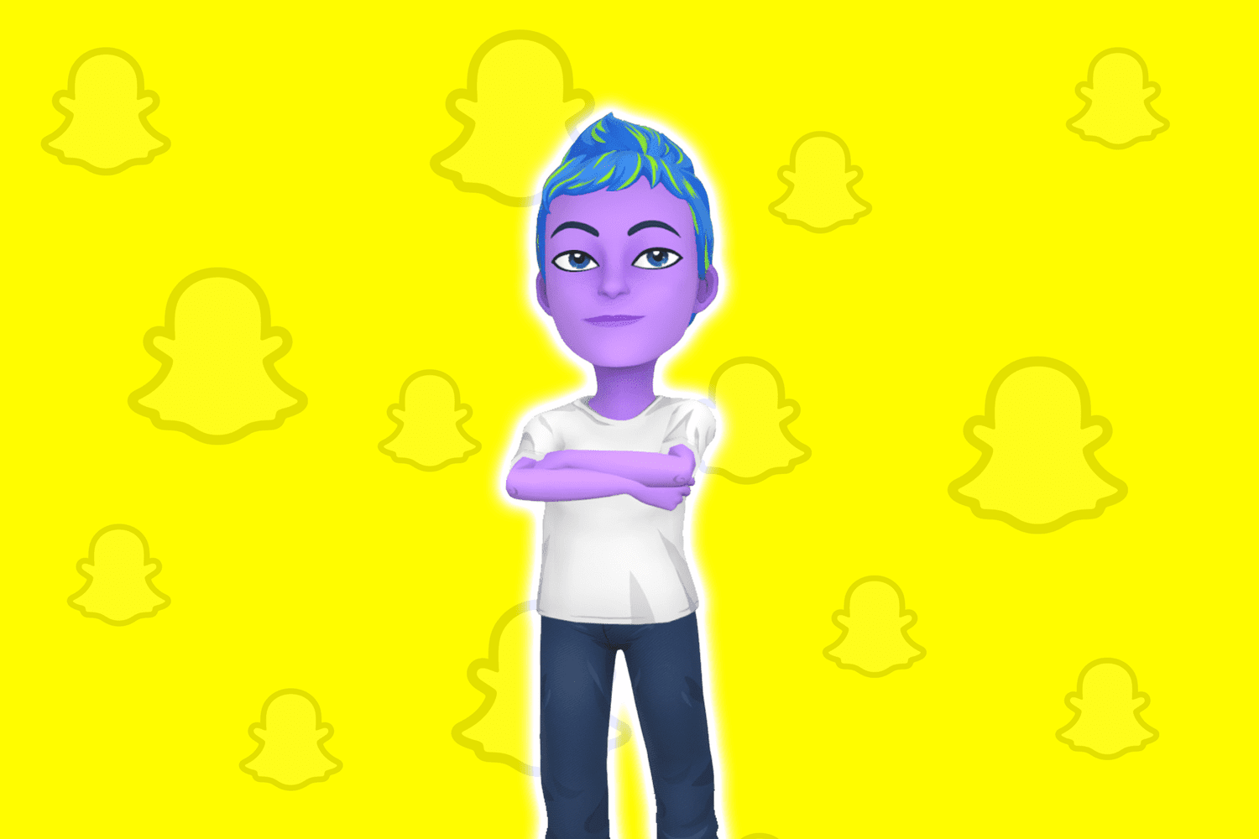

According to the Snapchat, website, My AI is an experimental, friendly, chatbot currently available to users, designed to be a ‘personal sidekick’.

This can be confusing for many of our students who may think that they are sharing their thoughts with a real person. We are unsure what happens to the information that may be shared with this ‘digital friend’ so we would recommend at this stage that My AI and other AI driven chat products is removed from your child’s Snapchat account.

Please note: ‘My AI’ may answer incorrectly or provide biased answers.

1. If you want to remove My AI you can do this, but you have to subscribe to Snapchat Plus.
2. Once subscribed you swipe right from the camera screen to bring up the chat screen and then press and hold on My AI.
3. Next, tap 'Chat Settings' followed by 'Clear from Chat Feed' to get rid of it.

Regards Andrew Grant -DSL [deputy@westlancs.lancs.sch.uk](mailto:deputy@westlancs.lancs.sch.uk)