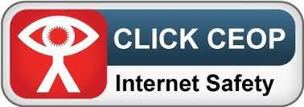 Dear Parents and Carers, welcome to September’s Safeguarding letter

**CEOP**

Returning to school is a happy time for Most of us. However, we must be mindful that whilst children get back to the classroom their safety once again is the top of our agenda.

The same threats that were there in the last days of July, still remain, particularly online.

The Child Exploitation and Online Protection Centre (CEOP) has released a series of pages on their site providing training, resources and information to professionals and carers.

To find out more please follow the link below

<https://www.thinkuknow.co.uk/parents/>

Mr Grant is our CEOP Ambassador, please feel free to ask for advice or if you have any questions or need advice.

**Please don’t forget that we are here to help with advice you can speak to Mr. Grant**

**01695-721487**

**deputy@westlancs.lancs.sch.uk**

Regards Andrew Grant -DSL