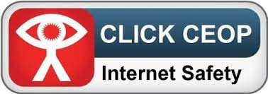
Dear Parents and Carers, welcome to September’s Safeguarding letter
CEOP

Returning to school is a happy time for most of us. However, we must be mindful that whilst children get back to the classroom their safety once again is the top of our agenda.
Re: Online safety please follow the links below .
The Child Exploitation and Online Protection Centre (CEOP) has a series of pages on their site providing training, resources and information to professionals and carers.
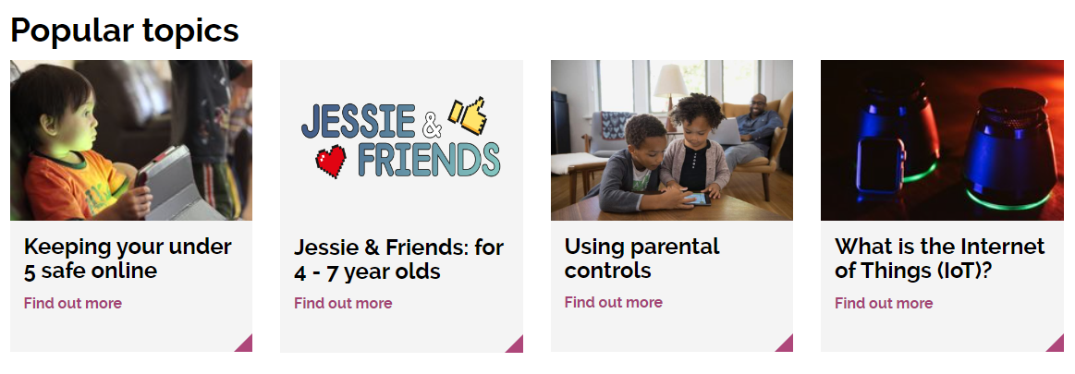
To find out more please follow the link below
https://www.thinkuknow.co.uk/parents/
Mr Grant is our CEOP Ambassador, please feel free to ask for advice or if you have any questions or need advice.
01695 721487
deputy@westlancs.lancs.sch.uk

Please don’t forget that we are here to help with advice you can speak to Mr. Grant
01695-721487
deputy@westlancs.lancs.sch.uk
Regards Andrew Grant -DSL

