LO: To be able to describe what characters are like from their actions.
Task
Listen to chapter 1 of The Lion, the Witch and the Wardrobe.
Cut and stick words next to each character to describe them.

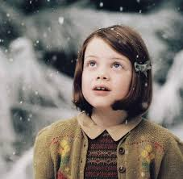
Lucy

Edmond

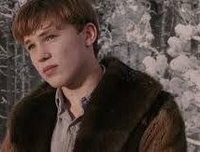
Peter

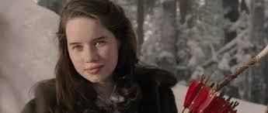
Susan

Words to cut and stick

Gentle Brave

Mean Cheerful

