LO: To be able to infer what characters are like from their actions.

**Task**

Read chapter 1 of The Lion, the Witch and the Wardrobe.

Write down words to describe each character and the evidence from the text to back up your answer.

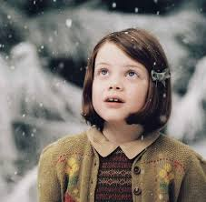Lucy

Edmond

Peter

Susan