The Lion, the Witch and the Wardrobe  What is Mr Tumnus like as a person? |  | 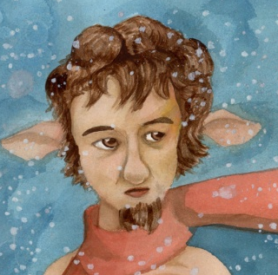
Mr Tumnus is… | Clues from the text:

