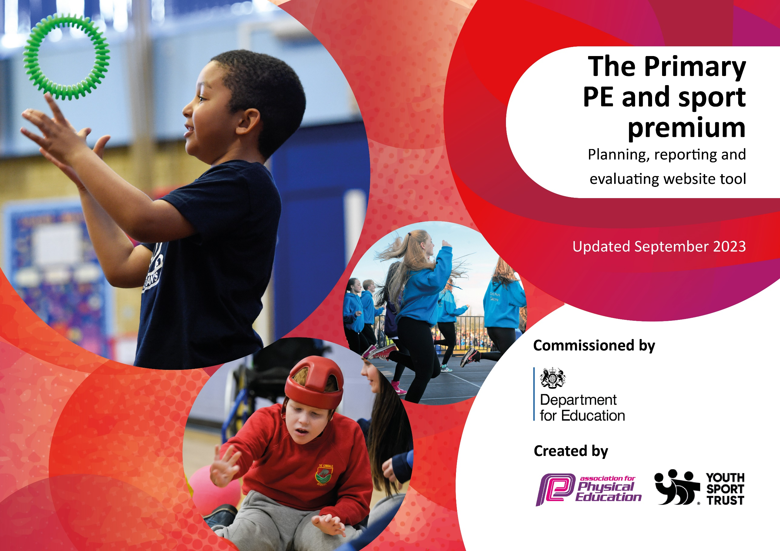

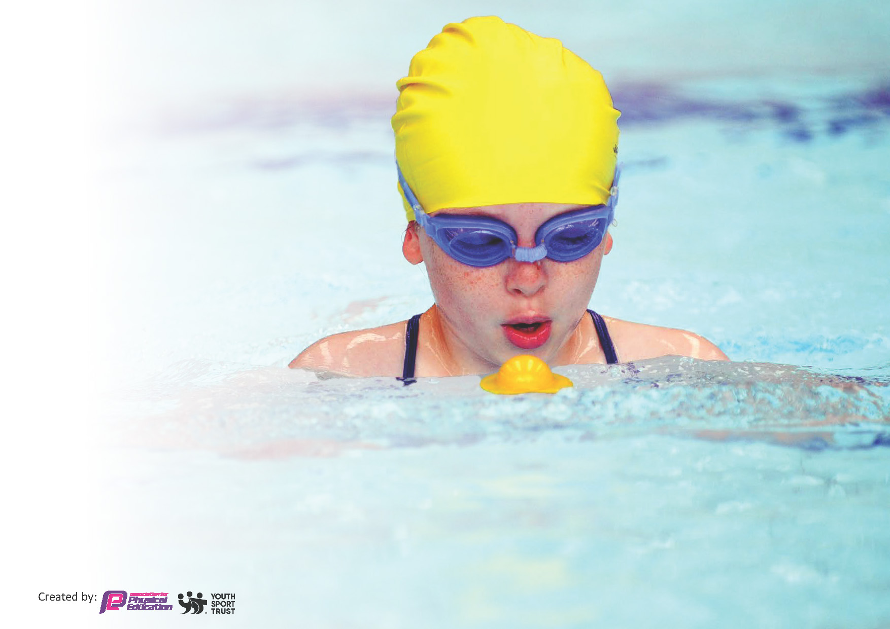
This template can be used for multiple purposes:
by:
- It enables schools to effectively plan their use of the Primary PE and sport premium
- It helps schools to meet the requirements (as set out in guidance) to publish information on their Primary PE and sport premium
- It will be an effective document to support Ofsted inspections enabling schools to evidence progress in Physical Education (PE) and evidence swimming attainment, which forms part of the PE National Curriculum. We would recommend schools consider
the Intent, Implementation and Impact of any spend, as examined within the Education Inspection Framework.

It is important that your grant is used effectively and based on school need.

Schools must use the funding to make additional and sustainable
improvements to the quality of the PE, School Sport and Physical Activity (PESSPA)
they offer. This means that you should use the Primary PE and sport premium to:

- Build capacity and capability within the school to ensure that improvements made now will benefit pupils joining the school in future years
- Develop or add to the PESSPA activities that your school already offers.

The Primary PE and sport premium should not be used to fund capital spend projects; the school’s core budget should fund these. Further detail on capital expenditure can be found in the updated Primary PE and sport premium guidance.

The Primary PE and sport premium guidance, outlines 5 key priorities that funding should be used towards. It is not

necessary that spending has to meet all the key priorities, you should select the priorities that you aim to use any funding towards.

Although completing this template is not a requirement for schools, schools are required to publish details of how they spend this funding. Schools must also outline what the impact this funding has had on pupils’ PE and sport participation and attainment and how any spending will be sustainable in the future. All funding must be spent by 31st July 2025.

The Department for Education has worked closely with the Association for Physical Education (afPE) and the Youth Sport Trust (YST) to develop this template and encourages schools to use it. This template is an effective way of meeting the reporting requirements of the Primary PE and sport premium.
Review of last year’s spend and key achievements (2023/24)

We recommend you start by reflecting on the impact of current provision and reviewing your previous spend.

Activity/Action | Impact | Comments
- Continue to improve extra-curricular clubs for all groups of children. This year we would like to offer a variety of clubs suitable for the needs of our children.  - Develop the curriculum map to include sport-related sessions.  - Playtime leaders  - Competitive school teams to be formed by the end of the year.  - All staff to use the RealPe assessment wheel. | - More children have participated in after school clubs this year. We have targeted after-school clubs to offer to a range of groups.  - The long term plan and curriculum map have been adapted to make sure the RealPE sessions link to a sport of some kind.  - Playtime leader were given training by external visitors. They ran groups for the Ks1 pupils during lunchtimes to help with their 60 active minutes.  - To help raise the profile of PE in the community and for our school.  - PE Lead will be able to track gaps in PE and to make sure all pupils are progressing in sports. | - We offered a large range of clubs this year which have shown a lot of engagement. PP children were offered a after school club free of charge.  - Teachers were able to plan ahead and choice when they will deliver the RealPe aspect and the sport aspect of PE. (3 weeks RealPe and 3 weeks sports or 5 weeks RealPe skills and 1 big sport game at the end)  - All the year 6 playtime leaders have really enjoyed the opportunity.  - Due to time and staff we have struggled to accommodate specialist clubs for competitive teams.  - Due to a new RealPe assessment tool coming out in September staff have been relucent to use the old assessment tool due to confidence.

Key priorities and Planning
This planning template will allow schools to accurately plan their spending.

Action – what are you planning to do | Who does this action impact? | Key indicator to meet | Impacts and how sustainability will be achieved? | Cost linked to the action
PE SLA (Livewire membership) For PE CPD and links for competitions and events.  Provide adequate time and resources for staff to engage with the school’s PE curriculum/scheme (RealPE) so that they know and understand what is to be taught.  Allocate sufficient dedicated leadership time to ensure that the subject lead of PE is up to date with new changes and that staff are supported. Time for CPD to be introduced to staff to help develop and implement new strategies.  Staff to take responsibility for teaching PE in 2023/2024, adapting and evaluating each lesson and completing the assessment tool.  Introduce 60 active minutes during playtimes. Using playleaders and MDAs.  Continue to offer a variety of extracurricular clubs and opportunities to improve the engagement of our pupils in physical activity and sport.  Updated equipment and new resources to make sure each class has a full set of equipment that is safe to use.  To further develop the profile of Westbrook Old Hall by creating displays to show our sporting superstars and to celebrate their achievements. Share these successes on the school website and on social media platforms. | All staff and the PE lead  All staff and the PE lead  All staff and the PE lead  All staff and the PE lead  Midday assistants/ year 6 pupils as playleaders and KS1 pupils to start with.  All pupils.  All pupils.  All pupils and the wider school community. | Key Indicator 1: Increased confidence, knowledge, and skills of all staff in teaching PE and sport.  Key Indicator 1: Increased confidence, knowledge, and skills of all staff in teaching PE and sport.  Key Indicator 1: Increased confidence, knowledge, and skills of all staff in teaching PE and sport.  Key Indicator 1: Increased confidence, knowledge, and skills of all staff in teaching PE and sport.  Key indicator 2: The engagement of all pupils in regular physical activity – the Chief Medical Officer guidelines recommend that all children and young people aged 5 to 18 engage in at least 60 minutes of physical activity per day, of which 30 minutes should be in school.  Key indicator 2: The engagement of all pupils in regular physical activity and sport.  Key indicator 2: The engagement of all pupils in regular physical activity and sport.  Key Indicator 3: raising the profile of PE and sport across the school, to support whole school improvement. | Primary teachers are more confident to deliver effective PE supporting pupils to undertake extra activities inside and outside of school.  Pupil attainment will increase due to teaching staff’s knowledge and understanding of the curriculum /scheme.  Increased knowledge for the subject leader resulting in better outcomes for pupils. The delivery of lessons will improve due to staff recognising support from the PE lead and delivering high quality physical education.  Improved percentage of teaching staff teaching PE on a weekly basis. As a result, staff confidence improves.  The more pupils meeting their daily physical activity goal, more pupils encouraged to take part in PE and Sport Activities.  Improved attendance at extracurricular clubs with more children engaging in regular physical activity (recognised through parental feedback).  The more pupils meet their daily physical activity goal, the more pupils are encouraged to take part in PE and Sport Activities.  Increased number of social media/website posts sent out promoting physical education, school sport and physical activity. | £3696 – Livewire membership for specialist CPD.  £695 – RealPE subscription and for high quality CPD opportunities.  Assessment tool subscription.  £1000 - Supply cover for PE lead and Staff  As part of RealPE subscription.  £4935 new equipment suitable for KS1 children. Tubs to organize resources.  Coach to come in and train the Year 6 pupils as playleaders and MDAs.  £1782 – Annual coaches for after school clubs.  £2000 on new equipment to replace old and broken resources.

Hold a high-profile Sports day inviting all parents/carers to the event. Sharing success with them on social media.  Organise further whole-school events, including inter and intra competitions throughout the 2023/24 academic year.  Further improve and enhance our extra-curricular provision by offering a wider range of sports (including orienteering)  Improve the systems used to collect and analyse the participation data so that we can better target specific groups of children and identify gaps in our provision.  Provide outdoor and adventurous opportunities to pupils across the school as well as Year 6 pupils.  Offer swimming lessons to a wide range of year groups to help close the gaps in society. Allow top-up lessons to help create confident swimmers by the time they leave in year 6.  Further develop whole school intra-competitions using the new house point system.  Continue to engage in inter-school competitions provided by Livewire, WASSP and Liverpool football academy.  Develop links with local schools in order to provide more opportunities for all pupils to participate in competitive sports.  Provide opportunities for our vulnerable pupils, including SEND pupils, to participate in competitive sports during the ability days at livewire. | The whole school community  Pupils  Pupils  PE lead and pupils.  Pupils  Pupils  Pupils  Pupils from our school community and other schools.  Pupils from our school community and other schools.  Pupils | Key Indicator 3: raising the profile of PE and sport across the school, to support whole school improvement.  Key Indicator 3: raising the profile of PE and sport across the school, to support whole school improvement.  Key Indicator 4: offer a broader and more equal experience of a range of sports and activities to all pupils  Key Indicator 4: offer a broader and more equal experience of a range of sports and activities to all pupils  Key Indicator 4: offer a broader and more equal experience of a range of sports and activities to all pupils.  Key Indicator 4: offer a broader and more equal experience of a range of sports and activities to all pupils.  Key Indicator 4: offer a broader and more equal experience of a range of sports and activities to all pupils.  Key indicator 5: increase participation in competitive sport.  Key indicator 5: increase participation in competitive sport  Key indicator 5: increase participation in competitive sport | Reports of positive impacts collected via pupils/parents/staff voice.  Improved number of inter and intra competitions offered to the children. All pupils participate in some form of competition.  Improve numbers to engage in a wider range of sports resulting in an increased percentage achieving their daily physical activity goal.  More groups of children participating in sports and physical activity.  More pupils from across the school engage in residential trips and/or outdoor and adventurous activities  More pupils from across the school engage in swimming lessons and top up, resulting in improved percentages of attainment in swimming and water safety.  More pupils from across the school participate in competitive sport, resulting in improved outcomes, attitudes and participation.  An improved number of events are attended resulting in a higher proportion taking part in competitive sports.  Improved links results in more opportunities for pupils to engage in competitive sport.  Increased participation numbers for all groups of children including SEND. Creates better attitudes towards a healthy active lifestyle. | £1200 - transport costs to sports events/competitions.  £950 – Orienteering hub subscription.  As part of Orienteering hub subscription.  As part of Livewire membership for specialist CPD.  As part of Livewire membership for specialist CPD.

Key achievements 2023-2024
This template will be completed at the end of the academic year and will showcase the key achievements schools have made with their Primary PE and sport premium spending.

Activity/Action | Impact | Comments
- To continue to improve the delivery of high-quality physical education by completing 1 hour of PE each week for all year groups. The curriculum is to be developed through teachers, staff training and improved resources.  - Children access more regular physical activity through active play at lunchtimes. To introduce play leaders and develop their confidence and skills to deliver active play.  - Continue to deliver a wide range of extracurricular clubs suitable for all groups of children. Attending ability days delivered by WASSP and livewire. Participate in as many competitions as possible to help raise the profile of the school.  - Completed the School Games Mark  - We have completed awareness days this year to help the pupils to understand why these groups of participants might need further support.  - Attended lots of competitions delivered by WASSP and Livewire. | Each class has continued to access their 1-hour PE lessons each week on the school timetable. The long-term plan explains they are a mixture of Real PE/Gym, alongside a Games based  Lessons. Which feeds into PE provision at Great Sankey High School.  This also accommodates Swimming provided by external coaches.  We have upcoming training booked in for our play leaders. Dave Ansell is booked in to train.  Each year group has participated in at least one sports competition this year through intra/inter competitions. This has given pupils the opportunities to represent their school. SEND and vulnerable groups has experiences the ability days involving a range of sports the pupils have never done before. Specific after school clubs for PP groups.  This year we have focused on the key activities we need to complete in order to achieve a school game mark. We have successfully achieved the Platinum award.  We raised the profile of equality in sport (Women’s football). We created a day all about women’s sports and completed a whole school tournament involving all the girls.  We also had an Olympic athlete in school to challenge the pupils to a sponsored circuit challenge. The pupils were delighted to meet a real Olympic athlete and they were so inspired by them.  Pupils have loved attending different competitions and have performed very well. In the Football and Rugby competitions they have got through all the way to the finals. This has encouraged children to start new clubs and given them the passion to continue being physically active. | Reported through staff voice – RealPE is a great tool to help build staff’s confidence when teaching PE. They know they are delivering a high quality PE lesson when the children can explain what they have learnt and why. All the children can access PE and it is easily adapted to suit the needs of the children in their class.  Reported through pupil voice – All the children who have been out to competitions have all said they have enjoyed the experience and would love to attend more competitions.  With support from WASSP and Livewire we have been successful when attending events/competitions. This has benefited the children as they have gained new experiences and will now be looking out for more sporting opportunities.  Here at Westbrook Old Hall, the pupils love to be a part of such passionate organisations and enjoy helping to make as many people aware as possible.  The pupils are proud of how hard they have worked to achieve great successes.

Swimming Data
Meeting National Curriculum requirements for swimming and water safety.
Priority should always be given to ensuring that pupils can perform safe self-rescue even if they do not fully meet the first two requirements of the National Curriculum programme of study

Question | Stats: | Further context  Relative to local challenges
What percentage of your current Year 6 cohort can swim competently, confidently and proficiently over a distance of at least 25 metres? | 63.6% | By the end of Year 5, 43 pupils were able to show they can swim competently and confidently over a distance. 19 pupils were still at KS2 beginner plus stage at the end of year 5.
What percentage of your current Year 6 cohort can use a range of strokes effectively [for example, front crawl, backstroke, and breaststroke]? | 60.0% | 43 pupils could confidently swim all 3 strokes over a distance. 19 were still at the beginner stage.

What percentage of your current Year 6 cohort are able to perform safe self-rescue in different water-based situations? | 49.1% | 27 pupils were new to swimming at the beginning of Year 4. They are currently on the KS2 improver level by the end of Year 5.
If your schools swimming data is below national expectation, you can choose to use the Primary PE and sport premium to provide additional top-up sessions for those pupils that did not meet National Curriculum  requirements after the completion of core lessons. Have you done this? | No | This has not been an option this year via Livewire.
Have you provided CPD to improve the knowledge and confidence of staff to be able to teach swimming and water safety? | Yes | After attending the PE conference and they shared the swimming update the PE lead shared it with all the staff who were attending swimming lessons with their class. They were then asked to read the guidance again before starting their lessons.

Signed off by:

Head Teacher: | Mary Lythall-Brennan
Subject Leader or the individual responsible for the Primary PE and sport premium: | Emma Steele PE Subject leader and class teacher.
Governor: | Jennifer Tinsley
Date: | 16th July 2025

