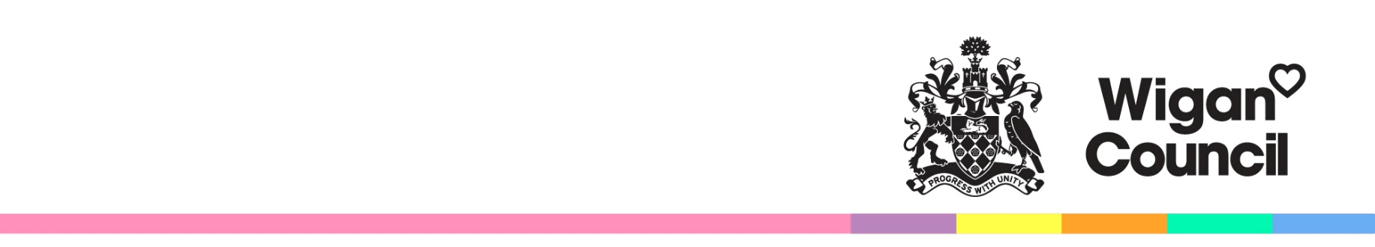
Consultation on Admission

Arrangements 2027/28

The Westleigh School

Admission arrangements include the admission number and oversubscription criteria which are used to decide on the allocation of school places.

The Shaw Education Trust is currently consulting on proposed changes to the admission arrangements for The Westleigh School for 2027-28.

The Trust are seeking to reduce Published Admission Number (PAN) from 210 to 180 for admission to the school in Year 7, in September 2027.

Changes to the admission arrangements for the school may affect parents and carers applying for places from 2027 onwards. This is your opportunity to comment on proposals before admission arrangements for 2027-28 are determined.

Details are available by accessing the school admissions consultations page at www.wigan.gov.uk/Consultations

Responses are invited from:
- parents with a child aged between 2 and 18 years old
- local community groups
- other interested persons
The consultation lasts for six weeks. Responses must be submitted to Wigan Council no later than 16 January 2026. Responses will be considered by the admission authority for each school.

Have your say –
- using the web form on the consultation webpage
- by email to consultation@wigan.gov.uk
- by writing to: Consultation, School Organisation Team, People Directorate, Wigan Council, PO Box 100, WN1 3DS.

If you are unable to view the consultation online you can request a paper version or other format by contacting the School Organisation Team on 01942 489013.

