

**Attendance Policy**

**The Westleigh School**

|  |  |
| --- | --- |
| **Date** **effective** **from** | 1st September 2024 |
| **Date** **of** **next** **review** | 1st September 2025 |
| **Review** **period** | Termly |
| **Status** | Statutory |
| **Person responsible** | D. Nicholls |
| **Date ratified by Governing Body** | December 2024 |
| **Version** | 4 |

Contents

Contact Details 3

Introduction and Aim 3

Legal Duty 4

School commitment 4

Recording attendance 5

Procedure 5

Communication between Parents/Carers and School 6

Absence monitoring 6

Early Identification and Intervention: assess, plan, do, review 6

Medical absence 7

Absences due to Medical Appointments 8

Lateness and punctuality 8

Unauthorised absence 8

Application for leave of absence 9

Religious observance 9

Enforced school closure 10

Monitoring arrangements 10

Links with other policies 10

Appendices 11

Appendix 1: Leave of Absence During Term Time Request Form 11

Appendix 2: Attendance codes 13

Appendix 3: Attendance and absence data 14

Appendix 4: CME referral form 15

# Contact Details

**The name and contact details of the senior leader responsible for the strategic approach to attendance in our school is:**

Name: Daniel Nicholls

Contact Details: daniel.nicholls@westleigh.set.org

**The name and contact details of the school staff member pupils and parents should contact about attendance on a day-to-day basis is:**

Name: Sarah Scotson

Contact Details: sarah.scotson@westleigh.set.org

**The name and contact details of the school Attendance Officer that pupils and parents should contact for more individual support with attendance:**

Name: Zoe Bramwell

Contact Details: zoe.bramwell@westleigh.set.org

**We are committed to ensuring that systems and processes are in place regarding promoting attendance and would encourage parents to make contact with school as soon as possible if they have any concerns about their child**.

# Introduction and Aim

The Westleigh School recognises the importance of good attendance and the impact it has on children’s progress, attainment, enjoyment of learning and relationships within school. Good attendance helps children to realise their potential and ensures they are motivated, confident, and able to enjoy a diverse range of curricular opportunities and experiences. Children must attend school every day during term time unless an exceptional circumstance applies.

Our school policy and prospectus promote good attendance, which is recognised and rewarded as an achievement. The school monitors attendance to ensure quick and early intervention if a problem is identified. We recognise that whole school preventative and proactive approaches are key to promoting the children’s wellbeing and attendance.

Our policy is accessible to leaders, staff, pupils, and parents, and is published on our school website. It will be sent to parents with any initial information when pupils join the school, and they will be reminded of it at the beginning of each school year. Parents/Carers will be informed if any updates are made to this policy.

The school recognises that barriers to attendance evolve quickly and as such this policy will be reviewed and updated as necessary. This Policy is based on the premise of equal opportunities for all.

# Legal Duty

The law entitles every child of compulsory school age to an efficient, full-time education suitable to their age, aptitude, and any special educational need they may have. It is the legal responsibility of every parent to make sure their child receives that education either by attendance at school or by education otherwise than at school.

Regular and punctual attendance at school is essential to enable children to maximise their educational attainment, opportunities, and further development.

Relevant Legislation and Legal Background:

• Section 7 of the Education Act 1996 states that ‘*The parent of every child of compulsory school age shall cause him/her to receive efficient full-time education either by regular attendance at school or otherwise*’.

• Section 444 (1) of the Education Act 1996 states that ‘*if a child of compulsory school age who is a registered pupil at a school fails to attend regularly at the school his parent is guilty of an offence*’.

• Section 576 Education Act 1996 stipulates that for the purposes of Education Law, parent includes:

* All biological parents, whether they are married or not.
* Any person who, although not a biological parent, has parental responsibility for a child or young person - this could be an adoptive parent, a step-parent, guardian or other relative.
* any person who, although not a biological parent and does not have parental responsibility, has care of a child or young person. This could be one parent, both parents and/or carers.

# School commitment & Attendance Vision

Everyone in school is committed to promoting the importance of good attendance and punctuality.

We will support pupils and parents to achieve good attendance and punctuality, and we will work closely with parents where absence is a cause for concern.

The Westleigh School strives for 100% attendance for all pupils. The whole school attendance target is **94%**.

We are committed to promoting a positive and welcoming atmosphere in which all pupils feel safe, secure, and valued. We will ensure that attendance is monitored effectively and reasons for absences are recorded promptly and consistently.

We will work with all pupils and their parents to maximise attendance and where necessary, we will put in place additional support and adjustments. If required we will engage additional support from wider services and external partners, making timely referrals.

**Our Attendance Approach:**

The Westleigh School is proudly recognised as an Inclusive Attendance school. Our unwavering commitment to attendance centres around child-centric actions, evidence-informed practices, and a shared understanding of everyone's roles and collective responsibilities to promote exceptional attendance.

**Inclusive Attendance Professional Development Model**

Our attendance approach is fundamentally guided by the Inclusive Attendance professional development model. Comprising six tailored Learning Modules, this model empowers us to deepen our understanding by facilitating continuous professional learning for all staff. Within this model, the four domains of practice ensure the provision of professional learning, professional development, evidence-based practices, and exemplary leadership and management to seamlessly integrate theory into practice.

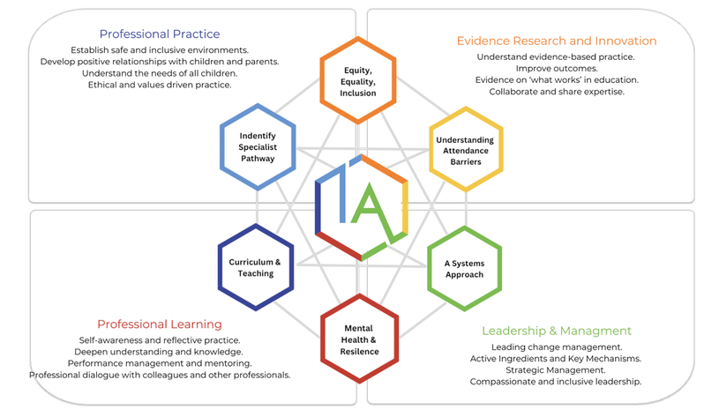

**Multi-Tiered System of Support**

To guarantee a comprehensive approach to attendance, we implement a Multi-Tiered System of Support. A Multi-Tiered System of Support (MTSS) for school attendance involves three tiers of intervention, with roles for teachers, the school, children, parents, and external agencies – including the Local Authority.  Data-driven decision-making and training requirements are pivotal to the implementation of the system.  The system aligns with the Department for Education's (DFE) "Working Together to Improve School Attendance" guidelines.

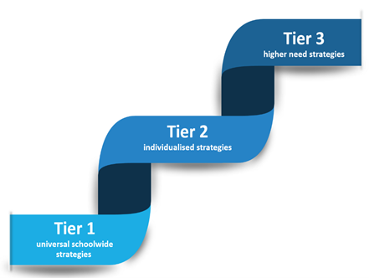

**Tier 1 - Universal Approach: Establishing a baseline universal attendance approach that benefits all children.**

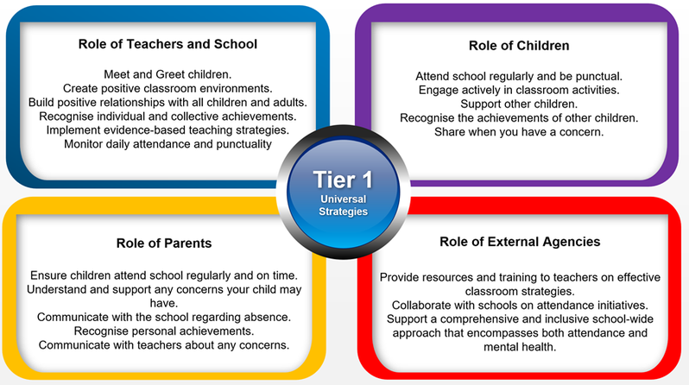

**Tier 2 - Individualised Strategies and Early Help Support: Tailoring strategies to individual needs and providing early help support for persistent attendance challenges.**

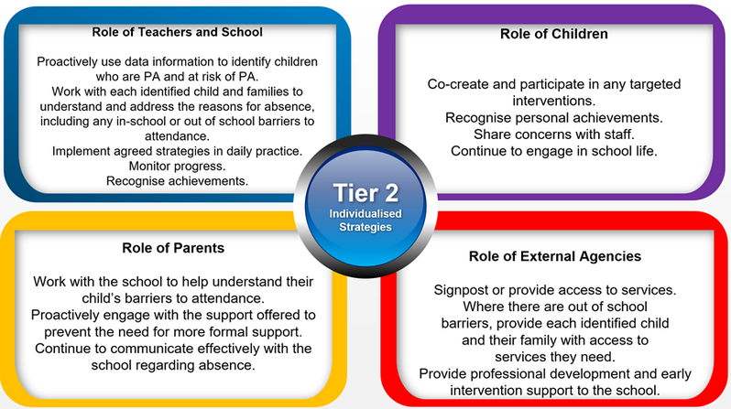

**Tier 3 - Higher Needs Strategies Support: Furnishing specialised support for children, young people, and families with complex attendance requirements, including access to external agency support when necessary.**

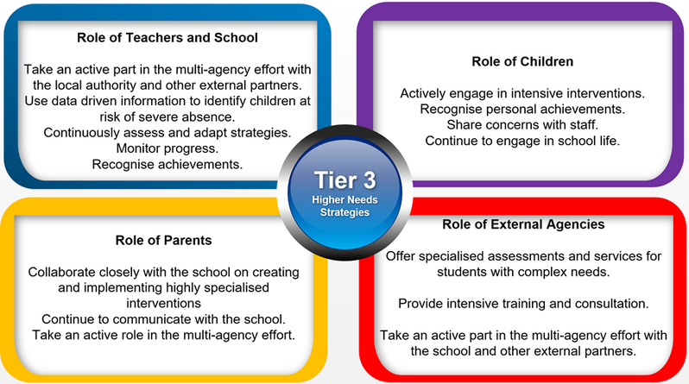

**The Importance of School Attendance**

School attendance is not merely a requirement but a fundamental pillar of education. It plays a pivotal role in shaping academic success, personal growth, and future prospects, making it an indispensable aspect of any educational system.

* *Academic Achievement:* Regular attendance directly correlates with academic success. Children who attend school consistently are more likely to keep up with the curriculum, perform better in exams, and improve their life outcomes.
* *Knowledge Acquisition:* School is where children acquire knowledge and skills that are crucial for their personal and professional growth. Missing days means missing out on valuable learning opportunities.
* *Social Development:* School provides a vital social environment for children and adolescents to interact with peers, develop friendships, and learn essential social skills. Consistent attendance ensures children remain connected to their peer group.
* *Building Routine:* School attendance establishes a structured routine in children’s lives, teaching them time management and responsibility, which are valuable life skills.
* *Teacher Interaction:* Regular attendance allows for meaningful teacher-child interactions. Teachers can provide personalised support, address questions, and assess individual progress more effectively when children attend regularly.
* *Preventing Knowledge Gaps:* Frequent absences can lead to significant knowledge gaps, making it challenging for children to catch up with missed lessons, potentially resulting in long-term academic struggles.
* *School Engagement:* Children who attend school regularly are more likely to engage in extracurricular activities, sports, and other enriching experiences that contribute to their overall development.
* *Legal and Parental Responsibility:* Parents or guardians are legally responsible for ensuring their child's regular school attendance. Failing to do so can lead to legal consequences.
* *Community Well-being:* High levels of school attendance contribute to the overall well-being of communities.

**Recognition-Based Approach**

Our attendance philosophy is rooted in a recognition-based approach that recognises both personal and collective achievements. This approach serves to thwart isolation, prevent victimisation, cultivate positive environments, nurture relationships, foster inclusivity, and ultimately cultivate intrinsic motivation among our children, families, and staff.

**Attendance Extravaganzas & Streaks 2024/25**

As attendance is high priority at The Westleigh School, we have introduced added rewards and incentives around positive attendance to school. All students are encouraged to engage in our half-termly attendance extravaganzas and reward ‘streaks’ for positive attendance. These activities are born from student voice and celebrated widely across school each time.

# Recording attendance

We will keep an attendance register and place all pupils onto this register. We will take our attendance register at the start of the first session of each school day and once during the second session. During both the first and second session we will record whether each pupil is:

* + Present
  + Attending an approved educational activity.
  + Absent; or
  + Unable to attend due to exceptional circumstances.

The school will follow up any absences to:

* Ascertain the reason for absence.
* Ensure the proper safeguarding action is taken.
* Identify whether the absence is approved or not.
* Identify the correct code to use before entering it on to the school’s electronic register, or management information system as a priority and returned to the school office in a timely manner. This is used to download data to the School Census.
* Consider early identification, assessment, intervention, and support processes that may need to be implemented.

The register is marked using the codes as advised by the Department for Education (DfE) ‘Working together to improve School Attendance Guidance’ (for maintained schools, academies, independent schools, and local authorities), for further information, please visit -

[Working together to improve school attendance (applies from 19 August 2024) (publishing.service.gov.uk)](https://assets.publishing.service.gov.uk/media/65f1b048133c22b8eecd38f7/Working_together_to_improve_school_attendance__applies_from_19_August_2024_.pdf)

# Procedure

Children are expected to attend school regularly, unless there is good reason for absence.

There are two types of absence:

* Authorised (where the school approves a pupil absence)
* Unauthorised (where school will not approve the absence)

The school has a duty to safeguard all pupils. If a child is absent, the parents/carers must inform the school on the first day of absence and each following day of absence, stating the reason.

Parents/Carers should phone school on the morning of the first day of absence and each following day of absence unless it has been agreed by school that this is not necessary if the absence is or likely to be long term.

Parents should call our attendance team, who are responsible for the day-to-day monitoring of attendance and will work with the pastoral team and wider staff to support attendance.

In the event a child is absent from school and the parent/carer has not notified the school of the absence, the school office will contact home as soon as possible. If no contact is established or the reason for absence is not accepted, the absence will be deemed unauthorised. Should contact be established later with parent and a reason for absence is provided, the school may amend this to authorised if they are satisfied with the reason given.

# Communication between Parents/Carers and School

Communication between parents/carers and the school is extremely important as this enables us to ensure that children are supported and feel settled in school. If your child is absent, you must inform the school immediately in line with the procedure as outlined above.

As a school we recognise that building respectful relationships with families and working in collaboration is essential to ensuring the best outcomes for children/young people. We require all parents to actively support the work of the school, including promoting attendance and engagement. We are committed to ensuring that systems and processes are in place with regards to promoting attendance and would encourage parents to make contact if they have concerns about their child.

In the event there is a persistent lack of engagement by parents, we may seek to secure engagement and school attendance through formal legal procedures.

# Absence monitoring

School robustly monitors and analyses attendance data to promptly identify and address possible concerns. This allows for early interventions to support the child/family’s underlying needs.

This monitoring will include:

* Weekly attendance code analysis
* Weekly analysis of types of persistent absence
* Specific cohort and group monitoring – particularly for vulnerable groups i.e. children with a social worker

Absence monitoring allows the school to use data to identify individuals who need support and to work towards reducing persistent and severe absence. In doing so we will consider the individual needs of pupils and their families who have specific barriers to attendance.

# Early Identification and Intervention: assess, plan, do, review.

Every pupil has a right to a full-time education and The Westleigh School sets high attendance expectations for all pupils. The Westleigh School will consider the individual needs of pupils and their families who have specific barriers to attendance.

For any child / young person who is absent from school, it is essential to fully understand the reasons for this so that targeted, evidence-based interventions and support can be put into place. All staff have a part to play in promoting attendance. We recognise the importance of ensuring that key members of staff from across the school, including class teachers, attendance, pastoral and SEND staff work in collaboration to consider and identify the holistic needs of the child/young person and to overcome barriers to attendance. In accordance with the principles of early intervention, a graduated approach of assess, plan, do and review will be followed, utilising a range of school-based resources, evidence-based interventions and seeking advice and support from external services at an appropriate stage, where required.

Appropriate assessments will be important to help understand the underlying reasons that may be contributing to attendance difficulties. This may be an assessment that focuses on the individual child’s needs and will include the views of the child/young person as well as parents/carers and identify strengths (what is working well) and needs (what is working less well).

Assessments undertaken may identify that a child/young person is experiencing underlying emotional based needs that are contributing to non-attendance. As a school we will access appropriate guidance developed by Wigan Local Authority in respect of this: Emotionally Based School Attendance – best practice tool. This is a whole school framework with a graduated approach to support the early identification and intervention of children/young people who may struggle to cope in school/attend school.

Information from assessments will inform a SMART (Specific, Measurable, Achievable, Realistic, Targets) action plan with focussed targets developed in partnership with families, and other services as appropriate. For example, Start Well and Social Care may have a part to play in the delivery of support and intervention to promote engagement and attendance. SMART plans should be personalised to effectively meet a child / young person’s needs and improve attendance and wellbeing outcomes.

Regular reviews of support and attendance plans are essential to monitor the impact of interventions and to adjust these accordingly. If, despite targeted support and intervention, attendance and wellbeing concerns persist, we may seek further advice and support from external services including mental health services, specialist teaching and education services.

# Medical absence

Absence due to sickness must be reported to the school by phone on the first day of absence. The school must be kept informed during longer periods of absence. School will contact parents during the first day if no satisfactory reason for absence has been received.

It is usually appropriate for parents and carers to send their children to school with mild respiratory illnesses. This would include general cold symptoms: a minor cough, runny nose, or sore throat. However, children should not be sent to school if they have a temperature of 38°C or above. Please read this link for further information [Is my child too ill for school? - NHS (www.nhs.uk)](https://www.nhs.uk/live-well/is-my-child-too-ill-for-school/)

If a medical absence is likely to be ongoing or long term, we will offer support in accordance with the school’s and Local Authority’s policies relating to children with health needs. As a school we need to plan how children can access education during periods of long-term absence and how and when the child will return to school. School will make reasonable adjustments for pupils where necessary and appropriate.

To ensure we have the appropriate pathway of support we will follow our ‘Early identification’ model and implement an individual plan tailored to a child’s medical needs to enable access to suitable education.

As a school we will adhere to the Local Authority policy [Education of pupils with medical needs (wigan.gov.uk)](https://www.wigan.gov.uk/Resident/Education/Alternative-education/Pupils-with-medical-needs.aspx) This policy includes a graduated response, supporting inclusive practice across all settings to ensure children’s continued links to their education provider when their health needs may impact their access to education.

# Absences due to Medical Appointments

We request that where possible, any dental, GP and other medical appointments are made outside of school time. If it is imperative that such an appointment must be arranged to take place in school time, we request that details of the same are provided to us as soon as possible.

# Lateness and punctuality

School begins at 8:30am and all pupils are expected to be in school for registration at that time.

* Register taken at 8:35am
* Registers close at 9:00am

Any child who arrives after the gates are closed must enter the school by the main entrance and report to the school reception to sign in.

* If pupils are not in class when the register is taken, they will be coded as ‘L’.
* If pupils arrive after registers close, they will be coded as ‘U’.

Children who are consistently late for school are disrupting not only their own education, but also that of other children. Where persistent lateness gives cause for concern, parents/carers will be invited to a meeting to resolve the issues. If there is no improvement following this meeting, further action will be taken which may include referral to external agencies.

You may approach the school at any time for support and advice if you are having difficulty getting your child to school on time or maintaining regular attendance.

# Unauthorised absence

An absence may be coded as ‘unauthorised’ if:

* no reason for absence has been given.
* reason for absence is deemed insufficient by School.
* a request for a holiday in term time has been unauthorised.
* a pupil arrives at school after registration has closed at 9.30am

Parents/carers should be aware that The Westleigh School may contact the Local Authority if a pupil has 10 sessions of unauthorised absence in a rolling period of 10 school weeks with a view to issuing an Education Penalty Notice or other legal action. The Education Penalty Notice is issued individually to each parent/carer who fails to ensure their child’s regular attendance at school. The penalty is £80 per parent/carer per child if paid within 21 days rising to £160 if paid within 28 days. Non-payment of the Fixed Penalty Notice may result in prosecution in the Magistrates court.

[Consequences of not attending school (wigan.gov.uk)](https://www.wigan.gov.uk/Resident/Education/Schools/School-Attendance/Legal-Proceedings-for-Non-Attendance.aspx#:~:text=Education%20Penalty%20Notice%20(EPN)&text=An%20EPN%20may%20be%20issued,after%20the%20close%20of%20registration.)

# Application for holiday in term time

A Head Teacher may not grant any holiday during term time unless it is deemed that there are exceptional circumstances.

The Head Teacher will determine what constitutes an exceptional circumstance on an individual basis. If parents/carers need to request a holiday in term time, they must complete the relevant form available from the school office. It should be noted that if any application is declined and absence occurs of a consecutive 5 or more unauthorised days, then school may apply to the Local Authority for an Education Penalty Notice to be issued to each parent/carer.

The following will not be deemed to be exceptional circumstances:

* Family holiday
* Availability of less expensive holiday
* Availability of holiday accommodation
* Parent/carer’s working commitments
* Holiday pre-booked by another family member

A child’s absence during term time seriously disrupts their continuity of learning. Not only do they miss the teaching on the days they are away but are less prepared for the lessons building on that teaching when they return to school. There is a consequent risk of under achievement, which we must seek to avoid.

# Religious observance

We recognise that some pupils may need to participate in days of religious observance.

Where a day of religious observance:

* falls during school time and;
* has been exclusively set apart for religious observance by the religious body to which the pupil belongs

We ask that parents/carers notify The Westleigh School in writing in advance where absence is required due to a religious observance.

# Enforced school closure

If The Westleigh School was forced to close for a period, we have the facility to operate an online virtual school. In such circumstances, children are expected to engage with ALL activities when work is set. Procedures for online learning will be sent to parents as and when required.

# Monitoring arrangements

This policy will be reviewed annually as a minimum by D. Nicholls. At every review, the policy will be approved by the Governing board.

In the occurrence of an unprecedented situation, temporary changes of this attendance policy may be implemented. The changes may be influenced by scientific guidance, government policy or school risk assessments which may take one of many forms. The plan for school attendance will be shared with parents when required. This will be communicated via social media, letters and emails or other methods that will be deemed appropriate at the time.

# Links with other policies

This policy links to the following school policies:

* Safeguarding policy
* Behaviour policy

Other guidance/policies:

- Keeping children safe in education - GOV.UK (www.gov.uk)

- Mental health issues affecting a pupil's attendance: guidance for schools - GOV.UK (www.gov.uk)

- [Working together to improve school attendance (applies from 19 August 2024) (publishing.service.gov.uk)](https://assets.publishing.service.gov.uk/media/65f1b048133c22b8eecd38f7/Working_together_to_improve_school_attendance__applies_from_19_August_2024_.pdf)

- [Children missing education (wigan.gov.uk)](https://www.wigan.gov.uk/Docs/PDF/Resident/Education/Schools/School-Attendance/Children-missing-education-Policy.pdf)

- [Consequences of not attending school (wigan.gov.uk)](https://www.wigan.gov.uk/Resident/Education/Schools/School-Attendance/Legal-Proceedings-for-Non-Attendance.aspx#:~:text=Education%20Penalty%20Notice%20(EPN)&text=An%20EPN%20may%20be%20issued,after%20the%20close%20of%20registration.)

# Appendices

## Appendix 1: Holiday in term time request form

|  |  |  |  |  |  |
| --- | --- | --- | --- | --- | --- |
| **Guidance Notes**   * Please ensure this form is completed at least 1 month prior to requesting leave. Completing this form **does not** mean your request has been approved. * The Education (Pupil Registration) Regulations 2024 states that headteachers may not grant any leave of absence during term time. * If your leave of absence request is not approved, then the absence will be marked as ‘unauthorised’ on the attendance register. * For such ‘unauthorised’ absence, you may be liable to be issued with a penalty notice (fine). The fine is £80 per parent per child if paid within 21 days, increasing to £160 per parent per child if paid between 21 and 28 days. If one or both parents fail to pay the penalty notice in full, then you may be prosecuted. The school also reserves the right to remove your child from the roll of the school. Where this happens, please be aware that it may not always be possible to re-admit your child to the school.   ***Exceptional Circumstances***: In considering whether any ‘exceptional circumstances’ apply, the Principal / Headteacher will consider if the reasons are **rare**, **significant**, **unavoidable,** and **short**. The Principal / Headteacher will also take into consideration the factors listed below:   * + can the event for which the absence requested can be reasonably taken during school holidays?   + levels of attendance and unauthorised absence over the last 12 months   + any leave of absence taken previously   + whether the leave is during the exam period, controlled exam periods or will result in not meeting assessment deadlines   + age and year group of the pupil | | | | | |
| **CHILD’S DETAILS** | | | | | |
| **Surname** | |  | **First Name** |  | |
| **Date of Birth** | |  | **Year Group** |  | |
| **Address** | |  | | | |
| **PARENT/GUARDIAN’S DETAILS** | | | | | |
| **Surname** | |  | **First Name** |  | |
| **Relationship to child** | |  | | | |
| **Address**  **(if different to above)** |  | | | | |
| **Telephone no.** |  | **Mobile no.** |  | | |
| **Email** |  | | | | |
| **DETAILS OF REQUEST FOR LEAVE** | | | | | |
| **Date of Departure** |  | **Date of Return** | |  | |
| **No. of School Days Absence** |  | **Destination** | |  | |
| ***Local* emergency contact name** |  | **Emergency contact number** | |  | |
| **Address resident at whilst on leave** |  | | | | |
| **Please provide details and reasons for requesting this leave of absence and in particular any ‘exceptional circumstances’.** If necessary, please provide any documentary evidence in support of your request. | | | | | |
|  | | | | | |
| **I certify that the information provided on this form is correct. I understand that the school reserves the right to issue a penalty notice or remove my child from the school register for unauthorised leave.** | | | | | |
| **Signature** |  | **Date** | |  | |

**– FOR COMPLETION BY THE SCHOOL –**

|  |  |  |  |
| --- | --- | --- | --- |
| **Authorised** | **YES / NO** | | |
| **Exceptional Circumstances** |  | | |
| **Signature** |  | **Date** |  |
| **Name** |  | **Position** |  |

|  |  |
| --- | --- |
| Code | Definition |
| / | Present (am) |
| \ | Present (pm) |
| K | Attending Education provision arranged the LA |
| B | Attending any other approved educational activity (approved by the LA) |
| C | Other authorised circumstances |
| D | Dual registered |
| E | Excluded |
| G | Unauthorised holiday |
| H | Authorised holiday |
| I | Unable to attend due to illness (both physical and mental health related). |
| J1 | Interview |
| L | Late arrival |
| M | Medical/Dental appointment |
| N | No reason of absence yet provided |
| O | Unauthorised absence |
| P | Sporting Activity |
| Q | Unable to attend school because of lack of access arrangements |
| R | Religious observance |
| S | Study Leave |
| T | Traveller Absence |
| U | Late (after registration has closed) |
| V | Educational trip or visit |
| X | Not compulsory |
| W | Work Experience |
| Y1 | Unable to attend due to transport normally provided not been available |
| Y2 | Unable to attend due to widespread travel disruption |
| Y3 | Unable to attend due to part of the school premises being closed |
| Y4 | Unable to attend due to the whole school site being closed unexpectedly |
| Y5 | Unable to attend as pupil is in criminal justice detention |
| Y6 | Unable to attend in accordance with public health guidance or law |
| Y7 | Unable to attend because of any other unavoidable cause |
| # | Planned whole or partial school closure |
| Z | Pupil not on roll |
|  | All pupils should attend |

## Appendix 2: Attendance codes

## Appendix 3: Attendance and absence data

The tables below equate percentage attendance to time missed from school.

**Table 1: Attendance over one whole school year for each pupil**

|  |  |
| --- | --- |
| **Attendance** | **Missed Days** |
| 100% | 0 |
| 98% | Less than 4 days / 8 sessions |
| 97% | Less than 5 days / 10 sessions (school target) |
| 95% | Less than 10 days / 20 sessions |
| 90% | 20 days / 40 sessions |
| 85% | 27 ½ days / 55 sessions |
| 80% | 37 ½ days / 75 sessions |

**Table 2: Attendance over 5 years for each pupil**

|  |  |
| --- | --- |
| **Attendance** | **Missed Weeks** |
| 85-90% | 19 weeks – ½ year absence from school |
| 80% | 38 weeks = 1 full year absence from school |

**What does ‘percentage attendance’ mean?**

Parents/carers should be advised that the Government have categorised those pupils who have attendance of 90% and below as ‘Persistent Absent’ pupils (PA). The table below shows the learning time lost against percentage attendance figures.

|  |  |  |  |  |
| --- | --- | --- | --- | --- |
| Attendance during one school year | **Equivalent Days Missed** | **Equivalent Sessions Missed** | **Equivalent Weeks missed** | **Equivalent Lessons Missed** |
| 95% | 9 days | 18 sessions | 1.4 weeks | 45 lessons |
| 90% | 19 days | 38 sessions | 3.4 weeks | 95 lessons |
| 85% | 29 days | 58 sessions | 5.4 weeks | 145 lessons |
| 80% | 36 days | 72 sessions | 7.1 weeks | 180 lessons |
| 75% | 48 days | 96 sessions | 9.3 weeks | 240 lessons |

As of May 2022, the Department for Education have categorised those pupils who have attendance of 50% and below as ‘Severely Absent’ pupils. The Department for Education advise for all pupils who fall within this category to have a robust multi-agency plan and approach in place to support.

## Appendix 4: CME referral form

**CHILDREN MISSING EDUCATION REFERRAL & CHECKLIST**

As outlined in the statutory guidance for Local Authorities ‘Children Missing from Education’ are children of compulsory school age who are not a registered pupil at a school or are not receiving suitable education other if they are not registered at a school.

Where a pupil has not returned to school for ten days without authorisation the school and the local authority have a responsibility to jointly make reasonable enquiries to establish the whereabouts of the child. The appropriate completion of this checklist ensures that the Local Authority and school have fulfilled this responsibility.

It is school’s responsibility to follow up all unexplained and unexpected absences in a timely manner and every effort should be made to establish the reason for a pupil’s absence. If you require advice and guidance, please contact the Children Missing Education inbox [CME@wigan.gov.uk](mailto:CME@wigan.gov.uk). Where there are concerns in relation to safeguarding or child protection issues contact the Children First Partnership Hub on 01942 828300.

It is important that one checklist is completed for each child within the family, please do not include all children on one.

During the first 10 days of absence (reason unknown), school must complete this referral form and checklist. Once completed if the child’s whereabouts remains unknown, please make a referral to the Children Missing Education [CME@wigan.gov.uk](mailto:CME@wigan.gov.uk) within 5 days or earlier if all checks have been completed.

**At any point if you feel a child is at risk of significant harm, FGM, human trafficking or sexual exploitation refer immediately to social care please contact 01942 828300**

Please note that if the child is residing or located in the Wigan Borough, they are not a CME and should not be removed from school roll. Policies in relation to school attendance should be followed in these cases.

**CHILD’S INFORMATION:**

|  |  |  |
| --- | --- | --- |
| Child’s Name: |  | DOB: |
| Child’s Address: |  | |
| Previous Address: (if known) |  | |
| School: |  | |
| Parent/carer’s names: |  | |
| Parent/carer’s address: |  | |
| Contact names & numbers:  (include emergency) |  | |
| Any known siblings & school: |  | |

|  |  |  |  |
| --- | --- | --- | --- |
| **Name of Member of staff completing form** | |  | |
| **School checklist** | **Dates/Times** | **Outcomes** | **Name** |
| School to attempt to contact parent on first day of absence.  This includes Truancy Call, First Day calling, Text, Email, all emergency contacts. Please detail all contact methods - whether a message was left, if the phone is working, is there an international dialling tone. |  |  |  |
| School to check possible whereabouts with staff and pupils?  This should include checking with family friends, all staff members, the child’s friends, social media  Contact all emergency contact numbers you hold in school. |  |  |  |
| Visit to address(es) by school.  Leave card if no answer  Does the property look empty?  Is someone at home but not answering the door?  NB if school policy does not permit home visit a police welfare check to be requested |  |  |  |
| Contact made with involved agencies within 5 working days (Social Care, EMAS team, School Nurse etc) |  |  |  |
| Contact made with agencies to understand when they last had contact/saw the child (no consent needed)  - Social care  - school nurse (when did health have any contact with the child) |  |  |  |
| School to contact the new school or Local Authority the child is believed to have moved to? What were the outcomes?  <https://www.gov.uk/find-local-council> |  |  |  |
| NB – Has the child been seen? State when & by whom  If not seen, what further action has been taken? (Refer to CME Policy Doc for advice) |  |  |  |

|  |  |
| --- | --- |
| Reason for CME checks: |  |
| Any other agencies involved: |  |
| Known vulnerability/risk factors  Do you feel this child is at risk of harm or neglect **Y/N** please provide detail: | |
| Is this child Gypsy Roma Traveller? **Y/N** | |
| Is this child parents service personnel? **Y/N** | |
| Has this child had any Missing from home episodes? **Y/N** | |
| Is this child known to the Youth Justice System? **Y/N** | |
| Does this child have any SEN/learning needs? **Y/N** | |
| Are there any other vulnerabilities you are aware of? Please provide detail; | |
| Date: | |

**All boxes must be completed, of not relevant please enter N/A**

**ALL BOXES MUST BE COMPLETED, IF NOT RELEVANT PLEASE ENTER N/A**

Please submit this referral to [CME@wigan.gov.uk](mailto:CME@wigan.gov.uk)