



**Teaching & Learning Policy**

|  |  |
| --- | --- |
| **Policy Originator:** | **K Burge** |
| **Approved by:** | **Academy Council** |
| **Date of Approval:** | **March 2025** |
| **Last review Date:** | **Jan 2025** |
| **Next review date:** | **Jan 2026** |
| **Audience:** | **All** |

Contents: Page No

1. Aim of the policy 2
2. Creating a Positive Learning Environment 2
3. Ensuring Quality First Teaching 2
4. Planning for Excellence in Teaching 2
5. The “Westleigh Way” 3
6. Marking and Feedback 3
7. Home Learning 5

The Aim of the Policy

The purpose of this policy is to ensure that every student’s individual needs are met and that any barriers to learning are addressed, enabling all students to access the curriculum fully and reach their potential.

Creating a Positive Learning Environment

Teachers are responsible for fostering a supportive and inclusive learning environment where students feel safe, confident, and motivated to learn. Key principles include:

* Physical Environment: Classrooms should be tidy, organised, and visually engaging. Displays should be relevant, celebrating student achievements and supporting their learning.
* Emotional Environment: Teachers should cultivate an atmosphere of respect, empathy, and encouragement, aligning with the school’s core values of being Ready, Respectful, and Safe.
* Health and Safety: Teachers must maintain a safe learning environment, ensuring the well-being of all students.

Ensuring Quality First Teaching

The quality of teaching and learning will be monitored and supported through:

* Data Analysis: Regular review of student progress and outcomes.
* Work Scrutiny: Faculty heads and SLT will examine student work to ensure consistency and quality.
* Learning Walks and Drop-Ins: Conducted by faculty heads and SLT to observe teaching practices.
* Student Voice: Gathering feedback from students to understand their learning experience.
* Collaborative Planning: Regular teacher discussions to reflect on lesson planning, share best practices, and adapt teaching strategies.

Planning for Excellence in Teaching

Effective lesson planning ensures students progress from their starting points. High-quality planning includes:

* Tailored Content: Lessons are sequenced and structured to match students’ needs, enabling significant progress.
* Differentiated Strategies: Activities should cater to all abilities, removing barriers and stretching the most able learners with higher-order thinking skills.
* Effective Use of Resources: Resources, including additional adults, should enhance learning and promote student independence.
* Assessment for Learning: Regular use of assessments to check understanding and provide opportunities for reflection, revision, and growth.
* Challenge and Feedback: Tasks should push students to improve through constructive feedback, highlighting strengths and areas for development.

The following planning and delivery **T&L cycle** was designed by Westleigh staff for Westleigh staff and should be followed when planning and delivering in order to ensure that lessons are effective:

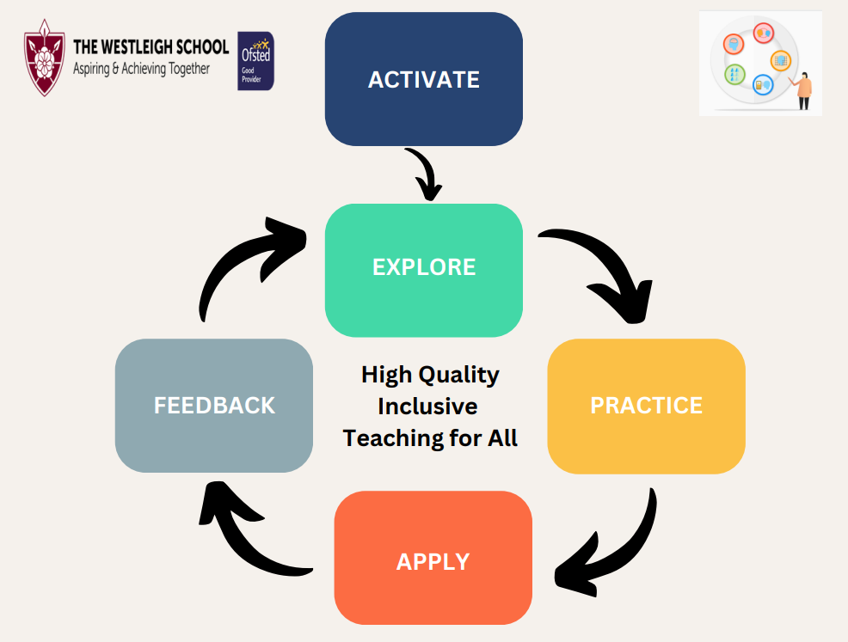

The “Westleigh Way”

To ensure consistency, the following expectations should be followed:

* Meet and Greet: Teachers welcome students at the door to set a positive tone.
* Seating Plans: Seating arrangements should be purposeful and annotated with information for SEND support.
* Student Records: Books, files and digital work should display targets and assessment scores for clear reference.

Marking and Feedback

Marking and feedback needs to be meaningful, manageable, motivating and is only of value if it improves student learning. Regular and effective feedback is essential to provide students with the skills to become independent learners and owners of their learning and progress. Effective feedback is an essential part of the learning process. It is the interaction between teacher and student: a way of acknowledging students’ work, checking learning against curricular goals and making decisions about what teachers and students need to do next to drive progress.

All our students should be able to answer two questions about their learning:

* What am I doing well in this subject?
* What do I need to do to improve my work in this subject?

Feedback Principles

* Curriculum plans will identify assessed key pieces of work and the methodologies for feedback in line with this policy
* Marking will be used to assess students’ learning against curricular goals and feedback should be posed as questions, focussing on knowledge and skills and addressing misconceptions
* When students receive feedback, they will be given time to reflect and act upon the feedback using a green pen to evidence the changes and progress made. Examples (but not an exhaustive list) of student responses to feedback include:
  + Redrafting / improving a part of or all the original task
  + Responding to an extension / challenge question
  + Completing an activity that reinforces or extends understanding
  + Completing an activity designed to address misconceptions
  + Repeating a process or applying a concept to another situation
* Feedback will additionally focus on developing students’ literacy skills using the Literacy Marking Codes and embedding the use of Frayer models

**Different forms of feedback will be more appropriate for different subjects. Curriculum areas, using the feedback principles, will decide on how feedback is consistently used to improve student learning and progress and develop its own procedures as an annexe to this policy, outlining the agreed approach to marking and feedback within their subject.**

Examples of feedback

|  |  |  |
| --- | --- | --- |
|  | **Ongoing formative feedback** | **Deeper formative feedback** |
|  | * Live modelling examples with visualiser, * I do - We do - You do*,* * Live whole class feedback, * Effective questioning, * Verbal feedback at point of learning, * Self/peer assessment using success criteria * Low stakes quizzing | Deep and detailed feedback to include strengths and targets. This feedback is subject specific to fully challenge and encourage students to improve the piece of work. This supports students to develop confidence, knowledge and skills in future work.  Deeper formative feedback can be whole class feedback or individualised |
|  | **Literacy feedback** | **Literacy feedback** |
|  | Self-regulated literacy corrections. Directed by teacher through ongoing feedback, students to identify and correct literacy errors  Use of Frayer model to teach vocabulary concepts | Teacher identified literacy marking. Teacher to highlight literacy errors using agreed codes. Students to self-correct following feedback |
| KS4 | Ongoing | In line with departmental curriculum plans and key identified pieces for formative assessment. Common misconceptions, highlighted from formative feedback, must be incorporated into ongoing curriculum plans  Minimum expectation for deeper formative feedback is once per half term |
| KS3 |

Presentation of students’ work

**Teachers should insist on good presentation, encouraging students to take pride in their work.**

* All work should have a date and title that links to the overarching challenging curricular goal
* Students should write in black or blue ink with drawings in pencil
* Students must understand the importance of writing legibly, as neatly as possible (no graffiti or doodling)
* All pages should be used (no skipped pages in books)
* Worksheets should be stuck into books to support and evidence learning

Marking for literacy

**All teachers are teachers of literacy and therefore it is the collective responsibility of all staff in all curriculum areas to ensure that literacy is constantly addressed in order to improve standards of disciplinary literacy. It is important to address misspelling of Tier 2/3 vocabulary so that students demonstrate correct use of academic language in subsequent work.**

Teachers’ marking will highlight literacy errors using the whole school literacy codes

|  |  |  |
| --- | --- | --- |
| **Literacy marking codes for all subjects** | | |
| **Mark** | **Means** | **Action** |
| Sp | Spelling mistake | Circle the spelling mistake. Students to self-correct in books, with green pen, using dictionary or teacher modelling |
| P | Punctuation error/omission | Circle the punctuation error/omission. Students to self-correct in books, using green pen |
| CL | Missing or misused capital letter | Circle the missing or misused capital letter. Students to self-correct in books, using green pen |
|  | Excellent vocabulary | Teacher to highlight ambitious vocabulary or key words used correctly |

It is recognised that it is not appropriate for every spelling error in a piece of writing to be corrected. Corrections should focus on subject specific key vocabulary, as highlighted in curriculum plans, and academic vocabulary.

Teachers should remain sensitively aware when correcting the work of students with a Specific Learning Disability, in line with the guidelines in their Pupil Profiles.

**Home Learning**

Homework enriches the curriculum and fosters independent learning habits.

**Aims:** Consolidate learning, prepare for new content, and develop commitment to learning beyond the classroom.

* **Routines:** Teachers will set clear and reasonable deadlines, regularly check homework, and provide constructive feedback.
* **Formats:** Homework may include projects, review tasks, assessments, and research activities.
* **Exit Quiz**: Students will routinely complete a range of low stakes quizzes for each subject to reinforce understanding.