Special Educational Needs and Disabilities (SEND) Policy and Information Report
The Enterprise Learning Alliance


Inclusion Team
SEND Governor:

SENCO
Jenelle Harvey-Aduca
Contact No. 01843 210056

Approved by: |  | Date:
Last reviewed on: | March 2025
Next review due by: | December 2026

Contents
1. What types of SEND does the school provide for? 4
2. Which staff will support my child? 5
3. What should I do if I think my child has SEND? 7
4. What happens if the school identifies a need? 8
5. How will the school measure my child’s progress? 9
6. How will I be involved in decisions made about my child’s education? 10
7. How will my child be involved in decisions made about their education? 11
8. How will the school adapt its teaching for my child? 12
9. How will the school evaluate whether the support in place is helping my child? 13
10. How will the school ensure my child has appropriate resources? 13
11. How will the school make sure my child is included in activities alongside pupils who don’t have SEND? 14
12. How does the school make sure the admissions process is fair for pupils with SEN or a disability? 15
13. How does the school support pupils with disabilities? 15
14. How will the school support my child’s mental health and emotional and social development? 16
15. What support is in place for looked-after and previously looked-after children with SEN? 16
16. What support will be available for my child as they transition between classes or settings or in preparing for adulthood? 17
17. What support is available for me and my family? (Local Offer) 18
18. What should I do if I have a complaint about my child’s SEND support? 19
19. Supporting Documents…………………………………………………………………………………………………………….19
20. Glossary 20

Dear parents and carers,
The aim of this Information Report is to explain how we implement our SEND policy. In other words, we want to show you how SEND support works in our school.
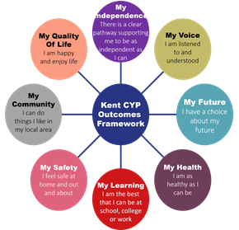
As educational professionals, we are all working towards the ultimate goal of growing independent young people as they prepare for adulthood. All provision and support we provide is working towards achieving the Kent Children and Young People (CYP) Outcomes Framework:

If you want to know more about our arrangements for SEND, read our SEND policy alongside this Information Report.
You can find our SEND policy on our website:
https://www.ela.kent.sch.uk/about-us/Information/Policies
Note: If there are any terms we’ve used in this information report that you’re unsure of, you can look them up in the Glossary at the end of the report.

1. What types of SEND does the school provide for?

Our school provides for pupils with the following needs (as outlined in the SEND Code of Practice 2015):

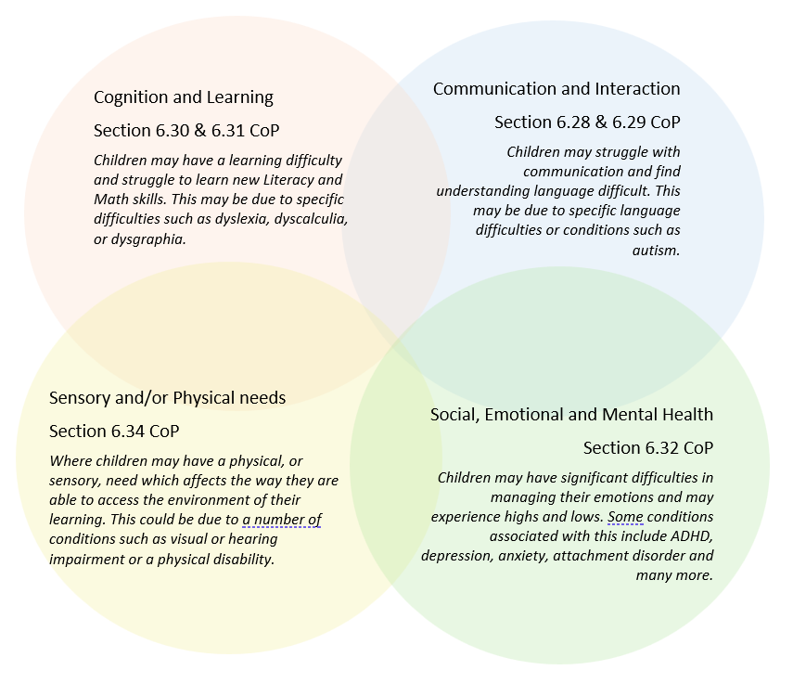

Often you will find that children’s needs overlap and are rarely confined to one area of need, which is why it is important to gain a wholistic overview of your child.
More information about the Areas of Need can be found in the Special educational needs and disability code of practice: 0 to 25 years (link below).
SEND_Code_of_Practice_January_2015.pdf (publishing.service.gov.uk)


2. Which staff will support my child, and what are their key responsibilities?

At The Enterprise Learning Alliance all staff are considered responsible for supporting the needs of pupils with SEND. Our staff are committed to regular, high-quality training to ensure that they have the knowledge and skills to better meet a wide range of pupil needs.
Below outlines key staff who will be supporting your child. Please note that this list is not exhaustive.
Our Special Educational Needs Co-ordinator, or SENCO
The named SENCO is Jenelle Harvey-Aduca
Our SENCO has 9 years’ experience in this role and is a qualified Teacher with the National Award for SEN Coordination, she has worked as a Teacher and managed the complex needs Centre within The ELA. The SENCO has completed a postgraduate certificate in SpLD along with the CTP3A course meaning she is a specialist assessor and able to assess for access arrangements. She has undertaken and achieved the Diploma in Trauma and mental health with Trauma informed schools UK and is about to undertake the Thrive Wellbeing Leadership qualification.

Class/subject teachers
All of our teachers receive in-house SEN training, and are supported by the SENCO to meet the needs of pupils who have SEN.
Training has included CPD through Inner Drive and Rosenshine’s principles of instruction, trauma informed practice, Supporting reading, Behaviour and Relationships, Embedding Formative Assessment with the EEF, Restorative practices, Assessment and Feedback, Supporting pupils through the use of technology, Metacognition, ADHD, ASC, Dyslexia, Dyscalculia.
Training needs are constantly analysed and met throughout the school year.
Teaching assistants (TAs)
We have a team of 15 TAs, including one higher-level teaching assistants (HLTAs) who are trained to deliver SEN provision, and three Behaviour Lead TA’s.
We have four Early Intervention Mentors who are trained to deliver interventions such as Thrive reparative and Trauma and Mental Health interventions.
In the last academic year, TAs have been trained in ADHD, ASC, Dyslexia, Dyscalculia, Trauma informed approaches, Inner drive Rosenshine’s principles of instruction, supporting reading, cognitive load, working memory, retrieval practice.
Training needs are constantly analysed and met throughout the school year.

External agencies
Sometimes we need extra help to offer our pupils the support that they need. Whenever necessary we will work with external support services to meet the needs of our pupils with SEND and to support their families. These may include:

- Child and adolescent mental health services (CAMHS)
- Education welfare officers
- Educational psychologists
- GPs or paediatricians
- NELFT practitioners
- Occupational therapists
- Therapeutic practitioners
- Behaviour coaches
- Safeguarding services
- School Liaison Officer
- School nurses
- SEND Inclusion Advisor
- Specialist Teacher Service
- Speech and language therapists



- Voluntary sector organisation

3. What should I do if I think my child has SEND?

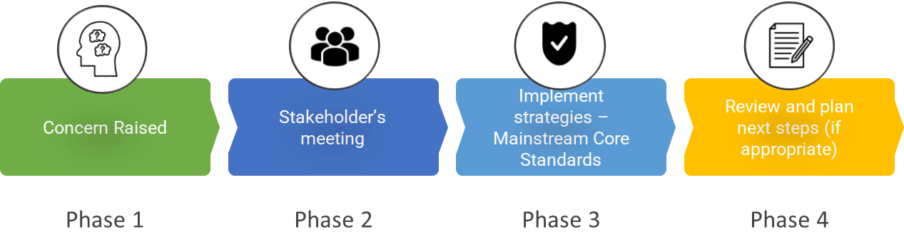

Phase 1 | If you think your child might have SEND, raise your concern with the school so that the SENCO is aware.  Initial concerns are discussed with the Class Teacher and/ or Head of Centre, this can be done via phone, email or requesting a meeting. Discussions take
Phase 2 | We will meet with you to discuss your concerns and try to get a better understanding of what your child’s strengths and difficulties are. Together we will decide what outcomes to seek for your child and agree on next steps. We will make a note of what’s been discussed and add this to your child’s record.
Phase 3 | We will implement the agreed strategies and monitor these over an agreed period of time. These are likely to be universal strategies set out in the mainstream core standards. A copy of this can be found here: https://www.kelsi.org.uk/__data/assets/pdf_file/0005/117257/Special-educational-needs-mainstream-core-standards-guide-for-parents.pdf . This will initiate the ‘Graduated Approach’ where support will be continually reviewed. See next page for more details.
Phase 4 | If we decide that your child needs SEND support, we will formally notify you and your child will be added to the school’s SEND register. They will receive additional support and this will be reviewed using the assess, plan, do, review model.

4. What happens if the school identifies a need?
The same process is followed if a concern is raised by the school.

We will assess each pupil’s current skills and levels of attainment on entry, which will build on previous settings and Key Stages, where appropriate. Class teachers will make regular assessments of progress for all pupils and identify those whose progress:
- Is significantly slower than that of their peers starting from the same baseline
- Fails to match or better the child’s previous rate of progress
- Fails to close the attainment gap between the child and their peers
- Widens the attainment gap
This may include progress in areas other than attainment, for example, social emotional or mental health needs.
Slow progress and low attainment will not automatically mean a pupil is recorded as having SEN.
When deciding whether special educational provision is required, we will start with the desired outcomes, including the expected progress and attainment, and the views and the wishes of the pupil and their parents. We will use this to determine the support that is needed and whether we can provide it by adapting our core offer, or whether something different or additional is needed.
Any pupil who has been identified as having difficulties may be further assessed, any additional assessment is done by the SENCO or Interventions team.
The school has various systems of identification.
- An early identification system, which collects information from the feeder schools and other agencies.
- A robust assessment package which pupils undergo prior to admission. Pupils also undertake reading assessments, and all pupils undergo regular school assessments. These include SDQ assessment, academic progress informing assessment, assessment by school counsellors, Senior Mental Health Lead and/ or Thrive practitioners. Our school identification system is fed by academic and social emotional and mental health tracking which collects information through subject teachers and pastoral support systems. Pupils are discussed regularly at placement panels, pupil progress meetings and bi weekly ACF meetings.
Pupils with a reading age below the expected norm will automatically trigger further assessment and support will be put in place. The Reading Lead organises and monitors the support for pupils requiring extra help with reading
If the teacher notices that a pupil is having difficulties, they try to find out if the pupil has any gaps in their learning. If they can find a gap, the school will provide appropriate support. Pupils who don’t have SEND usually make progress quickly once the gap in their learning has been filled.
If the pupil is still finding it difficult to make the expected progress, the teacher will talk to the SENCO, and will contact you to discuss the possibility that your child has SEND, and the school will follow the graduated approach (see previous page).

All vulnerable learners to be included on the ELA vulnerable/monitoring register.
- All learners will have access to high quality teaching.
- For children with EAL it is recognised that language acquisition is best promoted through a range of good, inclusive strategies, interventions and differentiation of the usual PRU curriculum.
- Some vulnerable learners will have access to Wave 1 or Wave 2 interventions. These will probably be pupils who are underachieving and have been identified by the PRU as needing to make accelerated progress but will not necessarily be pupils with special educational needs. This is considered as scaffolding of the usual curriculum – not a special intervention for pupils with SEN.
- All vulnerable learners will be included on a detailed ELA SEN provision map which outlines and monitors all additional intervention across the school. The whole ELA provision map enables the school to:
  - Plan strategically to meet pupils’ identified needs and track their provision.
  - Audit how well provision matches need
  - Recognise gaps in provision
  - Highlight repetitive or ineffective use of resources
  - Demonstrate accountability for financial efficiency
  - Demonstrate to all staff how support is deployed
  - Inform parents, LEA, external agencies and OFSTED about resource deployment
  - Focus attention on whole-school issues of learning and teaching as well as individual needs, providing an important tool for self-evaluation.

The school places great importance on ensuring that pupils:

- follow an integrated approach
- have access to high quality inclusive teaching

Support for pupils is focused:
- By “in-class” support where appropriate
- By the development of coping strategies
- Through support by ‘withdrawal’ if it is considered necessary to meet individual need
- Through personalised learning programmes.

The school recognises that all teachers are teachers of pupils with SEND. To this end all staff receive training on how to address SEND issues within the school.

The school recognises that behaviour management is part of Special Educational Needs and has developed whole school strategies within the Behaviour Policy.

Access to a Broad and Balanced Curriculum
No pupils are discriminated against in studying any subject area within the School’s curriculum on the grounds of their SEND. Professional advice is given to guide pupils into an appropriate course, at points of transition.
Arrangements to ensure this happens use some or all of these strategies:
- In class support - the teaching assistant liaises with the class teacher and supports targeted pupils. Support may include writing for the pupil and reading texts.
- All pupils are taught in small groups using modified work based on the curriculum being delivered
- Withdrawal for a specific literacy and numeracy programme - time allocated to individuals or small groups who need intensive support in order to develop basic literacy and numeracy skills.
- Modification of curriculum materials in curriculum areas.
- Individual target setting.
- Extra time allowed for completion of assignments.
- Other methods of recording work are used.
- Pupil guidance.
- Smaller group teaching in all lessons which allows for a smaller teacher pupil ratio and therefore more 1:1 support.
- Exam Access Arrangements in Years 10 and 11 in order that pupils are not disadvantaged,

Identification and Assessment at Stage 1
Children’s needs should be identified and met as early as possible through:

- The analysis of data including entry profiles, initial literacy and numeracy assessments, reading and comprehension ages, other whole-school pupil progress data.
- Classroom-based assessment and monitoring arrangements. (Cycle of assess, plan, do and review based on the graduated approach with the new code of practice.)
- Following up parental concerns
- Tracking individual children’s progress over time,
- Liaison with referring schools
- Information from home schools
- Information from other services
- Maintaining the SEN register and a provision map for all vulnerable learners which clearly identifies pupils receiving additional SEN Support in addition to the personalised support provided through the ELA. This provision map is updated termly through meetings between the teachers and SENCO at staff meetings.
- Undertaking, when necessary, a more in depth individual assessment - this may include a range of commercially available assessments, carefully chosen to deliver appropriate, useful information on a pupil’s needs. It may include a bilingual assessment where English is not the first language.
- Involving an external agency where it is suspected that a special educational need is significant i.e. Educational Psychologist, Speech and Language therapist or Specialist teachers from the local outreach team.

Stage 2 Additional SEN Support

- Pupils will be offered additional SEN support when it is clear that their needs require intervention which is “additional to” or “different from” the well-differentiated curriculum offer for all pupils in the ELA i.e. they have a special educational need as defined by the SEN Code of Practice 2014.
- Under-achieving pupils and pupils with EAL who do not have SEN will not be placed on the list of pupils being offered additional SEN support (but will be on the PRU’s vulnerable monitoring register).
- In keeping with all vulnerable learners, intervention for pupils on the SEN list will be identified and tracked using the whole-ELA provision map.
- On very rare occasions, where a pupil has a significant, severe and sustained need, it may be necessary to enter a multi-disciplinary assessment process with health and social care in order to consider the need for an Education Health and Care Plan.
- Where a pupil is in receipt of High Needs Funding and/or an Education Health and Care Plan, a decision will be made as to whether a short-term Individual Learning Plan is required.
- Our approach to IEPs, which we recognise are no longer prescribed in the SEN Code of Practice 2014, is as follows:

- Our IEPs are a planning, teaching and reviewing tool which enables us to focus on particular areas of development for all pupils in the PRU, including those with special educational needs. They are seen as working document which can be constantly refined and amended.
- Our IEPs for pupils with SEN will record that which is additional to or different from the differentiated curriculum plan which is in place as part of their personal provision. Targets will address the underlying reasons why a pupil is having difficulty with learning – they will not simply be “more literacy” or “more maths”.
- Our IEPs will be accessible to all those involved in their implementation – pupils should have an understanding and “ownership of the targets” through the mentoring process.
- Our IEPs will be based on informed assessment and will include the input of outside agencies,
- Our IEPs have been devised so that they are manageable and easily monitored and therefore will be monitored and evaluated regularly.
- Our IEPs will be time-limited and subject to termly reviews. There will be an agreed “where to next?”
- Our IEPs will have a maximum of four short / medium term SMART targets set for or by the pupil.
- Our IEPs will state what the learner is going to learn – not what the teacher is going to teach and will be clear about what the pupil should be able to do at the end of the given period.
Targets for an IEP will be arrived at through:
Discussion between Teachers/ TA’s and SENCo
Discussion with parents/carers and pupil
Discussion with another professional if appropriate

Stage 3: Statement of Special Educational Needs or Education Health and Care Plan
As set out by the PRU agreement (KCC), we are unable to provide admission and support for pupils with a finalised EHCP. However, we recognise that some pupils who are referred to us need the ongoing level of support which can only be achieved through the award of an EHCP. We work collaboratively with parents/carers, pupils and mainstream school to decide if this is appropriate. We then fully support the process in the most appropriate way possible, including facilitating expert testing, providing in-house evidence of need, completing Appendix 2s, meeting with stakeholders and providing updates to Educational Psychologists.
Should an EHCP be awarded to a pupil during their time with us, appropriate and timely transition plans are put in place to support them in moving to the best provision to meet their needs, either named on the EHCP or identified in conjunction with their parents/carers and mainstream school. In rare situations where an EHCP is awarded near the end of a pupil’s time at The ELA, or at a point in their KS4 where transferring schools would negatively impact their GCSEs, we may decide to continue to work with that pupil until the natural point of moving, working collaboratively to ensure the most appropriate destination is secured and transition work is undertaken.
Pupils with a statement of educational needs (pre September 2014) or an Education Health and Care Plan (post September 2014) will have access to all arrangements for pupils on the SEN list (above) and, in addition to this, will have an Annual Review of their statement/plan.

Our PRU will comply with all local arrangements and procedures when applying for
- High Needs Block Funding however we as a PRU do not have access to High Needs Funding.
- An Education Health and Care Plan
- We will ensure that all pre-requisites for application have been met through ambitious and pro-active additional SEN Support at an earlier stage.
- Our review procedures fully comply with those recommended in Section 6.15 of the Special Educational Needs Code of Practice and with local NCC policy and guidance - particularly with regard to the timescales set out within the process.

5. How will the school measure my child’s progress?
We will follow the ‘graduated approach’ to meeting your child’s SEND needs.
The graduated approach is a 4-part cycle of assess, plan, do, review.
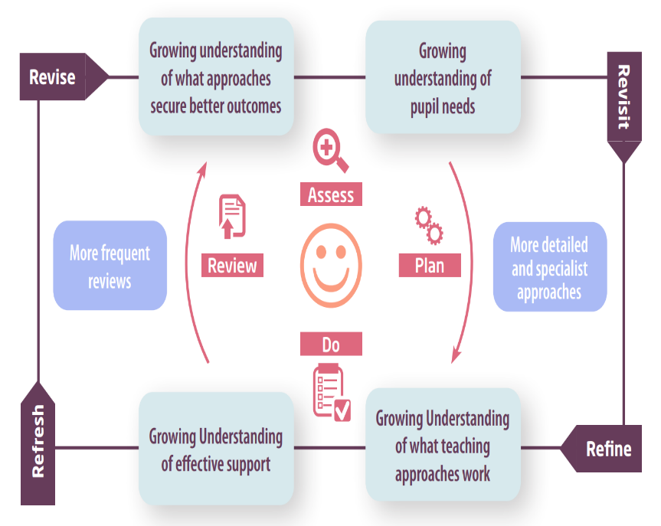

Assess | If your child is not making the expected level of progress, we will make an assessment to find out what strengths and difficulties your child has. We will ask for you and your child’s input, as well as getting help from external professionals where necessary.
Plan | In discussion with you and your child, we will decide what outcomes we are hoping to achieve. We will make a plan of the support we will offer your child to help them meet those outcomes. We will make a record of this and share it with you and all relevant school staff.
Do | We will put our plan into practice.  The class teacher, with the support of the SENCO, will be responsible for working with your child on a daily basis, and making sure the support we put in place is having the impact we intended.
Review | We will assess how well the support we put in place helped the pupil to meet the outcomes we set. We will use our improved understanding of your child’s needs to improve the support we offer; this may mean the Plan, Assess, Do, Review cycle continues.

6. How will I be involved in decisions made about my child’s education?

We will provide Termly reports on your child's progress on Parent consultation days.
A member of staff who knows your child well will meet you four times a year to:
- Set clear outcomes for your child’s progress
- Review progress towards those outcomes
- Discuss the support we will put in place to help your child make that progress
- Identify what we will do, what we will ask you to do, and what we will ask your child to do
The SENCO may also attend these meetings to provide extra support.
We know that you’re the expert when it comes to your child’s needs and aspirations. So, we want to make sure you have a full understanding of how we’re trying to meet your child’s needs, so that you can provide insight into what you think would work best for your child.
We also want to hear from you as much as possible so that we can build a better picture of how the SEND support we are providing is impacting your child outside of school.
If your child’s needs or aspirations change at any time, please let us know right away so we can keep our provision as relevant as possible.
If you have concerns that arise between these meetings, please contact the Head of Centre in the first instance.

7. How will my child be involved in decisions made about their education?

The level of involvement will depend on your child’s age and individual needs. We recognise that no two pupils are the same, so we will decide on a case-by-case basis, with your input.
We may seek your child’s views by asking them to:
- Attend meetings to discuss their progress and outcomes
- Prepare a presentation, written statement, video, drawing, etc.
- Discuss their views with a member of staff who can act as a representative during the meeting
- Complete a survey



8. How will the school adapt its teaching for my child?
Your child’s teachers are responsible and accountable for the progress and development of all the pupils in their class.
High-quality teaching is our first step in responding to your child’s needs. We will make sure that your child has access to a broad and balanced curriculum in every year they are at our school.
We will adapt our approaches to how we teach to suit the way the pupil works best. There is no 'one size fits all’ approach to adapting the curriculum, we work on a case-by case basis to make sure the adaptations we make are meaningful to your child and are guided by the Mainstream Core Standards in the first instance.

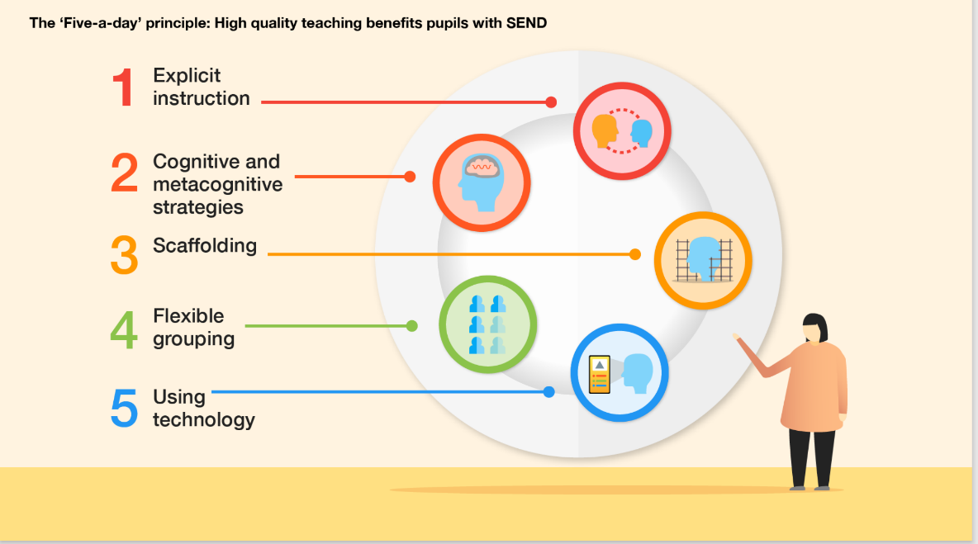
We are following the ‘5 a day’ principle.

These adaptations may include:
- Adapting our approaches, for example, giving longer processing times, pre-teaching of key vocabulary, reading instructions aloud, etc.

- Adapting our resources and staffing

- Using recommended aids, such as laptops, coloured overlays, visual timetables, larger font, etc.

- Teaching assistants or support staff will support pupils appropriately depending on their presentation of need. Effective use of TA’s to promote self-scaffolding and independence in learning.

- Scaffolding lesson materials
At the ELA we aim:
- To create a positive and supportive environment for pupils without exception.
- Build an ongoing, holistic understanding of our pupils and their needs.
- Ensure all pupils have access to high quality teaching.
- Complement high quality teaching with carefully selected small group and one-to-one interventions.
- Work effectively with Teaching Assistants.
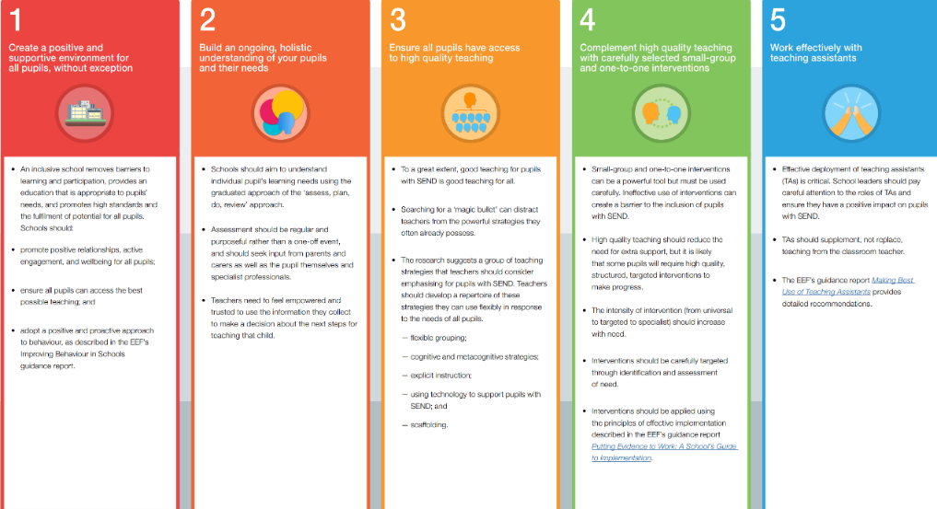

We may also provide the following interventions:
Family wellbeing support
Learning Mentors
Reciprocal reading approach
Paired reading/ SNIP/ RFM/ Toe by Toe/ Phonics
Emotional literacy/ Zones of regulation/ Thrive
1:1 tuition (2 week catch up)
Offsite engagement tuition (time limited)
Peer mentoring
Behaviour mentors within each setting
School counselling service
Time out card
Language for learning strategies embedded to create language friendly environments.
Specialist Teacher and assessor SpLD
Pre teaching and over learn opportunities
Drawing and Talking therapy
GCSE booster sessions
Emotional regulation group
Positive Day card
Mental health lead for whole school.
Trauma informed practice
Table top board game intervention
Learn Pathway
Empower Pathway

These interventions are part of our contribution to Kent County Council’s local offer.

9. How will the school evaluate whether the support in place is helping my child?
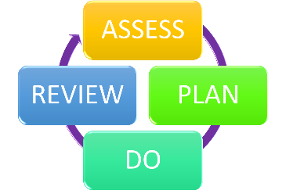
We will evaluate the effectiveness of provision for your child by:
- Reviewing their progress towards their goals each term
- Reviewing the impact of interventions after 6 weeks
- Using pupil questionnaires
- Monitoring by the SENCO
- Using provision maps/ intervention trackers to measure progress
- Holding an annual review (if they have an education, health and care (EHC) plan)

10. How will the school ensure my child has appropriate resources?
It may be that your child’s needs mean we need to provide additional resources such as:
- Additional resources to support their learning
- Adaptations to in class support
- Further training for our staff
- External specialist expertise
Where appropriate, we will consult with external agencies to get recommendations on what will best help your child access their learning and use our best endeavours to ensure these are supplied.

11. How will the school make sure my child is included in activities alongside pupils who don’t have SEND?


The expectation is that all schools providing an inclusive provision for all pupils. It may be necessary for some pupils to receive interventions in addition to a broad and balanced curriculum.
All our extra-curricular activities and school visits are available to all our pupils.
All pupils are encouraged to go on our residential trip(s) if applicable, residential camping trips are sometimes undertaken by pupils on certain vocational courses but not always.
All pupils are encouraged to take part in sports day/school plays/special workshops.
No pupil is ever excluded from taking part in these activities because of their SEN or disability.
Where it is necessary, the school will use the resources available to it to provide additional adult support to enable the safe participation of the pupil in the activity.

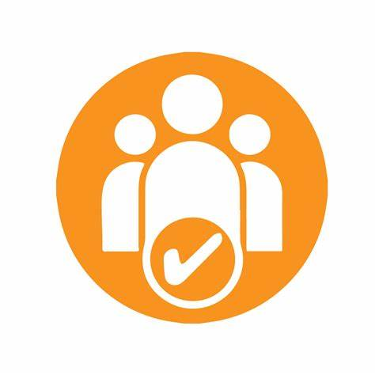
12. How does the school make sure the admissions process is fair for pupils with SEN or a disability?

Admission to The ELA PRU is through local schools rather than having an admissions process of its own. The ELA PRU will ensure that pupils with SEN or a disability are accepted on dual roll with their home school.

13. How does the school support pupils with disabilities?


You’re disabled under the Equality Act 2010 if you have a physical or mental impairment that has a ‘substantial’ and ‘long-term’ negative effect on your ability to do normal daily activities.
Confidentiality
The ELA recognises and values parents’ knowledge of their child’s disability and its effect on his/her ability to carry out normal activities and respects the parents and child’s right to confidentiality.
Improving Access
It is our intention to remove, as far as possible, these barriers which make it difficult for any individuals who have difficulties within the following broad categories of need, if it gets in the way of school life:
- Physical access to the learning environment.
- Access to published information/ lessons/learning/school.
- Access to the curriculum.
We aim to seek
- The views and aspirations of disabled pupils and staff themselves
- The views and aspirations of the families of disabled pupils
- The views and aspirations of other disabled people or voluntary organisations
Detailed arrangements for any pupil or member of staff who has a disability will be discussed in full prior to their first day to ensure that any necessary adjustments are in place.
We aim to address the three areas of improving access to
- The physical environment
- Access to the curriculum
- Access to information usually provided in written form
Physical environment
The ELA has accessible toilet facilities for both staff and pupils. The pupil space is large enough to accommodate a toilet and washbasin, wheelchair and up to two adults.
The Southwood Centre and Northwood Centre are ground floor only accommodation, providing same floor exit points in case of fire. The Westwood Centre has two floors with a lift to the upper floor available accessed through Liberty College entrance.
All doors are wheelchair access compliant.
The ELA is committed to reviewing and updating accessibility to the building and facilities to ensure that they are suitable for the disabled.
The ELA is committed to ensuring that any new build or renovations are accessible by all potential pupils, staff and visitors.
Access to the curriculum
All areas of the curriculum should be available to pupils regardless of their disability. Where an activity cannot be made accessible or would be inappropriate then an alternative activity should be made available. For example, football may be inappropriate for an individual wheelchair user but an alternative physical activity should be offered.
Handwriting practice might be inappropriate for a disabled pupil but practising keyboard skills would be a suitable and valuable alternative. Planning to improve access to the curriculum will include identifying reasonable adjustments to offer an equality of opportunity.
Where disabled pupils are admitted to The ELA, we are committed to planning specific staff training to understand their needs and to purchasing any specialist equipment to allow full access to the curriculum
For school trips staff will ensure the accessibility to coaches and mini buses for wheel chair users.
Access to written information
The ELA will raise awareness of font size and page layouts to support any pupil with visual impairments and ensure that the library facility carries large font and easy read texts to improve access for any visually impaired pupils.
Signage around the building and grounds will be reviewed regularly to ensure that it is accessible to all.

14. How will the school support my child’s mental health and emotional and social development?
At The Enterprise Learning Alliance we understand that an important feature of the school is to enable all pupils to develop emotional resilience and social skills, both through direct teaching for Zones of Regulation and through PSHE and Tutor time and indirectly with every conversation adults have with pupils throughout the day.
For some pupils with the most need for help in this area we also can provide the following; Staff trained in CBT approaches (School counsellors), staff trained in teaching the of The Zones of Regulation, Thrive, access to school counsellor, mentor time with appropriate member of staff, external referral to CAMHS, time-out space for pupil to use when upset or agitated.
Pupils in the early stages of emotional and social development because of their special educational needs will be supported to enable them to develop and mature appropriately. This will usually require additional and different resources, beyond that required by pupils who do not need this support.
The students who attend The ELA have a wide range of emotional, social and educational needs. The patterns of behaviour exhibited by the students vary greatly, therefore support, responses and provision is differentiated according to the emotional, social and communication needs as well as learning needs.
Many students starting at The ELA have experienced interrupted patterns of education and may require additional support in the transition from KS3 to KS4 as well as KS4 to post-16 education, work or training.
We have a zero tolerance approach to bullying.

15. What support is in place for looked-after and previously looked-after children with SEND?


Our SENCO Jenelle Harvey-Aduca is also the Designated Teacher for Children in Care, she will make sure that all teachers understand how a looked-after or previously looked-after pupil’s circumstances and their SEND might interact, and what the implications are for teaching and learning.
Pupils who are looked-after or previously looked-after will be supported much in the same way as any other child who has SEND. However, looked-after pupils will also have a personal education plan (PEP). We will make sure that the PEP and any SEND support plans or EHC plans are consistent and complement one another.

16. What support will be available for my child as they transition between classes or settings or in preparing for adulthood?
Between years
To help pupils with SEND be prepared for a new school year we:
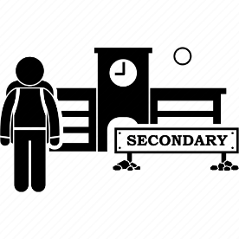

- Ask both the current teacher and the next year’s teacher to attend final meeting of the year when the pupil’s SEND is discussed

Between schools
When your child is moving on from our school, we will ask you and your child what information you want us to share with the new setting. We provide a comprehensive report outlining successful provision and recommended strategies to go to the new setting or home school when they return.
The SENCO of the new setting or home school will meet with our SENCO. They will discuss the needs of all the pupils who are receiving SEND support.
Onto Adulthood

We provide all our pupils with appropriate advice on paths into work or further education.
We work with the pupil to help them achieve their ambitions, which can include goals in higher education, employment, independent living and participation in society. We aim for positive aspirational destinations for all our pupils including pupils with SEND.

17. What support is available for me and my family?
If you have questions about SEND, or are struggling to cope, please get in touch to let us know. We want to support you, your child and your family.
To see what support is available to you locally, have a look at the KCC Local offer. Kent County Council publishes information about the local offer on their website:
About the SEND local offer - Kent County Council
Our local special educational needs and disabilities information advice and support services (SENDIASS) organisations are:
IASK
Home | IASK

National charities that offer information and support to families of pupils with SEND are:
- IPSEA
- SEND family support
- NSPCC
- Family Action
- Special Needs Jungle

18. What should I do if I have a complaint about my child’s SEND support?
The normal arrangements for the treatment of complaints at The Enterprise Learning Alliance are used for complaints about provision made for special educational needs. We encourage parents to discuss their concerns with the Form Tutor, Head of Centre, SENCo, Senior Leadership Team or Executive Headteacher to resolve the issue before making the complaint formal to the Chair of the governing body.
If the complaint is not resolved after it has been considered by the governing body, then a disagreement resolution service or mediation service can be contracted. If it remains unresolved after this, the complainant can appeal to the First–tier Tribunal (Special Educational Needs and Disability), if the case refers to disability discrimination, or to the Secretary of State for all other cases.
There are some circumstances, usually for children who have an Education, Health and Care Plan where there is a statutory right for parents to appeal against a decision of the Local Authority. Complaints which fall within this category cannot be investigated by the school.
If you are not satisfied with the school’s response, you can escalate the complaint. In some circumstances, this right also applies to the pupil themselves.
To see a full explanation of suitable avenues for complaint, see pages 246 and 247 of the SEND Code of Practice.
If you feel that our school discriminated against your child because of their SEND, you have the right to make a discrimination claim to the first-tier SEND tribunal. To find out how to make such a claim, you should visit: https://www.gov.uk/complain-about-school/disability-discrimination
You can make a claim about alleged discrimination regarding:
- Admission
- Exclusion
- Provision of education and associated services
- Making reasonable adjustments, including the provision of auxiliary aids and services
Before going to a SEND tribunal, you can go through processes called disagreement resolution or mediation, where you try to resolve your disagreement before it reaches the tribunal. Global Mediation is the company used by KCC for mediation:
Special Educational Needs and Disability - Global Mediation

19. Supporting documents

- Equality Information and Objectives Policy
- Child protection and safeguarding policy
- Behaviour and Relationships Policy
- Accessibility Plan
- Attendance and punctuality policy
- SEN & Disabilities Code Of Practice 2015
- Mainstream Core Standards

20. Glossary
- Access arrangements – special arrangements to allow pupils with SEND to access assessments or exams
- Annual review – an annual meeting to review the provision in a pupil’s EHC plan
- Area of need – the 4 areas of need describe different types of needs a pupil with SEND can have. The 4 areas are communication and interaction; cognition and learning; physical and/or sensory; and social, emotional and mental health needs.
- CAMHS – child and adolescent mental health services
- Differentiation – when teachers adapt how they teach in response to a pupil’s needs
- EHC needs assessment – the needs assessment is the first step on the way to securing an EHC plan. The local authority will do an assessment to decide whether a child needs an EHC plan.
- EHC plan – an education, health and care plan is a legally-binding document that sets out a child’s needs and the provision that will be put in place to meet their needs.
- First-tier tribunal/SEND tribunal – a court where you can appeal against the local authority’s decisions about EHC needs assessments or plans and against discrimination by a school or local authority due to SEND
- Graduated approach – an approach to providing SEND support in which the school provides support in successive cycles of assessing the pupil’s needs, planning the provision, implementing the plan, and reviewing the impact of the action on the pupil
- Intervention – a short-term, targeted approach to teaching a pupil with a specific outcome in mind
- Local offer – information provided by the local authority which explains what services and support are on offer for pupils with SEND in the local area
- Outcome – target for improvement for pupils with SEND. These targets don't necessarily have to be related to academic attainment
- Reasonable adjustments – changes that the school must make to remove or reduce any disadvantages caused by a child’s disability
- SENCO – the special educational needs co-ordinator
- SEN – special educational needs
- SEND – special educational needs and disabilities
- SEND Code of Practice – the statutory guidance that schools must follow to support pupils with SEND
- SEND information report – a report that schools must publish on their website, that explains how the school supports pupils with SEND
- SEND support – special educational provision which meets the needs of pupils with SEND
- Transition – when a pupil moves between years, phases, schools or institutions or life stages

