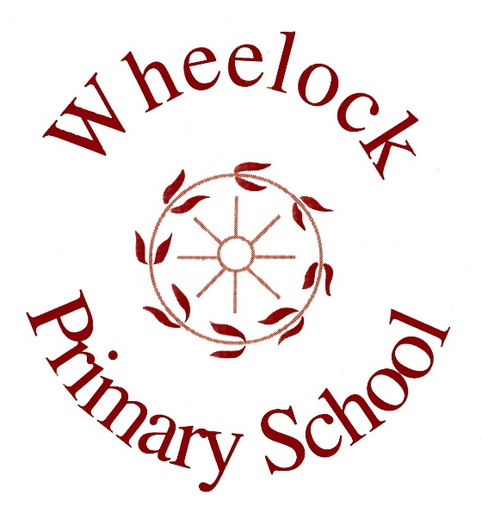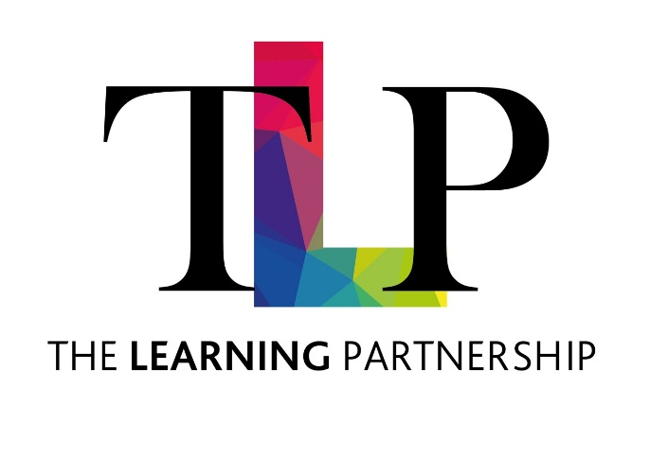

**Wheelock Primary School**

**Policy for Relationships and Sex Education (RSE)**

Next Review: summer 2025

.

At Wheelock Primary School we value PSHE as one way to support children’s development as human beings, to enable them to understand and respect who they are, to empower them with a voice and to equip them for life and learning. We include the statutory Relationships and Health Education within our whole-school PSHE Programme.

In September 2021, we introduced Jigsaw, the mindful approach to PSHE, as our chosen teaching and learning programme and tailor it the children’s needs. To ensure progression through the spiral curriculum, we follow the

mapping document: Jigsaw 3-11 and statutory Relationships and Health Education, which shows exactly how Jigsaw and therefore our school, meets the statutory Relationships and Health Education requirements.

It is important to explain that whilst the Relationships Puzzle (unit) in Jigsaw covers most of the statutory Relationships Education, some of the outcomes are also taught elsewhere in Jigsaw e.g. the Celebrating Difference Puzzle helps children appreciate that there are many types of family composition and that each is important to the children involved. This holistic approach ensures the learning is reinforced through the year and across the curriculum.

In addition, within both key stages, through Science lessons, teachers inform children about puberty and how a baby is born. For this aspect of our teaching we follow the guidance material in the national scheme of work for science. In Key Stage 1 we teach children about how animals, including humans, move, feed, grow and reproduce, and we also teach them about the main parts of the body. Children learn to appreciate the fact that people are not all the same, and that we need to respect each other. In Key Stage 2 we teach about life processes, and the main stages of the human life cycle, in greater depth.

In Year 6 we place a particular emphasis on health education, as many children experience puberty at this age. Teachers endeavour to answer all questions with sensitivity and care within the focus of the lesson’s objectives.

# Roles, responsibilities and monitoring

The subject leader is responsible for monitoring the standard of children’s work and quality of teaching in RSE. This can be done through conversations with staff that teach RSE, talking to children, and looking at the physical work the children produce. The subject leader is also responsible for supporting colleagues in their teaching and for being informed about current developments in the subject.

It is the role of the class teacher to ensure that all of their cohort objectives are covered over a two year rolling plan and that they have addressed any misconceptions within their class. It is also the role of the class teacher to address any concerns they may have in line with the school’s Safeguarding policy.

The school is well aware that the primary role in children’s sex education lies with parents and carers. We therefore wish to build a positive and supporting relationship with the parents of children at our school, through mutual understanding, trust and cooperation.

The governing body monitor and review the impact of our sex education policy on an annual basis. The GOVERNING BODY gives serious consideration to any comments from parents about the sex education programme, and makes a record of all such comments.

# Assessment and reporting

Class teachers assess RSE. This is done informally throughout the year and can be based on conversations, discussions and the work the children produce. Depending on the age of the child, they will demonstrate their knowledge in different ways. In Reception and KS1, this might be done through discussions, conversations and drawings. In KS2, as well as discussions, conversations and drawings, they might also produce labelled diagrams, posters, pose questions and complete some short pieces of writing.

**Links to legislation**

Our school’s policy on relationships and sex education (RSE) is based on the DfE’s document ‘Relationships and sex education (RSE) and health education guidance’.

This guidance can be found here: <https://assets.publishing.service.gov.uk/government/uploads/system/uploads/attach> [ment_data/file/908013/Relationships_Education Relationships_and_Sex_Educatio](https://assets.publishing.service.gov.uk/government/uploads/system/uploads/attachment_data/file/908013/Relationships_Education__Relationships_and_Sex_Education__RSE__and_Health_Education.pdf) [n RSE and_Health_Education.pdf](https://assets.publishing.service.gov.uk/government/uploads/system/uploads/attachment_data/file/908013/Relationships_Education__Relationships_and_Sex_Education__RSE__and_Health_Education.pdf)

In the DfE’s document, the purpose of relationships education is to ‘put in place the key building blocks of healthy, respectful relationships, focusing on family and friendships, in all contexts, including online. This will sit alongside the essential understanding of how to be healthy’.

The DfE also states that ‘In teaching Relationships Education and RSE, schools should ensure that the needs of all pupils are appropriately met, and that all pupils understand the importance of equality and respect. Schools must ensure that they comply with the relevant provisions of the Equality Act 2010.

As of September 2020, it is now compulsory for all Primary Schools to teach Relationships Education. Therefore, while parents do not have the right to withdraw their children from Relationships Education, they do have the right to withdraw their children from any elements of Sex Education that are not covered in the Primary Science National Curriculum – a copy of which can be found here:

<https://assets.publishing.service.gov.uk/government/uploads/system/uploads/attach> [ment_data/file/425618/PRIMARY_national_curriculum_-_Science.pdf](https://assets.publishing.service.gov.uk/government/uploads/system/uploads/attachment_data/file/425618/PRIMARY_national_curriculum_-_Science.pdf)

If a parent wishes their child to be withdrawn from sex education lessons, they should put this in writing to the principal making it clear which aspects of the programme they do not wish their child to participate in.

Our website is used inform parents of the content and objectives that the children will cover in RSE. If a class teacher has any concerns about a child’s understanding of a certain topic, it is their responsibility to report this to parents and seek further advice if needed.

# Inclusion and accessibility

When planning RSE, teachers take into account the needs of the children in their class. We ensure that every child is able to access the lessons and progress their understanding. Where children need extra support, this can be done through pre-teaching, adult support, or differentiated tasks.