

Wheelock Primary School
Year 2026 - 2027
Year group: 1
 | Autumn 1 | Autumn 2 | Spring |  | Summer 1 | Summer 2
Literacy (book title & genre of writing) | Old Bear  Finding narrative  A Message | Rapunzel  Traditional tale narrative  Instructions-How to catch a witch | Last Tree in the City  Environment narrative  Where The Wild Things Are.  Portal narrative  Information text |  | There’s a Tiger in the Garden  Search narrative  Invitation | The last wolf.  Hunting narrative  Whirly Twirly Me  Feelings narrative
Reading (book titles and genres) | Not now Bernard  Oi frog  How many spots has a cheetah got? |  | Chocolate cake  Poems out loud  Human body odyssey |  | Fantastic Mr Fox  How to grow a unicorn  The bee book
Maths | Numbers to 10  Part-whole within 10  Addition within 10  Subtraction within 10  2D and 3D shapes |  | Numbers to 20  Addition and subtraction within 20  Numbers to 50  Introducing length and height  Introducing mass and capacity |  | Multiplication and division  Fractions  Position and direction  Numbers to 100  Money  Time
Science | Everyday materials | Seasonal changes | Animals including humans |  | Plants
Computing  (including online safety) | Introduction to purplemash | Creative computing | Data explorers.  Creating and following instructions. | Animated stories | Coding | Technology around us  Making beats
Geography |  | What is it like here? |  | What is the weather like in the UK? |  | What is it like to live in Shanghai?
History | How have toys changed? |  | How am I making History? |  | How have explorers changed the world?
Art | Woven wonders |  | Painting and mixed media |  | Make your mark
Music | My favourite things | Snail and the mouse | Seaside | Fairytales | Superheroes | Under the sea
D & T |  | Structures |  | Food and nutrition |  | Mechanisms – wheels and axis
PE | Object control | Fundamental skills | Gymnastics | Fundamental skills | Striking and fielding games | athletics
RE | Christianity | Christianity | Christianity/Judaism Enquiry 1 | Christianity | Judaism Enquiry 2 | Judaism Enquiry 3
PSHE (including RSE) | Being me in my world. | Celebrating difference. | Dreams and goals. | Healthy me. | Relationships. | Changing me.
No Outsiders | Going to The Volcano  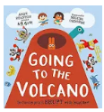  To join in | Want to Play Truck?  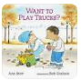  To find ways to play together | All are Welcome  To know I belong  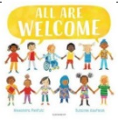 | How to be a Lion  To have self-confidence  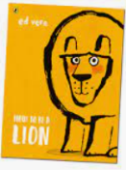 | Amazing  To think about what it means to be a good friend  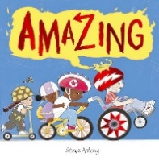 | What the Jackdaw Saw  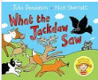  To communicate in different ways.
French (MFL)
Forest School

