

Wheelock Primary School
Year 2026 - 2027
Year group: 4 (Kingfishers & Lapwings)
 | Autumn 1 | Autumn 2 | Spring 1 | Spring 2 | Summer 1 | Summer 2
Literacy (book title & genre of writing)  (2025-2026) | The Whale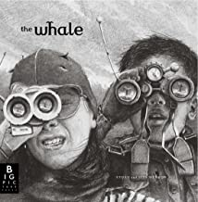  - Narrative: Setting Narrative  - Recount: Newspaper report | Leaf  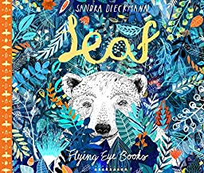  - Narrative: Outsider Narrative  - Information: Polar Bears | The Great Kapok Tree  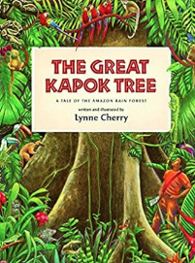  - Persuasive letter  Arthur and the Golden Rope  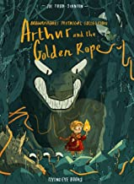  - Narrative: Myth Narrative  - Information: Defeating a Viking Monster |  | Leon & The Place Between  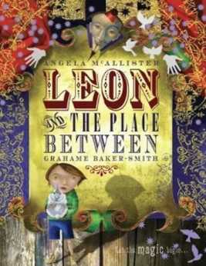  - Portal narrative  - Persuasive magic show report | Manfish  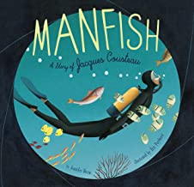  - Narrative: Invention Narrative  - Recount: Jacques Cousteau Biography
Reading (book titles and genres)  (2025-2026) | Fiction: The Wild Robot  Non-Fiction: Young Gifted & Black  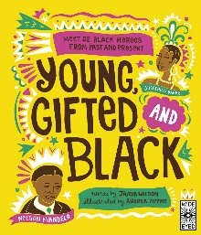  Poetry: The Same Inside  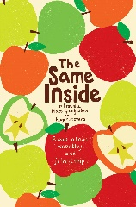  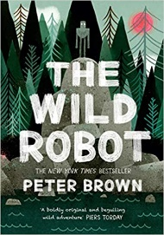 |  | Fiction: Varjak Paw  Non-Fiction: So you think you’ve got it bad?  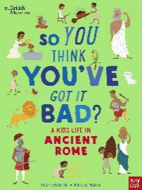  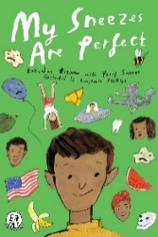  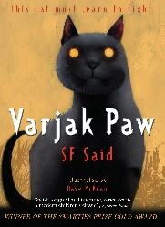  Poetry: My sneezes are perfect |  | Fiction: Boy at the Back of Class  Non-Fiction: 100 Scientists Who Made History  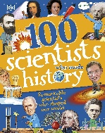  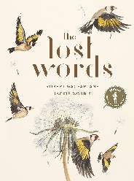  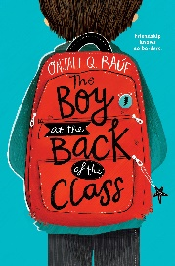  Poetry: Lost Words
Maths | Place Value: 4-digit numbers  Addition & Subtraction  Measure – area  Multiplication & Division |  | Multiplication & Division  Length & Perimeter  Fractions  Decimals |  | Decimals  Money  Time  Geometry – angles & 2D shapes  Statistics  Geometry – position & direction
Science | Animals including Humans | Changing States | Living Things and their Habitats |  | Electricity |  | Sound
Computing – Purple Mash | Online safety and Animations | Unpacking hardware and software & Sound stories | Logo & Online Safety | Effective searching | Coding & Online Safety | Composing beats & Introduction to AI
Geography |  | What are rivers and how are they used? | Why are rainforests important to us? |  |  | Where does our food come from?
History | How have children’s lives changed? |  |  | How did the achievements of the ancient Maya impact their society and beyond? | British History 3: How hard was it to invade and settle in Britain? Anglo-Saxons
Art | Drawing: Texture, tone and proportion |  | Painting and mixed media – Light & dark |  | Craft and Design: Fabric of Nature (rainforest themed)
D & T |  | Cooking & Nutrition – Adapting a recipe |  | Electrical Systems (torches) (linked to electricity in Science and STEM) |  | Mechanical systems – Mechanical cars
Music (KAPOW) | Rock & Roll | Changes in Pitch, Tempo and Dynamics (Rivers) | Body & Tuned Percussion (Rainforests) | Haiku Music and Performance (Hanami Festival for Spring) | Adapting and Transposing Motifs (Romans) | Samba & Carnival Sounds (South America)
PE | Netball | Tag Rugby | Gymnastics / Swimming | Hockey | Athletics | Cricket & Rounders
RE | Islam  Ages 7-9 Enquiry 3  What is the best way for a Muslim to lead a good life? | Christianity  What is the most significant part of the nativity story for Christians today? | Judaism  Ages 7-9 Enquiry 2  Judaism – How do Jewish beliefs, teachings and stories impact on daily life | Christianity  Is forgiveness always possible for Christians? | Judaism  Ages 7-9 Enquiry 3  Does celebrating Shavuot help Jewish children feel closer to God? | Christianity  Do people need to go to church to show they are Christians?
PSHE (including RSE) | Being my in my world | Celebrating difference | Dreams & Goals | Healthy Me | Relationships | Changing Me
No Outsiders  (Cycle B from mixed planning overview) | Beegu  To be welcoming | Along Came a Different  To help someone accept differences | Aalfred and Aalbert  To find common ground | Red  To be who you want to be | When Sadness Comes to Call  To look after mental health | We’re all Wonders  To understand what a bystander is
French (MFL)  (Year 4 Planning) | Welcome to School | My town, your town | Alien faces and family | Moving our bodies | At the doctors and jungle animals | Summertime
Forest School |  |  | Year 4 Forest school
Trips and Visits | Swimming | Theatre Trip  Swimming |  |  | Residential 5th – 7th May  Swimming non-swimmers | Swimming non-swimmers

