

Wheelock Primary School
Year 5: 2026 – 2027
 | Autumn 1 | Autumn 2 | Spring 1 | Spring 2 | Summer 1 | Summer 2
Literacy (book title & genre of writing) | New Text  Curiosity  Space Journey Narrative  Formal Mission Log  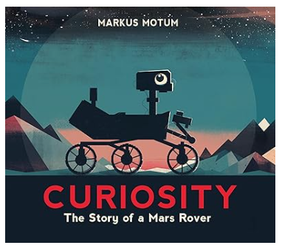 | New Text  The Lost Book of Adventure  Survival Narrative  Survival Guide  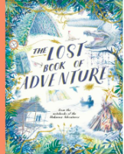 | The Promise  Character Narrative  Newspaper Report  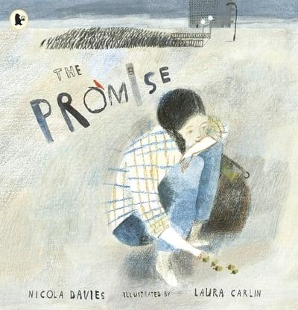 | Greta and the Giants  Restoring the environment narrative  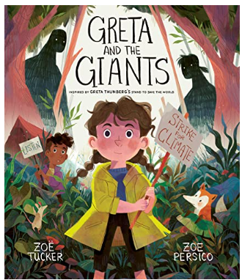 | Macbeth  Embracing emotions narrative  Persuasive letter  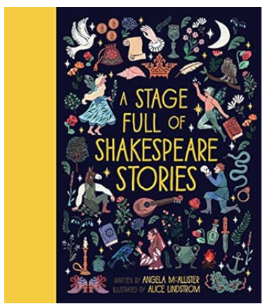 | King Kong  Dilemma narrative  Balanced argument  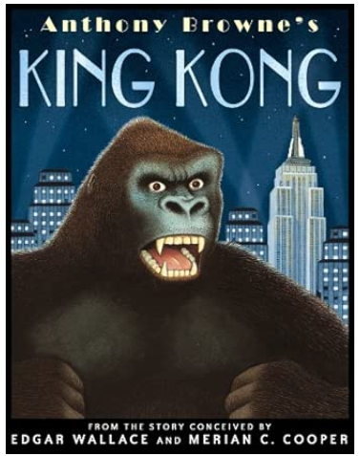
Maths – Year 5 | Number and Place Value (8) (6)  Addition & Subtraction (12)  Multiplication and Division (10)  Fractions (8)(11) |  | Multiplication and Division (10)  Fractions (7)  Decimals & Percentages (15)  Measure – Perimeter & Area (8)  Graphs & Tables (6) |  | Geometry - Properties Of Shape (12)  Geometry - Position & Direction (6)  Decimals (15)  Negative Numbers (4)  Measures – converting units (10)  Measures – volume (3)
Reading (book titles and genres) | The Boy in the Tower - Fiction  The Highwayman - Poetry  I am not a label – Non-fiction  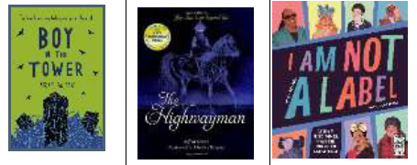 |  | Holes - Fiction  Be the change - Poetry  Sportopedia – Non-fiction  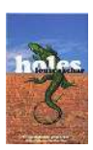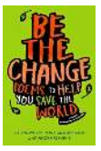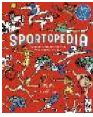 |  | Room 13 - Fiction  Funny Poems - Poetry  The Big Book of the UK – Non-fiction  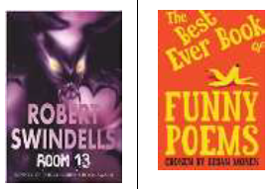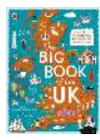
Spelling | Revision of y3/4 words  silent b  ible / able | silent t  ibly and ably  ent | ence  ei | ance, ancy, ant  cious | tious  cial and tial | Year 5 and 6 revision words
Science | Earth and Space | Forces | Animals including Humans | CONT: Animals Including Humans | Living things and their habitats | Materials
STEM | Making salt crystals |  | Secret messages – invisible ink |  | Build a solar oven
Computing  (including online safety) | Quizzing (5)  Databases (4) | Game Creator (5) | Spreadsheets (6) | Coding (6) | Word processing (6) | Concept Maps (4)  ADDITIONAL UNIT: Microbits (4)
Geography |  | What is life like in the Alps? (6) |  | Why do oceans matter? (7) |  | Would you like to live in the desert? (6)
History | British history 4: Were the Vikings raiders, traders or something else? (6) |  | British History 5: What was life like in Tudor England? (6) |  | What is the legacy of the ancient Greek civilisation? (6)
Art | Drawing – I need space |  |  | Sculpture and 3D – Interactive Installations  IN THE FOREST | Painting and Mixed Media - Portraits (5)
D & T |  | Textiles: stuffed toys  (Christmas themed?) | Mechanical Systems – Gears & Pulleys |  |  | Wobble Bots
Music | Ancient Egypt | Blues | South and West Africa | Holi music | Looping and remixing | Musical theatre
PE
RE | Hindu Dharma  Enquiry 1 | Christianity  Is the Christmas story true? | Islam  Enquiry 1 | Christianity  How significant is it for Christians to believe that God intended Jesus to die? | Humanism Enquiry 1  Humanist role models and how they impact on actions a Humanist might take. | Christianity  What is the best way for a Christian to show commitment to God?
PSHE (including RSE) | Being Me in My World | Celebrating Differences | Dreams and Goals | Healthy Me | Relationships | Changing Me
No Outsiders | A Day in the Life of Marlon Bundo  To consider democracy | The only Way is Badger  To consider language and freedom of speech | Leaf  To overcome fears about differences | Introducing Teddy  To show acceptance | King of the Sky  To consider responses to immigration | The Island  To challenge the causes of racism
French (MFL) | Me and my friends | Time in the city | At the market | Clothes | Out of this world | Going to the seaside
Forest School |  |  |  | Forest School
School Trips/Visits | Safety Central | Vikings Lady Visiting  Theatre for Christmas | Bikeability | Tatton Park Visit  Easter Service @ Church

